



KINGSFIELD FIRST SCHOOL

ASTHMA POLICY

2025

*July 2026*

*To be reviewed:*

*Agreed and ratified by the Local Advisory Board on:*

*Headteacher – Mrs C Hodson (Asthma Champion)*

*Responsible Officer:*

*Mr C. Clulow*

*Chair of Board:*

The Asthma Policy in respect of Kingsfield First School has been discussed and adopted by the Local Advisory Board in Summer 2025

**Asthma**

Asthma is a condition that affects small tubes (airways) that carry air in and out of the lungs. When

a person with asthma comes into contact with something that irritates their airways (an asthma

trigger), the muscles around the walls of the airways tighten so that the airways become narrower

and the lining of the airways becomes inflamed and starts to swell. Sometimes, sticky mucus or

phlegm builds up, which can further narrow the airways. These reactions make it difficult to

breathe, leading to symptoms of asthma.

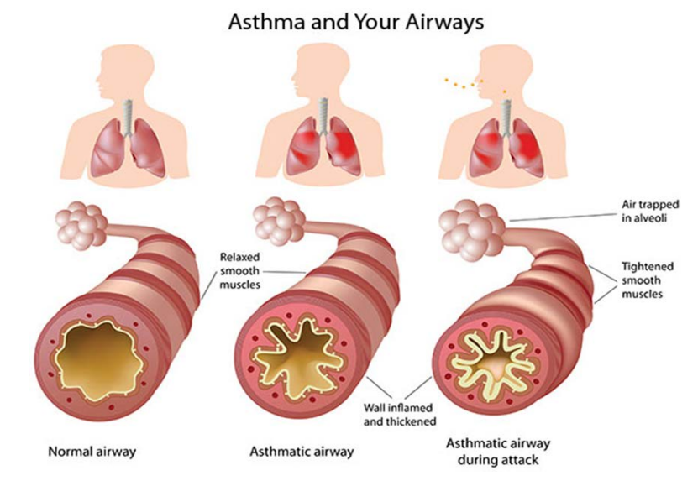

At Kingsfield First School, we recognise that asthma is a common, controllable condition that can be serious if the child has poorly controlled asthma and/or is having an asthma attack. Our school welcomes all pupils with asthma and aims to support these children in participating fully in school life. We endeavour to do this by ensuring we have:

* an asthma register
* an up-to-date asthma policy
* an asthma champion
* all pupils with immediate access to their rescue inhaler at all times
* all pupils with an up-to-date asthma care plan
* an emergency salbutamol inhaler available
* ensured all staff have regular asthma training
* promoted asthma awareness to pupils, parents and staff

**Common ‘day to day’ symptoms of asthma**

At Kingsfield First School we require that children with asthma have an asthma care plan completed by the child’s parent. These plans inform us of the day-to-day symptoms of each child’s asthma and how to respond to them individually. We will also send home our own information and consent form for every child with asthma each school year (see appendices 1 and 2). These need to be returned immediately and kept with our asthma register.

However, we also recognise that some of the most common day-to-day symptoms of asthma are:

* Wheeze (a ‘whistle’ usually heard on breathing out)
* Shortness of breath
* Tight chest
* Dry cough

These symptoms are usually responsive to the use of the child’s rescue (usually blue) inhaler and rest (e.g., stopping exercise). As per the Department of Health document (link below), if the child uses the low dose rescue (usually blue) inhaler and responds, they would not usually be required to be sent home from school or to need urgent medical attention.

(<https://assets.publishing.service.gov.uk/government/uploads/system/uploads/attachment_data/file/416468/emergency_inhalers_in_schools.pdf>)

**Asthma Register**

At Kingsfield First School we have an asthma register of children within the school, which we update each term. We do this by asking parents/carers if their child is diagnosed as having asthma **or** has been prescribed a rescue (usually blue) inhaler by a healthcare professional. All Children and Young People (CYP) prescribed a rescue inhaler within the last 12 months but without a formal diagnosis will be included on the register; so that the emergency inhaler and spacer can be made available to them with the consent of their parents/guardian.

When parents/carers have confirmed that their child has asthma **or** has been prescribed a rescue inhaler we ensure that the pupil has been added to the asthma register and has:

* an up-to-date copy of their asthma care plan completed by a parent/carer (Appendix 1).
* their rescue inhaler in school clearly labelled with their name and an age and ability appropriate spacer.
* permission from the parents/carers to use the emergency salbutamol rescue inhaler and spacer if they require it and their own inhaler is broken, out of date, empty or has been lost (Appendix 2).

This register will be displayed in the school office and staffroom alongside emergency procedure instructions (appendix and be available to all staff members including sports and after school club staff (see example register in appendix 3).

We also have a class asthma file, with a class register of the names of children with asthma (appendix 8), a copy of their care plan and permission to use the school inhaler signed by parents (appendix 1 and 2), a record of when they have used their personal/ school inhaler (appendix 9) and the count it out chart for their inhaler (appendix 5).

**Asthma Champion**

Kingsfield First School’s asthma champion is Mrs Hodson, the headteacher. It is the responsibility of the asthma champion to manage the asthma register, update the asthma policy, manage the emergency salbutamol inhalers as per the Department of Health Guidance on the use of emergency salbutamol inhalers in schools (<https://assets.publishing.service.gov.uk/government/uploads/system/uploads/attachment_data/file/416468/emergency_inhalers_in_schools.pdf>) and to ensure measures are in place so that children have immediate access to their inhalers.

The role of the asthma champion will also include ensuring that all school staff have received regular (annual) training on the management of asthma symptoms via the local NHS School Nursing Team.

**Medication and Inhalers**

All children with asthma should have immediate access to their rescue (usually blue) inhaler at all times. The rescue inhaler is a fast-acting medication that opens up the airways and makes it easier for the child to breathe.

Some children will also have a preventer inhaler, which is usually taken morning and night, as prescribed by the doctor/nurse. This medication needs to be taken regularly for maximum benefit. Children typically should not bring their preventer inhaler to school as it should be taken regularly as prescribed by their doctor/nurse at home. However, if the pupil is going on a residential trip, we are aware that they will need to take the inhaler (and other prescribed asthma medication) with them so they can continue taking their inhaler as prescribed.

Children are encouraged to carry their rescue inhaler as soon as they are responsible enough to do so. However, we will discuss this with each child’s parent/carer and teacher.

Whilst we recognise that children may still need supervision in taking their inhaler, school staff are not required to administer asthma medicines to pupils. However, many children have poor inhaler technique or are unable to take the inhaler by themselves and failure to receive their medication could end in hospitalisation or even death. Staff who have had asthma training and are happy to support children as they use their inhaler, can be essential for the well-being of the child. If we have any concerns over a child’s ability to use their inhaler, we will advise parents/carers to arrange a review with their GP/nurse.

**Asthma Care Plans**

Asthma UK evidence shows that if someone with asthma uses a personal asthma care plan, they are four times less likely to be admitted to hospital due to their asthma. At Kingsfield First School, we recognise that having to attend hospital can cause stress for a family. Therefore, we believe it is essential that all children with asthma have a personal asthma care plan to ensure asthma is managed effectively within school to prevent hospital admissions. All asthma care plans are updated annually or upon any changes to the child’s condition as advised by parents/carers.

**Staff training**

Kingsfield First School have committed to ensuring that a minimum of 85% of all staff will receive asthma training, including lunchtime supervisors and classroom support staff. This training will be provided by the Local NHS School Nursing Team.

It is the role of the asthma champion to maintain a record of all staff who have completed asthma training via the local NHS School Nursing Team and to schedule refresher training for all staff when it becomes due for renewal (annually).

**School Environment**

Kingsfield First School does all that it can to ensure the school environment is favourable to pupils with asthma. The school has a definitive no-smoking policy. Pupil’s asthma triggers will be recorded as part of their asthma care plans and the school will ensure that pupil’s will not come into contact, where possible, with their triggers.

We are aware that triggers can include:

* Colds and infection
* Dust and house dust mite sensitivity
* Pollen, spores and moulds
* Feathers
* Furry animals
* Exercise, laughing, crying
* Stress
* Cold air, change in the weather
* Chemicals, glue, paint, aerosols, perfume
* Food allergies
* Fumes and cigarette/vape smoke
* Outdoor air pollution

As part of our responsibility to ensure all children are kept safe within the school grounds and on trips away, a risk assessment will be performed by staff. These risk assessments will establish asthma triggers which the children could be exposed to, and plans will be put in place to ensure, where possible, these triggers are avoided.

**Exercise and activity**

Taking part in sports, games and activities is an essential part of school life for all pupils. All staff will know which children in their class have asthma and all PE teachers at the school will be aware of which pupils have asthma from the school’s asthma register.

Pupils with asthma are encouraged to participate fully in all activities. Teaching staff will remind pupils whose asthma is triggered by exercise to take their rescue inhaler via a spacer before the lesson if this is part of their asthma care plan, and to thoroughly warm up and cool down before and after the lesson. It is agreed with staff that pupils who are mature enough will carry their inhaler with them and those that are too young will have their inhaler labelled and kept in a box at the site of the lesson. If a pupil needs to use their inhaler during a lesson, they will be encouraged to do so.

There has been a large emphasis in recent years on increasing the number of children and young people involved in exercise and sport, in and outside of school. The health benefits of exercise are well documented, and this is also true for children and young people with asthma. It is therefore important that the school involve pupils with asthma as much as possible in and outside of school. The same rules apply for out of hours sport as during school hours PE lessons.

**School Trips/Residential Visits**

No child will be denied the opportunity to take part in school trips/residential visits because of asthma, unless so advised by their GP or consultant. The child’s rescue inhaler will be readily available to them throughout the trip, being carried either by the child themselves or by the supervising adult.

For residential visits, staff will be trained in the use of all the CYP regular treatments, as well as emergency management. It is the responsibility of the parent/carer to provide written information about all asthma medication required by their child for the duration of the trip. Parents must be responsible for ensuring an adequate supply of medication is provided which is clearly labelled with the prescribed instruction. Group leaders will have appropriate contact numbers and a copy of each personal asthma care plan. A school spare rescue inhaler and spacer will be taken on the trip.

**When asthma is affecting a pupil’s education**

At Kingsfield First School we are aware that the aim of asthma medication is to allow people with asthma to live a normal life. Therefore, if we recognise that asthma is impacting on their life, and they are unable to take part in activities, tired during the day, or falling behind in lessons we will discuss this with parents/carers, and with consent the school nurse who may suggest they make an appointment with their asthma nurse/doctor. It may simply be that the pupil needs an asthma review, to review inhaler technique, medication review or an updated personal asthma care plan, to improve their symptoms. However, the school recognises that pupils with asthma could be classed as having a disability due to their asthma as defined by the Equality Act 2010, and therefore may have additional needs because of their asthma.

**Emergency Salbutamol Inhaler in school**

At Kingsfield First School we are aware of the guidance ‘The use of emergency salbutamol inhalers in schools from the Department of Health’ (March 2015) (<https://assets.publishing.service.gov.uk/government/uploads/system/uploads/attachment_data/file/416468/emergency_inhalers_in_schools.pdf>) which gives guidance on the use of emergency salbutamol inhalers in schools. The emergency inhaler held by a school is considered a back-up device and is not a replacement for a child or young person’s own medication as prescribed by their GP.

As a school we are able to purchase salbutamol inhalers and spacers from community pharmacists without a prescription (see appendix 4).

All staff are aware that we have three emergency asthma kits, which are kept in the KS1 and EYFS buildings, and the main office in the KS2 building so they are easy to access. Posters are displayed in schools that list the locations these are stored.

Each kit contains:

* A salbutamol metered dose inhaler
* At least two spacers compatible with the inhaler
* Instructions on using the inhaler and spacer
* Instruction on cleaning and storing the inhaler
* Manufacturer’s information
* A checklist of kit contents, inhalers to be identified by their batch number and expiry date, with monthly checks recorded
* Process for emergency/acute asthma attack
* Count it out document
* A list of children permitted to use the emergency inhaler (asthma register)
* A record of administration (ie when the inhaler has been used)
* Asthma Champion name and contact details

Emergency kits are also made available for any off-site activities/excursions and for before/after school clubs.

We understand that salbutamol is a relatively safe medicine, particularly if inhaled, but all medicines can have some adverse effects. Those of inhaled salbutamol are well known, tend to be mild and temporary and are not likely to cause serious harm. The child may feel a bit shaky or may tremble, or they may say that they feel their heart is beating faster.

We will ensure that the emergency salbutamol inhaler is only used by children who have asthma or who have been prescribed a rescue inhaler, and for whom written parental consent has been given.

The school’s asthma champion and team will ensure that:

* On a half termly basis the inhaler and spacers are present and in working order, and the inhaler has sufficient number of doses available
* Replacement inhalers are obtained if expiry is within 3 months
* Replacement spacers are available following use
* The plastic inhaler housing (which holds the canister) has been cleaned, dried and returned to storage following use, or that replacements are available if necessary. Before using a salbutamol inhaler for the first time, or if it has not been used for 2 weeks or more, shake and release 2 puffs of medicine into the air
* A record of how many doses have been delivered has been made on the ‘Count It Out’ table as the inhaler only contains 200 metered doses of medication and will continue to spray propellant after that (Appendix 5)

The spacer cannot be reused without thorough cleaning. We will clean spacers following use. The inhaler can be reused, so long as it hasn’t come into contact with any bodily fluids. Following use, the inhaler canister will be removed, and the plastic inhaler housing, cap and spacer will be washed in warm running water and left to dry in air in a clean safe place. The inhaler canister will be returned to the housing when dry and the cap replaced.

The emergency salbutamol inhaler will only be used by children:

* Who have been diagnosed with asthma and prescribed a rescue inhaler

OR

* who have been prescribed a rescue inhaler

AND

* For whom written parental consent for use of the emergency inhaler has been given

The name(s) of these children will be clearly written in our emergency kit(s). The parents/carers will always be informed in writing if their child has used the emergency inhaler, so that this information can also be passed onto the GP (appendix 7).

**Asthma Attacks**

Kingsfield First School recognises that if all of the above is in place, we should be able to support pupils with their asthma and hopefully prevent them from having an asthma attack. However, we are prepared to deal with asthma attacks should they occur.

All staff will receive an asthma update annually, and as part of this training, they are taught how to recognise an asthma attack and how to manage an asthma attack. In addition, guidance will be displayed in the staff room (see appendix 6).

The Department of Health Guidance on the use of emergency salbutamol inhalers in schools (March 2015) states the signs of an asthma attack are:

* Persistent cough (when at rest)
* A wheezing sound coming from the chest (when at rest)
* Difficulty breathing (the child could be breathing fast and with effort, using all accessory muscles in the upper body)
* Nasal flaring
* Unable to talk or complete sentences. Some children will go very quiet
* May try to tell you that their chest ‘feels tight’ (younger children may express this as tummy ache)

If the child is showing these symptoms, we will follow the guidance for responding to an asthma attack recorded below. However, we also recognise that we need to call an ambulance immediately and commence the asthma attack procedure without delay if the child:

*Appears exhausted *is going blue

*Has a blue/white tinge around lips *has collapsed

In the event of an asthma attack we will take the following actions:

1. Keep calm and reassure the child
2. Encourage the child to sit up and slightly forward, loosen any tight clothing
3. Use the child’s own rescue (usually blue) inhaler – if not available, use the emergency rescue inhaler
4. Remain with the child while the rescue inhaler and spacer are brought to them
5. Remove the cap from the rescue Inhaler
6. Shake the rescue Inhaler and insert the Inhaler mouthpiece into the hole in the end of the spacer device
7. Put the mouthpiece of the spacer into the child’s mouth and ask them to close their lips around to ensure a good seal or place the mask securely over the nose and mouth (spacer with mask is only usually used for a child under 4 years)
8. Press the inhaler canister down to release 1 puff of medicine into the spacer and ask the child to breath in and out of the spacer 5 times
9. Remove from the child’s mouth then repeat from step 6 onwards and give another puff (total of 2 puffs now given).
10. If there is no improvement after 5 -10 minutes, give a further 2 puffs following steps 6 to 9 (total of 4 puffs now given)
11. If no improvement after 5-10 minutes give a further 2 puffs following steps 6 to 9 (total of 6 puffs now given)
12. Stay calm and reassure the child. If the child has responded allow to sit for 15-20 minutes observed by a member of staff. The child can return to school activities when they feel better
13. If you have had to treat a child for an asthma attack in school, it is important that the parents/carers are informed
14. If the child has had to use the rescue Inhaler again during the same day, then ask the parents to collect from school
15. If the child has not responded to 6 puffs stay calm, continue to give 1 puff every 30 seconds following steps 6 to 9 up to a total of 10 puffs
16. If you have had to give 10 puffs, call the parents to collect from school
17. If the child does not feel better or you are worried at ANYTIME call 999 FOR AN AMBULANCE and call for parents/carers
18. If an ambulance does not arrive in 10 minutes give another 10 puffs in the same way
19. A member of staff will always accompany a child taken to hospital by an ambulance and stay with them until a parent or carer arrives

**Appendix 1**

**Personal Asthma Care Plan** **Date:**

|  |
| --- |
| Name:………………………………………………………………………………………………………………………………  Date of birth:…………………………………………………………………………………………………………………  Allergies:……………………………………………………………………………………………………………………………  Emergency contact:……………………………………………………………………………………………………………  Emergency contact number:………………………………………………………………………………………………  Doctor’s name & phone number:………………………………………………………………………………………  Class:……………………………………………………………………………………………………………………………… |

|  |
| --- |
| What are the symptoms or signs that your child may be having an asthma attack?  Are there any key words that your child may use to express their asthma symptoms? |

|  |
| --- |
| What is the name of your child’s reliever medicine?  Does your child need help using their inhaler/spacer? (please circle) Yes No |

|  |
| --- |
| What are your child’s known asthma triggers? |

|  |
| --- |
| When does your child need to take their reliever medicine? What is the dosage that has been prescribed? |

|  |
| --- |
| I give my consent for school staff to administer/assist my child with their own reliever inhaler and spacer as required. Their inhaler and spacer are clearly labelled and in date.  Signed:……………………………………………………... Date:……………………………………………..….……………….  Print Name:………………………………………..…..... Relationship to child:…………………….…………… |

**Appendix 2**

**PARENT/CARER CONSENT FORM**

**USE OF EMERGENCY SALBUTAMOL INHALER**

1. I can confirm that my child has been diagnosed with asthma/has been prescribed a salbutamol inhaler (delete as appropriate)

2. My Child has a working, in-date inhaler, clearly labelled with their name, which will be left at school

3. In the event of my child displaying symptoms of asthma, and if their inhaler is not available or is unusable, I consent for my child to receive salbutamol from an emergency inhaler held by the school for such emergencies

Signed:……………………………………………………………………………………

Date:………………………………………….….

Name (print):………………………………………………………………………………………………………………………..………….

Relationship to child:………………………………………………………………………………..……………………………………..

Child’s Name:…………………………………………………………………………………………..………………………………………

Class:………………………………………………………………………………………………………………………………………

Parent’s address and contact details:

………………………………………………………………………………………………………………….

………………………………………………………………………………………………………………….

Telephone:………………………………………………………………………………………………….

Email:………………………………………………………………………………............................

**Appendix 3**

**Asthma Register (Example)**



**Appendix 4**

**Letter to pharmacist for spare inhaler**

Dear Pharmacist,

We wish to purchase Salbutamol inhalers and spacers for use in our school. The Salbutamol inhalers and Spacers will be used in accordance with manufacture’s guidelines and the Human Medicines (Amendment) (No. 2) Regulations 2014, allowing schools to buy salbutamol, without a prescription, for use in emergencies.

|  |  |
| --- | --- |
| Item | Quantity |
| Salbutamol MDI Inhaler |  |
| Spacers |  |
| AeroChamber Plus Flow-Vu Anti-Static yellow with facemask (Trudell Medical UK Ltd) |  |
| AeroChamber Plus Flow-Vu Anti-Static youth 5+ years (Green/blue) with mouthpiece (Trudell Medical UK Ltd) |  |
| Disposable Able Spacer Pack x 10 (Clement Clarke) |  |

|  |  |
| --- | --- |
| School |  |
| Address |  |
| Telephone number |  |

Yours faithfully,

Head Teacher

**Appendix 5**

**‘Count it out’ Table**

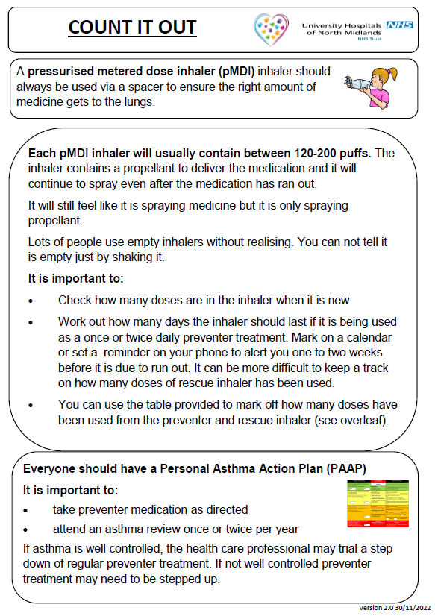

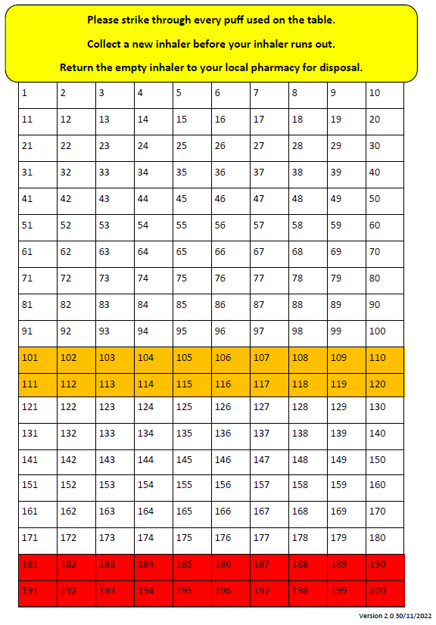

**Appendix 6**

**Instructions for Inhaler Use**

**Procedure for Emergency / Acute Asthma Attack**

Symptoms of an asthma attack:

* Not all symptoms listed have to be present for this to be an asthma attack
* Symptoms can get worse very quickly
* If in doubt, give emergency treatment
* Side effects from salbutamol tend to be mild and temporary. These side effects include feeling shaky, or stating that the heart is beating faster

Cough

A dry persistent cough may be a sign of an asthma attack.

Chest tightness or pain

This may be described by a child in many ways including a ‘tight chest’, ‘chest pain’, tummy ache

Shortness of breath

A child may say that it feels like it's difficult to breathe, or that their breath has ‘gone away’

Wheeze

A wheeze sounds like a whistling noise, usually heard when a child is breathing out. A child having an asthma attack may or may not be wheezing.

Increased effort of breathing

This can be seen when there is sucking in between ribs or under ribs or at the base of the throat. The chest may be rising and falling fast and in younger children, the stomach may be obviously moving in and out. Nasal flaring.

Difficulty in speaking

The child may not be able to speak in full sentences

Struggling to breathe

The child may be gasping for air or exhausted from the effort of breathing

CALL AN AMBULANCE IMMEDIATELY, WHILST GIVING EMERGENCY TREATMENT IF THE CHILD:

* Appears exhausted
* Has blue/white tinge around the lips
* Is going blue
* Has collapsed

**Instructions for Administering rescue inhaled therapy through a spacer**

A metered dose inhaler should be used through a spacer device. **If the inhaler has not been used for 2 weeks then press the inhaler twice into the air to clear it.**

|  |  |
| --- | --- |
| A Spacer might be:   * Orange * Yellow * Blue * Clear | A spacer may have:   * A mask * A mouthpiece |

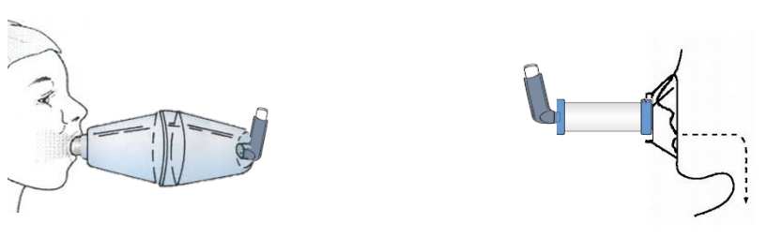

1. Keep calm and reassure the child
2. Encourage the child to sit up and slightly forward, loosen any tight clothing
3. Use the child’s own rescue Inhaler – if not available, use the emergency blue rescue Inhaler
4. Remain with the child while the rescue Inhaler and spacer are brought to them
5. Remove the cap from the rescue inhaler
6. Shake the rescue Inhaler and insert the Inhaler mouthpiece into the hole in the end of the spacer device
7. Put the mouthpiece of the spacer into the child’s mouth and ask them to close their lips around to ensure a good seal or place the mask securely over the nose and mouth (spacer with mask is only usually for a child under 4 years)
8. Press the canister down to release 1 puff of medicine into the spacer and ask the child to breath in and out of the spacer 5 times
9. Remove from the child’s mouth then repeat from step 6 onwards and give another puff (total of 2 puffs now given).
10. If there is no improvement after 5 -10 minutes, give a further 2 puffs following steps 6 to 9 (total of 4 puffs now given)
11. If no improvement after 5-10 minutes give a further 2 puffs following steps 6 to 9 (total of 6 puffs now given)
12. Stay calm and reassure the child. If the child has responded allow to sit for 15-20 minutes observed by a member of staff. The child can return to school activities when they feel better
13. If you have had to treat a child for an asthma attack in school, it is important that the parents/carers are informed
14. If the child has had to use the rescue Inhaler again during the same day then ask the parents to collect from school
15. If the child has not responded to 6 puffs stay calm, continue to give 1 puff every 30 seconds following steps 6 to 9 up to a total of 10 puffs
16. If you have had to give 10 puffs call the parents to collect from school
17. If the child does not feel better or you are worried at ANYTIME call 999 FOR AN AMBULANCE and call for parents/carers
18. If an ambulance does not arrive in 10 minutes give another 10 puffs in the same way
19. A member of staff will always accompany a child taken to hospital by an ambulance and stay with them until a parent or carer arrives

**Appendix 7**

Dear parent/guardian of : ………………………………

Your child has had problems with his/her breathing today which has required the use of their **own inhaler/school’s emergency inhaler**. (delete as appropriate)

Since this may indicate your child’s asthma is not well controlled at this time you are strongly advised to see your own doctor or practice nurse as soon as possible. If your child needs to use their reliever medication 3 times a week or more, seek a medical review.

|  |  |  |  |  |
| --- | --- | --- | --- | --- |
| Date | Time | Number  of puffs | Where/Activity  (eg.classroom/PE) | Given By |
|  |  |  |  |  |

Yours sincerely

If your child needed to use the school emergency inhaler would you please ensure they have their own labelled inhaler and spacer in school.

**If your child is needing to use their reliever inhaler more than 4 hourly please seek an urgent medical review.**

**Appendix 8**

CLASS ASTHMA REGISTER

CLASS ……………………..

NAME Expiry date of

Inhaler

--------------------------- ----------------------------

--------------------------- ----------------------------

--------------------------- ----------------------------

--------------------------- ----------------------------

--------------------------- ----------------------------

--------------------------- ----------------------------

--------------------------- ----------------------------

--------------------------- ----------------------------

--------------------------- ----------------------------

--------------------------- ----------------------------

--------------------------- ----------------------------

--------------------------- ----------------------------

--------------------------- ----------------------------

**Appendix 9**

**Record of Inhaler Use (Audit Form)**

|  |  |  |  |  |  |  |  |  |
| --- | --- | --- | --- | --- | --- | --- | --- | --- |
| **Name** | **Date** | **Time** | **No. of puffs** | **Where /activity**  **eg. classroom/ PE** | **Child’s own Inhaler** | **School Inhaler** | **Parent**  **letter** | **Given By** |
|  |  |  |  |  |  |  |  |  |
|  |  |  |  |  |  |  |  |  |
|  |  |  |  |  |  |  |  |  |
|  |  |  |  |  |  |  |  |  |
|  |  |  |  |  |  |  |  |  |
|  |  |  |  |  |  |  |  |  |
|  |  |  |  |  |  |  |  |  |
|  |  |  |  |  |  |  |  |  |
|  |  |  |  |  |  |  |  |  |
|  |  |  |  |  |  |  |  |  |
|  |  |  |  |  |  |  |  |  |
|  |  |  |  |  |  |  |  |  |
|  |  |  |  |  |  |  |  |  |
|  |  |  |  |  |  |  |  |  |
|  |  |  |  |  |  |  |  |  |
|  |  |  |  |  |  |  |  |  |
|  |  |  |  |  |  |  |  |  |
|  |  |  |  |  |  |  |  |  |

|  |  |  |
| --- | --- | --- |
| Version | Review Date | Changes Made |
| V2 | 14.05.25 | Identified asthma champion on the front cover. The role of the asthma champion is listed on page 4. |
|  |  | Newly updated guidance from the NHS Staffordshire and Stoke-on-Trent Integrated Care Board used to create the policy and present the information in a new format. |
|  |  | Appendix 1 and 2-Asthma Care Plans updated and consent to use emergency salbutamol inhaler |
|  |  | Appendix 3-Whole school asthma register update. This register will be displayed in the school office and staffroom alongside emergency procedure instructions (appendix and be available to all staff members including sports and after school club staff. |
|  |  | Multiple emergency inhaler kits to be available in school (minimum of 2), that includes the contents listed on page 7 and posters to display their location. |
|  |  | School spacers can be reused as long as they are thoroughly cleaned (monthly maintenance cleans need to take place) inhalers can be reused as long as they do not come into contact with bodily fluids. (Letter to be sent to parents if they use the school emergency inhaler). |
|  |  | Appendix 6-what to do in the event of an asthma attack to be shared with staff and displayed in the staff room. |
|  |  |  |