Intended outcomes - Review Jan 2024
This explains the outcomes we are aiming for by the end of our current strategy plan, and how we will measure whether they have been achieved.
Intended outcome | Success criteria | Review/Impact
Improved levels of independence, resilience, confidence and metacognition amongst our DA SEN pupils. | Observations and pupil voice activities indicate our DA pupils operate with motivation and purpose within all lessons.  Success in progress of the SEND DA pupils indicated on the Bsquared tracker. | TADAC meetings have identified individuals that require support in these areas. Individual targets have been set using the defining grades from the Triple A Strategy. These are reviewed termly to measure impact.  An alternative to B Squared is being purchased, which will track progress in more detail.
Improved oral language skills and vocabulary amongst disadvantaged pupils. | Assessments and observations indicate significantly improved oracy skills among disadvantaged pupils. This is evident when triangulated with other sources of evidence, including engagement with their peers and ongoing formative assessment. | 2 out of the 9 DA children in reception received Speak Write during the autumn term and have now been taken off by DW as good progress has been made. They will be monitored and re assessed if required.  Currently 2 out of the 4 DA children in nursery and 3 out of the 9 DA children in reception are currently having Speak Write from Debbie Wilshaw.  Child V can now articulate all sounds in isolation. She appears a little shy and is mumbling a bit which may cause speech to lose clarity but with advice to slow her down, remind her to use a big voice, model back speech so that she can hear the adult using a big clear voice she no longer requires the support of Speak Write.  Language development remains a key focus in the EYFS, they continue to embed the strategies put into place last academic year as well as introducing some additional ones. This academic year the use of a knowledge organiser wall has been rolled out. This is to further development the language and vocabulary in early years, not just exposing them to the language but regularly revisiting and recalling it. Another strategy that has more recently being rolled out is ‘drawing club’. Since January, in reception they now teach ‘drawing club’ as part of their curriculum to develop writing, language and imagination. The language and vocabulary is developed through a specific set of high level words being taught and then revisited each day that week, using actions and put into context. They are chosen by the staff and related to the story.
Improved reading writing & maths attainment amongst disadvantaged pupils across KS 1 and 2. | R, W & M outcomes in 2024/25 show an improved % of disadvantaged pupils met the expected standard.  DA pupils working below expected attainment make accelerate rates of progress to close the DA attainment gap. | Example of improved attainment include gains in writing:-  EYFS-of the 9 PP pupils, at baseline 4 were working at ARE, this has increased to 5  Y1 – of the 4 PP pupils, at baseline 2 were working at ARE, this has increased to 3  Y2 – of the 11 PP pupils, at baseline 6 were working at ARE, this has increased to 7  Y3 - of the 13 PP pupils, at baseline 6 were working at ARE, this has increased to 8  Y4 – of the 12 PP pupils, at baseline 8 were working at ARE, this has increased to 9
Improved numbers of DA pupils meet at least school phonic milestones. | Percentages of DA pupils achieve in line with non-DA peers for the phonic screening checks. | Out of the 5 PP children, 3 of them, 60% have already passed the threshold mark of 32. The 2 other children not far behind. All predicted to pass.  The remaining year 1 children (27) 10 of these passed the threshold of 32, 37%.  Altogether 88% is the predicted pass rate for 2024.
Increase the number of disadvantaged pupils working above ARE. | Percentages of DA pupils working above ARE fall in line with non-DA peers in reading, writing and maths. | DA are working below NDA across the school in most areas, yet since baseline gains in attainment are being made with a small impact on ARE, except in Year 3. See the table below:-  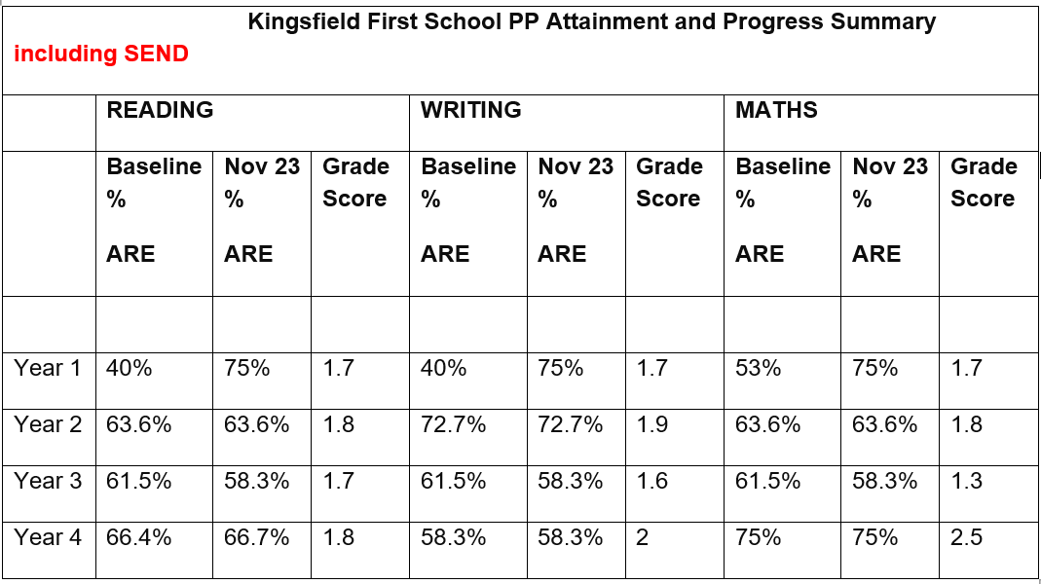
To achieve and sustain improved wellbeing support for all pupils in our school, particularly our disadvantaged pupils. | Sustained high levels of wellbeing from 2024/25 demonstrated by:  - qualitative data from pupil voice, parent voice/feedback  - a significant increase in participation in enrichment activities, particularly among disadvantaged pupils | Pupil observations indicate good levels of engagement, increasing independence and resilience. Participation levels included:-  Trips, Hook Days, visits etc in which all PP children attended our recent visit to The New Vic Theatre. All trips to date this year have been fully attended by PP children.
To achieve and sustain improved attendance for all pupils, particularly our disadvantaged pupils. | Sustained high attendance from 2024/25 demonstrated by:  - the attendance gap between disadvantaged pupils and all non-disadvantaged pupils being closed.  - the percentage of all disadvantaged pupils who are persistently absent is in line with their peers.  - Improved annual attendance, from individuals. | DA PA improving?  Clear gains in attainment were made in the Autumn with PP PA attendance dropping from:-  National 9.6% Sept Oct Dec  PP % 24.4% 17.1% 15.7%  PP number of pupils 10/41 7/41 8/51
To ensure all disadvantaged pupils have access to a full and wide-ranging curriculum offer. | All DA pupils access wider curriculum learning opportunities such as clubs, forest school and visits. | PP children are given priority in advance when booking places on clubs. They have free, priority access to the holiday club, which runs on our site. Trips continue to be funded where required, to ensure 100% PP attendance.
To provide parents of disadvantage children relevant support that they need. | All PP parents increase engagement with activities including:- parental engagement activities, workshops, parents evenings and engage with outside agency support, if offered and when relevant. | A selection and parent activities have taken place including workshops, assemblies, parents evening and engagement days including forest schools have taken place. Participation levels are:-  EYFS-67%  KS1-79%  KS2 – 87%.

