SEND and Inclusion Hub Newsletter

ISSUE 38 8th August 2023

This newsletter is published to share useful links, training & resources for the Moorlands district. This is for Staff, Children & their families. **In this edition there is information for parents on various initiatives and activities taking place throughout the summer holidays. Please share via your school website, FB page or newsletter.**

**SERVICES COMMISIONED FOR PDIP**

**SEND and INCLUSION HUB**

CAMHS Trailblazer 16 Schools involved

**Please note: Shane Knott is no longer seconded to the PDIP for Inclusion Support.**

**Helpdesk**

We encourage Schools to use the weekly helpdesk held on a Tuesday 1.30p.m. to 3.30p.m. You need to complete a referral and send it to the Moorlands SEND/Inclusion inbox [SendInclusionMoorlands@staffordshire.gov.uk](mailto:SendInclusionMoorlands@staffordshire.gov.uk). The aim is to facilitate the Earliest Help available and to avoid crisis point. The helpdesk is primarily run by Reggie Hodge EPDO Moorlands/SEND & Inclusion Coordinator, however other partners will sit at this helpdesk as and when required for example: Pam Clulow – Cedars Education Inclusion: Claire Butters and Visyon: Louise Marsh. This is not a decision- making helpdesk it is for advice & guidance only and will still be discussed at the PDIP but a helpdesk update will be given

**SEND/Inclusion referral form**



Schools are asked that any student who receives 3 or more fixed term exclusions within the current term, should be brought to the helpdesk for further guidance/support.

Information on the SEND/Inclusion process is outlined on the last pages of this bulletin

SEND/Inclusion Hub referral form



**Non Attendance**

**If Schools are unable to attend the SEND/Inclusion Hub and you have made a referral, please could you email an update to the SEND/Inclusion inbox prior to the Hub meeting. Should Schools make a referral and not attend either the helpdesk or the SEND/inclusion hubs on 3 occasions the referral will be closed and a new referral will need to be made.**

**Educational Psychology**

•         All School’s will be able to access their own Educational Psychologist, you do not need refer into the SEND/Inclusion Hub. If you are unsure of who your EP is please contact [lesley.schofield@staffordshire.gov.uk](mailto:lesley.schofield@staffordshire.gov.uk)

**INFORMATION FOR SCHOOLS ON THE SEND/INCLUSION PROCESS**

Please see the information below for the SEND/Inclusion process.

**Only schools** can refer into the SEND & Inclusion Hub.

**Educational Psychology**

* All School’s will be able to access their own Educational Psychologist, you do not need refer into the SEND/Inclusion Hub. If you are unsure of who your EP is please contact [lesley.schofield@staffordshire.gov.uk](mailto:lesley.schofield@staffordshire.gov.uk)

**EHCP**

* Any Child with an EHCP, can still be referred into the SEND/Inclusion hub, however the contents, hours & alternative provision cannot be discussed. Please raise this at your next annual review if you have any concerns.

**Earliest Help: What Does It Mean?**

* We are clear that helping children and families as early as possible when issues first arise is a priority. Children, young people and families receive Earliest Help through universal services and organisations (including: schools, colleges, academies, community groups/projects and universal health services). These services and organisations have their roots in local neighbourhoods and villages, and are therefore   well-placed to both provide support to families with relative informality, and to apply a practical approach to meeting needs. Earliest Help is provided through a range of organisations. Some examples are:

* Schools, Academies, alternative education providers & Colleges
* Children & Families Groups
* Faith Organisations & Groups
* School Nurses
* Wellbeing Services
* Voluntary Organisations
* Children’s Centres SPACE Summer Programme (OPCC)
* Individuals

* Early Years / Pre-School Settings
* Maternity Services / Health Visitors
* Private Sector Providers
* GP’s / Primary Care Services
* National Citizenship Programme
* Sporting/Leisure Organisations
* Volunteers & Locally Elected Members

**Early Help : What Does It Mean?**

* Children, young people and families that are most in need of support, receive support through a multi-agency service response through an Early Help Assessment. The emphasis on targeting Early Help resources for those children, young people and families that most need support is a key element of the Building Resilient Families and Communities programme. Our Early Help Offer continues to harness the engagement of the wider economy of services that touch the lives of families in one way or another is crucial if we are to identify and address issues as soon as possible. Some examples of services are below:
* Families First
* Direct Health Services (e.g. Primary Care)
* Crime Prevention Service (SYOS)
* Police Vulnerability Hubs
* Emotional Wellbeing & Mental Health Services
* Building Resilient Families Programmes
* Families First Edge of Care Services
* Parenting & Families Programme’s
* Commissioned Organisations & Providers
* Health Visitors / Schools Nurses
* National Charities & Organisations
* Organisations, services and groups providing Earliest Help
* Locality Team Partnership Meetings

**Staffordshire Connects**

* To access the SEND/Inclusion Processes and the Assess, Plan, Do, Review please use the following link <https://www.staffordshireconnects.info/kb5/staffordshire/directory/home.page>

**SEND Local Offer**

* https://www.staffordshireconnects.info/kb5/staffordshire/directory/localoffer.page?lo[calofferchannel=0](https://www.staffordshireconnects.info/kb5/staffordshire/directory/localoffer.page?localofferchannel=0)
* <https://www.facebook.com/StaffordshireSENDLocalOffer/>

An extensive and invaluable directory of support and services available to schools and communities.

<https://www.staffordshireconnects.info/kb5/staffordshire/directory/advice.page?id=0rWBovMeR5E>

**Useful links and resources**

**Funding Available For Free Call Blocker Devices**

**Funding Available For FREE Call Blocker Devices for Vulnerable Residents.**

Do you know someone that is receiving a number of unwanted & nuisance calls to their home phone and would benefit from a call blocker? Please do get in touch with us at Staffordshire Trading Standards as we currently have funding in place to apply for free call blocker devices for vulnerable residents in Staffordshire.

A call blocker is a small device that sits between your home phone & wall socket that blocks up to 95% of unwanted nuisance calls.  Once we’ve received a referral, we arrange a visit, (either with the person concerned or a relative/carer) to install, demonstrate & test the device.

We now have an online referral form that is quick and easy to complete that you can find over at;

[Call Blockers - Staffordshire County Council](https://www.staffordshire.gov.uk/Business/Tradingstandards/Community-intervention/Call-Blockers.aspx)

**New Scam Alert Newsletter**

Just a quick plug for our monthly Scams Email Newsletter highlighting emerging threats both nationally and within Staffordshire. By raising awareness of common scams, as well as signposting to support and assistance available, our aim is to help protect Staffordshire residents from ongoing scams and fraud. You can sign up over at;

[Scam Awareness Newsletter - Staffordshire County Council](https://www.staffordshire.gov.uk/Business/Tradingstandards/Community-intervention/Scam-Awareness-Newsletter.aspx)

**HOME-START STAFFORDSHIRE MOORLANDS - SCHEME MANAGER VACANCY**

Job Vacancy for Scheme Manager: Home-Start Staffordshire Moorlands

Closing date: 9 am 14th August 2023 Interview date: Wednesday 23rd August 2023

Hours: 30 hrs per week

Salary: NJC Scale 26 – 30 (£32,909 – 36,298) pro rata

Permanent contract dependent on future funding.

Home-Start Staffordshire Moorlands have an exciting opportunity to join our small team committed to providing support to families across the Moorlands, responding to the challenge of the post-pandemic period, current recession and beyond.

We are seeking a manager with a range of skills, able to lead the team, oversee the operations of the charity, provide support to the Trustee board, and ensure the future financial strength of the charity. We are seeking a manager who can provide strategic leadership and vision, has strong communication skills, has knowledge of charity finance and skills in bid writing and income generation, and who is passionate about the early years and the work of Home-Start.

Home-Start Staffordshire Moorlands has operated successfully in the Moorlands district for 25 years. We have a strong track record in the delivery of both home visiting support through our skilled Coordinators and Volunteer team and in Group provision for the early years.

The successful candidate should:

Demonstrate commitment to the importance of the early years and the importance of support to parents who may be facing difficulties.

Demonstrable experience of leadership and management in a changing environment

Experience of securing funding and income generation

Ability to form partnerships with voluntary, statutory and community organisations.

For details and application pack please download a pack and application form from our website: https://homestartsm.org.uk/about-us/#vacancies. Applicants are welcome to telephone for more information (01538 387231) or to arrange a visit to see the scheme and gain a better understanding of the role.

Home-Start Staffordshire Moorlands is committed to equality of opportunity and diversity and the safeguarding of children and vulnerable persons.

**SPACE is back**

School Holidays are approaching and the good news is that the SPACE Scheme is back!!

There is lots of fun activities for 8-17 year olds during the school summer holidays across Staffordshire and Stoke on Trent.

Please sign up to hear about all the activities available in your area. SPACE will run between July 31st and September 1st.

[Staffordshire Space | Space](https://s-url.co/x0cHAA)

**Move to Universal Credit**

cross Staffordshire and Derbyshire the 'Move to UC' will begin in August 2023. This will be for a mix of customers currently in receipt of Working Tax Credits or Child Tax Credits.

As the Partnership Team for Staffordshire and Derbyshire, we are offering Awareness Sessions around the basics of Universal Credit and the upcoming 'Move to UC' for our Partners and Stakeholders. These will take place throughout July, August and September. To register please follow the links below:

[Monday 24th July 10:00 – 11:00](https://events.teams.microsoft.com/event/1ab49b37-e87a-4100-bf6c-8ac7f916ec97@96f1f6e9-1057-4117-ac28-80cdfe86f8c3)

[Monday 24th July 14:00 – 15:00](https://events.teams.microsoft.com/event/db23498d-d7aa-4c93-a02c-03b7aca61526@96f1f6e9-1057-4117-ac28-80cdfe86f8c3)

[Wednesday 26th July 14:30 – 15:30](https://events.teams.microsoft.com/event/7b86f4dd-32bc-4f65-b3ad-5711f4900d17@96f1f6e9-1057-4117-ac28-80cdfe86f8c3)

[Monday 31st July 10:00 – 11:00](https://events.teams.microsoft.com/event/0b532d4e-6a40-496f-b493-eb3caf6adb1c@96f1f6e9-1057-4117-ac28-80cdfe86f8c3)

[Tuesday 1st August 10:00 – 11:00](https://events.teams.microsoft.com/event/757b69eb-fe89-4c42-94f9-e5cf3f4daaad@96f1f6e9-1057-4117-ac28-80cdfe86f8c3)

[Monday 14th August 11:00 – 12:00](https://events.teams.microsoft.com/event/a80c79ac-6e8a-44f1-8bb7-054ce4041fc4@96f1f6e9-1057-4117-ac28-80cdfe86f8c3)

[Thursday 14th September 10:30 – 11:30](https://events.teams.microsoft.com/event/ea2c016c-05c4-48d1-a9a8-34f032ab7118@96f1f6e9-1057-4117-ac28-80cdfe86f8c3)

The sessions will run for approximately 1 hour as a Microsoft Teams Live Event. You will be able to ask questions using the chat/side bar, where we will endeavour to respond as soon as possible.

**Please feel free to share this invitation across your networks.**

**Home-Start Staffordshire Moorlands 25th Anniversary Challenge walks - Sunday 10th September 2023**

**Take up a challenge this September**

**Home-Start Staffordshire Moorlands is 25 years old!**

We’re looking for people eager to walk in our glorious district and raise funds for our charity on

**Sunday 10th September 2023**

**Because Childhood Can’t Wait**

This year Home-Start Staffordshire Moorlands is 25 years old!  And to celebrate and help raise much needed funds we are organising a variety of walks:  a **Challenge Walk** for those who like a long hike; **Half Challenges** or gentler options and a shorter **Family Challenge**.  There will also be a **Toddler Trail** in Leek’s Brough Park and a **gentle stroll** option.  Most walks are linear and there are bookable transport options.  More details are available on our website here: <https://homestartsm.org.uk/support_us/#walk-for-homestart> and to get involved you just need to register with us on our [Registration Form](https://homestartsm.org.uk/wp-content/uploads/2023/07/Registration-Form-25th-Anniversary-Challenge-Walk-HSSM.docx) and make a donation to the scheme via our [Just Giving campaign page](http://justgiving.com/campaign/walkforhomestart).  Once those wanting to participated have registered and donated, we’ll provide further information, guidance for walkers, transport options and fundraising information. Nearer to the time will send detailed route guidance and maps.

The walks have been chosen to give a sense of the size of the district covered by our scheme and of the varied landscapes – with the full Challenge Walk stretching from one side of the district to the other.

All proceeds will be used to help us support families with young children who are going through difficult times and to help us continue to run our well used groups across the district now and in the year ahead.  If you would like to sponsor or support those who are walking you can do so here: [Just Giving campaign page](http://justgiving.com/campaign/walkforhomestart) .

If you have queries or would like to volunteer to help on the day, please email [Info@homestartsm.org.uk](mailto:Info@homestartsm.org.uk).

**Free Animal Care programme for young people aged 16-30**

Our animal care programme is coming up again, starting on Monday 14th August from our delivery centre in Hanley. The programme is suitable for anyone who has an interest in animals and wants to work on their confidence and social skills whilst learning about the animal/zoo industry. It would also be suitable for someone who is going to college in September to do animal management.

Further information about the Animal care programme!

We have our popular Get Started with Animal Care programme returning to our Stoke (Hanley) Centre, the programme will be delivered face to face where young people aged 16 to 30 can get hands on with exotic animal breeds (including owls, giant tortoise, snakes, skunks, bearded dragons, insects, laughing kookaburras, guinea pigs, tenrecs etc.) learn more about animal care, conservation and zoo industries and learn how to care for the animals on a day to day basis. The programme is ideal for anyone who has an interest in animals and wants to learn more about the industry, as well as any young person who would benefit from a therapeutic week to help boost their wellbeing.

If you are working with anyone interested in the programme, I am happy to arrange a meeting with them to discuss in more detail and get them signed up. If they would like to sign up first and then arrange a meeting with me, they can sign up and secure a place on the programme by clicking the link below. They can also do this by scanning the QR code on the attached poster.

[Click here to sign up for the programme](https://forms.office.com/Pages/ResponsePage.aspx?id=aAtwVheHd02CavK-NeA3_z90RxHD4YdLhhPwZqQuBNpUODYwTUg4MVJKOUNHRUFHSjlIMEVSU1M4Si4u)

During the programme young people will also get the chance to design animal enclosures that will be used as base designs for real animal enclosures within the zoo. They will also design and build enrichment activities that will be used in the animal enclosures at the zoo.

Throughout the programme young people will be reimbursed for bus travel costs as well as having food provided for lunch at no cost for the young person. It is a 5-day, hands on animal care workshop, following the programme young people will get 3 months of progression support and 1:1’s to help support them into a positive outcome or to keep engaging in something positive, plus the chance to access a development award to get financial support for your next steps.

Programme Start Dates:

|  |  |  |  |  |  |
| --- | --- | --- | --- | --- | --- |
|  | **Date** | **Time** |  |  |  |
| **Taster Day** | Thursday 10th August | 11am to 1pm |  |  |  |
|  |  |  |
| **Programme Dates** | Monday 14thth August to Friday 18th August | 10am to 3pm |  |  |  |
|  |  |  |

Throughout the programme young people will:

* Work in a fun environment, meet likeminded people and learn about the animal care industry.
* Gain experience of animal handling, exotic/zoo animal health checks, Husbandry tasks & more!
* Learn about animal enrichment and help design and build enrichment activities that will be displayed at the zoo and used in real animal enclosures.
* Have lunch and travel expenses provided.
* Gain advice from industry experts on how to get into the industry.
* PLUS get up to 3 months of personal mentoring to help you achieve your goals!

Young people can sign up by clicking the profile form link below, or you can send me some details and I will contact them to arrange a visit. We are now back in our centre part time, so we are available most Tuesdays, Wednesdays, and Thursdays if you wanted to bring a young person for an initial visit to talk about the programme and get signed up.

[Click here to sign up for the programme](https://forms.office.com/Pages/ResponsePage.aspx?id=aAtwVheHd02CavK-NeA3_z90RxHD4YdLhhPwZqQuBNpUODYwTUg4MVJKOUNHRUFHSjlIMEVSU1M4Si4u) and secure a place on the programme.

**Volunteering opportunity with the Commissioner's Independent Scrutiny Panel**

Could you volunteer to review Police powers to ensure they are being used correctly?

The Commissioner’s Independent Scrutiny Panel is looking for a diverse group of people to scrutinise Police powers including the use of stop & search, the use of force and powers within custody.

Volunteers will help interrogate information and body worn video to identify issues and be involved in suggesting solutions.

Applications are now open, find out more or apply here: [Independent Scrutiny Panels - Staffordshire Commissioner (staffordshire-pfcc.gov.uk)](https://s-url.co/e40HAA)

**Meals out to support over the summer holidays!**

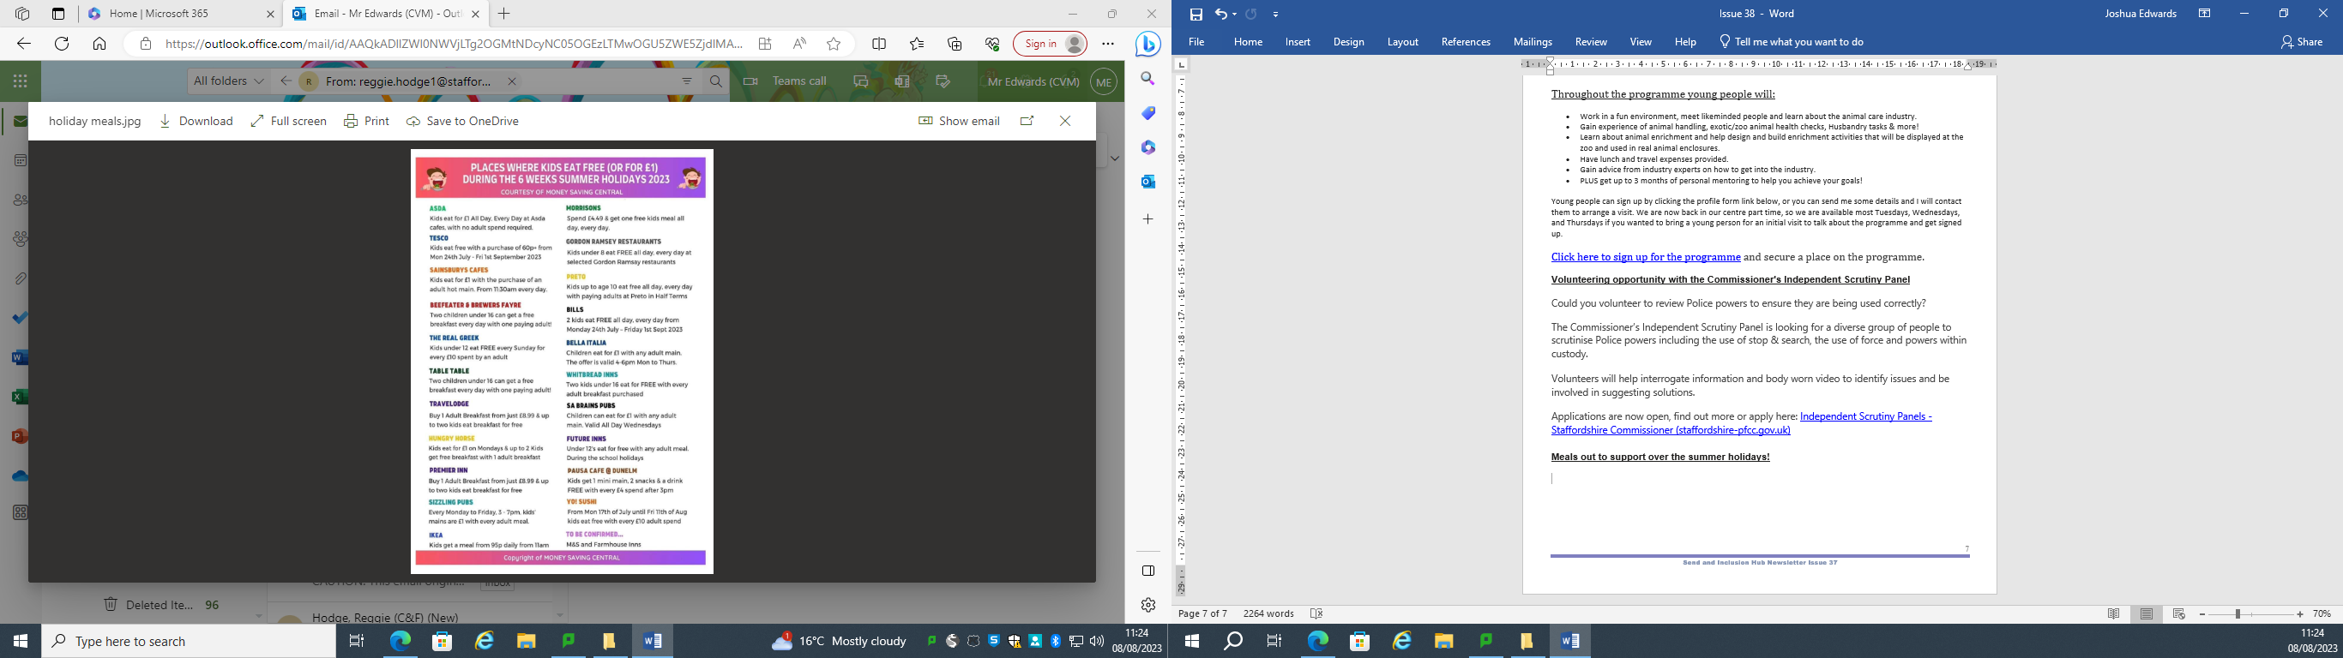

**Partner SPEAK- Free Event**

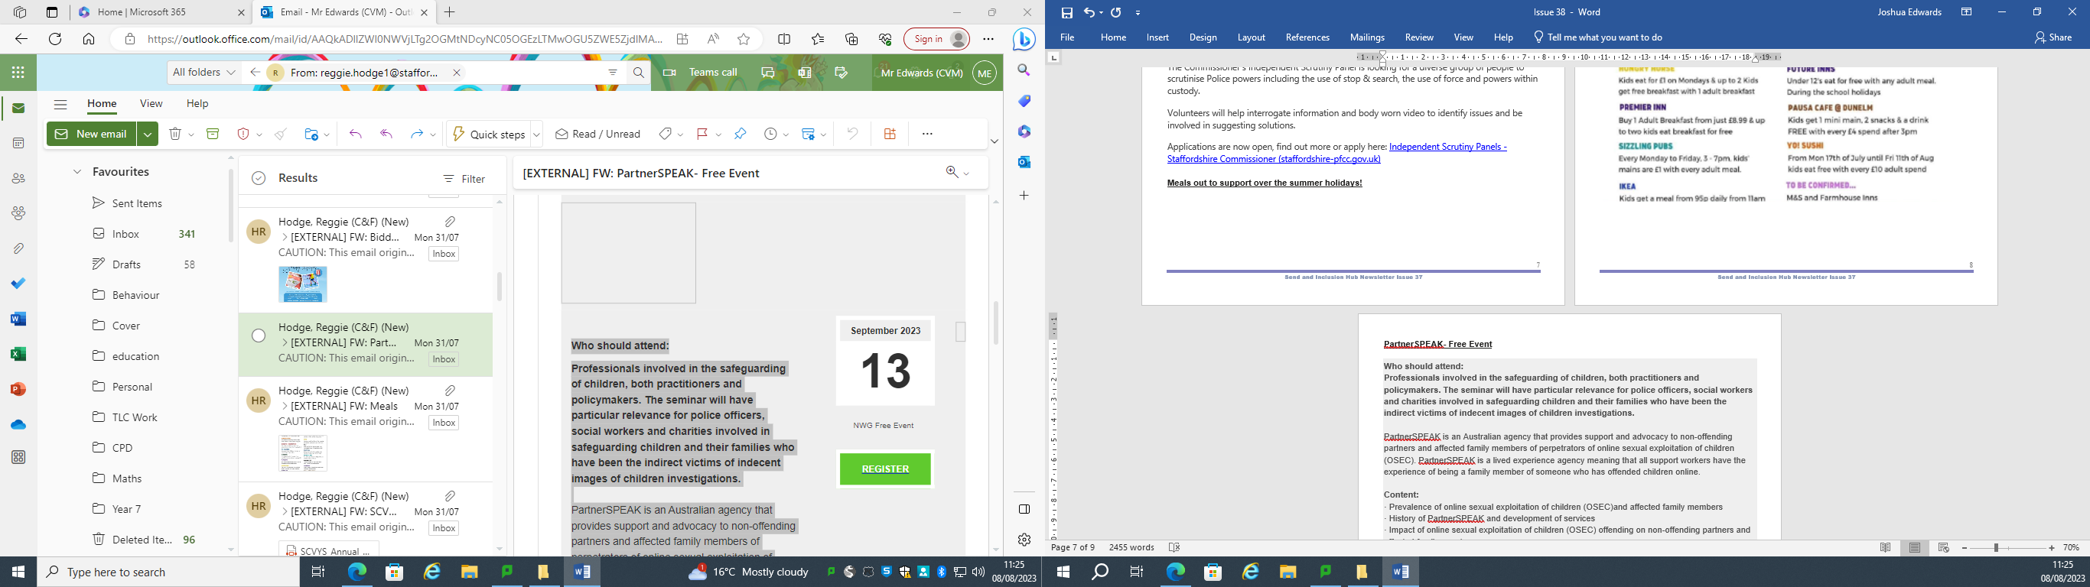**Who should attend:**

**Professionals involved in the safeguarding of children, both practitioners and policymakers. The seminar will have particular relevance for police officers, social workers and charities involved in safeguarding children and their families who have been the indirect victims of indecent images of children investigations.**  
  
PartnerSPEAK is an Australian agency that provides support and advocacy to non-offending partners and affected family members of perpetrators of online sexual exploitation of children (OSEC). PartnerSPEAK is a lived experience agency meaning that all support workers have the experience of being a family member of someone who has offended children online.

**Content:**

· Prevalence of online sexual exploitation of children (OSEC)and affected family members

· History of PartnerSPEAK and development of services

· Impact of online sexual exploitation of children (OSEC) offending on non-offending partners and affected family members

· Intentional Peer Support as a service response

· Intersection of online sexual exploitation of children (OSEC) offending with family violence

· Impact of working with affected family members on investigator well-being/welfare and online sexual exploitation of children (OSEC) intelligence

· Models of working with LEA· Advocacy and Government

· Lessons learned

**Biddulph HAF**

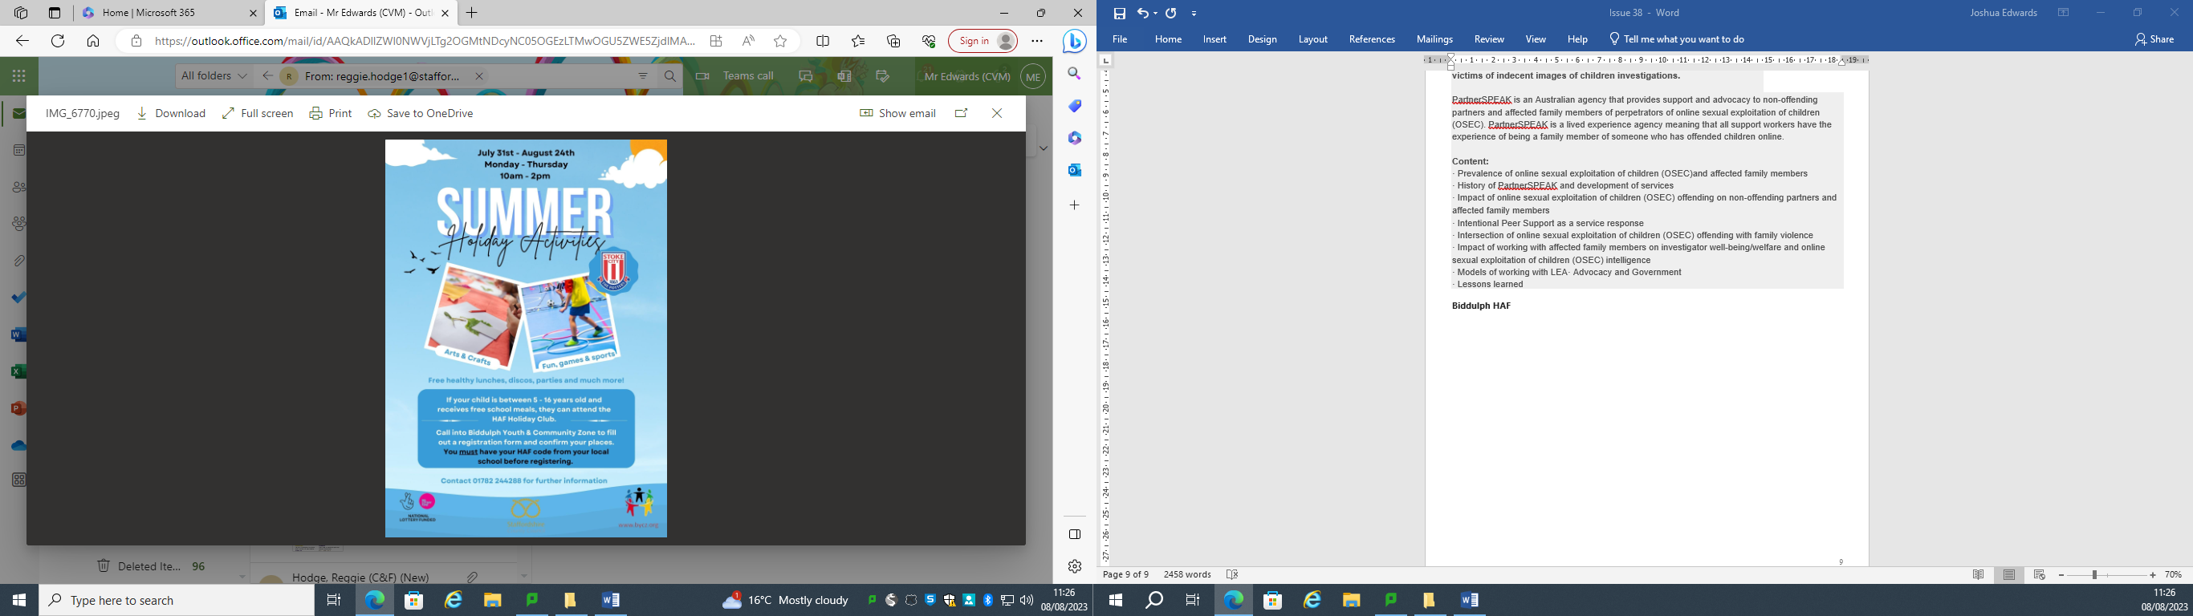

**Vehicle Technicians - Staffordshire Police and Staffordshire Fire & Rescue VACANCY - 31st August Deadline**

📢Looking for a new challenge?

🚔We're recruiting Vehicle Technicians to service, maintain and repair Staffordshire Police and Staffordshire Fire and Rescue fleet vehicles.

🚒It is a diverse role which includes analysis, diagnostics and road testing of vehicles. All of our technicians are provided with relevant manufacturer training and development to further their career portfolio.

👥The team play a key role in the emergency services and help to make a positive difference to Staffordshire communities.

📲We will be hosting online familiarisation events in August, where we will share more information about the roles and answer any questions.

➡️To register and apply please visit: <https://orlo.uk/FTDHB>

**Road Safety Quiz for Kids**

If you’re looking for a fun way to teach your children about road safety during the summer break, take a look at our printable Kash the police dog road safety activity sheet for a true or false quiz about the green cross code.

Make sure you check out the road safety tips for parents too when you download it:

[https://orlo.uk/mgvmD](https://s-url.co/7vAHAA) (Click the link under **'Advice for parents'**)

**Healthwatch Staffordshire is doing a Deep Dive into teenage mental wellbeing and health outcomes for care experienced young people – Can you assist?**

Healthwatch Staffordshire has been working with partners across the ICS to explore the views of care experienced young people (CEYP), and the health services they have used, with the aim of improving health services and health outcomes, for young people in care and moving out of care, in the long term.

They are interested in hearing the views of young people aged 16 - 25+, via this survey, regarding their transitioning from children and adolescent mental health services into adult mental health services. Attached is a paper version of the survey that can be emailed to daniela.ballantine@healthwatchstaffordshire.co.uk when completed, and a simplified version of the survey for children or young people with special educational needs and/ or neurodivergent conditions can also be accessed here.

If you work with or support a young person who could input into this work, please forward the survey on.

If you are able to promote this survey, please see the attached image that can be used on your social media channels.

For more information, please contact Daniela directly: daniela.ballantine@healthwatchstaffordshire.co.uk.

Please see below attached:



**adult learning courses for September**

Please see below attached

