Reception Long Term Plan

 | Autumn 1 | Autumn 2 | Spring 1 | Spring 2 | Summer 1 | Summer 2
 | This is me! 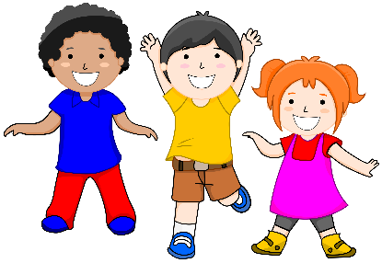 | Our wonderful world   | A world of pure imagination..  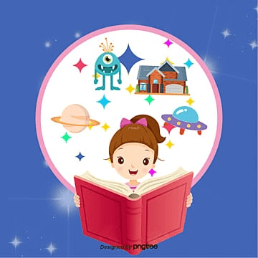 | All Creatures great and small  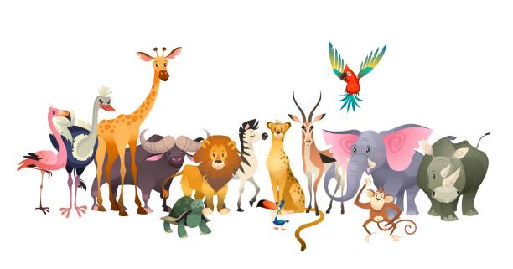 | Happily Ever After…  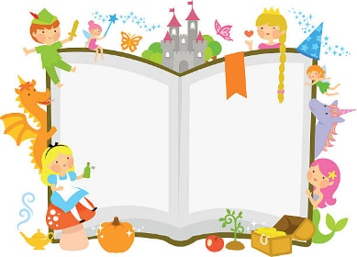 | Little people Big Adventures!  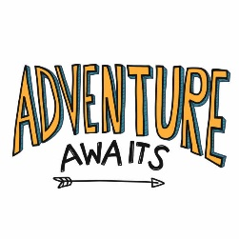
Suggested coverage | Settling in, rules and routines.  Family, being different, abilities, feelings, healthy mind and body- brushing teeth, healthy eating, friendships, when I grow up, job roles of familiar people, kindness, sharing | Seasons, Christmas, weather, day and night, hibernation, Diwali, Bonfire night, Christmas | story telling / giants and fairies, figures from the past in stories | minibeasts/ animals /dinosaurs/ Countries that relate to animals e.g Africa | traditional tales, prince & Princesses , past and present home and castles | Transition to year 1, sun sea and sand, holidays, different countries and cultures healthy mind and body
Suggested texts | 3 weeks baseline familiar stories ( three little pigs/ goldilocks and three bears.)  Starting school  Super me  All are welcome  Funny bones  What I like about me  Incredible you  Tooth Fairy | Day monkey night monkey  The squirrels that squabble  Percy the park keeper  Scarecrows wedding  Polar bear who saves Christmas | Smartest giant in town  The gruffalo  Room on the Broom  The bear, the girl and the magic shoes  Aliens love underpants  Zog  The sugarlump and the unicorn | Handa’s surprise  Giraffes can’t Dance  What the ladybird heard  The ugly five  Monkey puzzle  How to grow a dinosaur  The lion who wanted to love | Princess and the pea OR  Rupunzel  How to catch a dragon?  The Princess and the wizard  The dragon that swallowed a knight  Jack and the Beanstalk | What the ladybird heard on holiday  Sharing a shell  My adventure island  Emma janes aeroplane  Town mouse & country mouse
Key Questions & suggested texts | What is it like in my new classroom?  Getting to know me activities (Boris Starts School)  How do we look after our bodies? (Oliver’s Vegetables)  Who is in my family and exploring our local community.  How have we grown and changed from being a baby? (Funny bones)  How do we look after our teeth and stay healthy? (The Tooth Fairy)  What makes us special? (Incredible you) | What is Diwali and how is it celebrated? (Dipal’s Diwali)  How and why do we celebrate bonfire night? (Sparks in the Sky) What is Autumn? What changes in autumn? (The squirrels that squabbled)  What happens to animals in autumn? (The Leaf Thief)  Exploring day and night-which animals are awake at night? (Owl babies)  What is winter? What changes do we see in winter? (One Snowy Night)  Why and how do we celebrate Christmas? (The Polar Bear Who Saved Christmas) | Where is the moon and what does an astronaut do? (Aliens Love Underpants) What will I find in space? (The Way Back Home)  How do animals survive in cold climates and winter? (Non-fiction winter texts) Which materials will float or sink? (The Night Pirates)  Who was the most famous pirate? (Pirates love Underpants)  How is Chinese New Year celebrated in China? (The Magic Paintbrush) How did a Knight protect themselves? (How to catch a dragon) | What is Spring? What changes do we see in Spring? (Spring non-fiction texts)  Where did the dinosaurs go? (How to grow a Dinosaur) What is a fossil? (Dinosaur non-fiction texts) How is it like to live in Kenya? (Handa’s surprise)  What is life in the Arctic like? (The snail and the Whale) What is life like in the jungle?  What is life like in the desert? | Why were castles built?  Who are great Britain’s king and queen? Who are the royal family?  Are dragons real?  How do plants grow? What do they need to grow? | Who lives in a lighthouse? (What the ladybird heard on holiday)  How big is the world? (emma Jaynes aeroplane)  What adventures have I had?  Thinking about the transition and the adventure going into year 1.
Enrichment | Halloween crafts and disco.  Making vegetable soup | Bonfire night safety assembly with our local fire station.  An Autumn walk Biddulph Grange. | Chinese new year engagement day | Trip to apple tree town | A royal tea party | Grow caterpillars

