Nursery Long Term Plan

 | Autumn 1 | Autumn 2 | Spring 1 | Spring 2 | Summer 1 | Summer 2
 | Eyes, nose, fingers and toes…  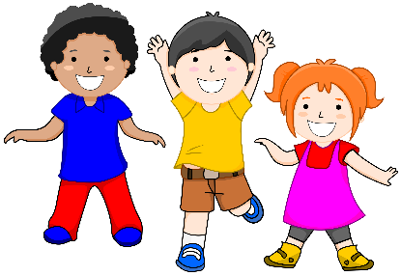 | Crazy Creations and Marvelous Music  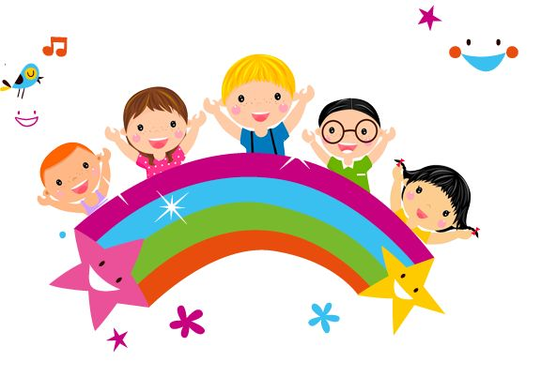 | Tell me a story  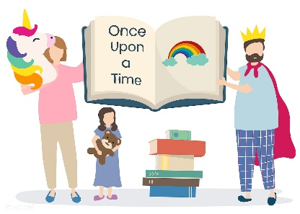 | Down on the Farm  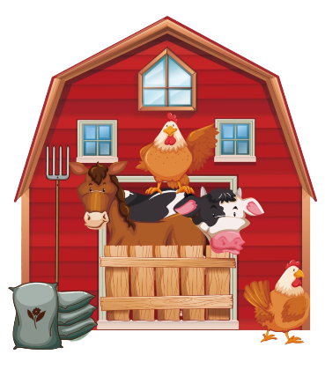 | What’s your superpower? | How does your Garden grow?  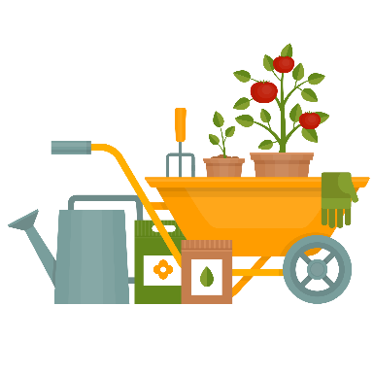
Suggested coverage | all about me, interest, songs and nursery rhymes familiar to them, transition into nursery, likes and dislikes, families etc  getting the basics in – toilet/coats on and off/zips/buttons (fingers part). | Transport, Music, singing, dancing, model making/explore how things work/ building / creating | nursery rhymes, rhyming stories, music traditional tales, repeated refrains, being imaginative | Animals/ animal needs/ different homes/ growth / lifecycles | people who help us/ aspirational people/ superheroes fictional and real/ job roles | Growth/ plants/changes over time/ weather/seasons/ lifecycles
Suggested texts | Nursery rhymes baseline weeks  Incredible me!  Hello Toes, Hello Feet  Everybody has a body  The growing story  Mum, Dad and Me | Box  Lighting a lamp  The Naughty Bus  The train ride  If I built a car  The animal bop  Over in the clover  we’re going on a bear hunt  Stick man | Goldilocks and three bears  Little red riding hood  The Gingerbread man  The three little pigs  The three billy goats gruff  Oi Frog | Squash and a squeeze  Farmer duck  Rosie’s walk  Little red hen  Enormous turnip  Ugly duckling | Superworm  Supertato  Superheroes like me  Zog and the flying doctors  How to save a superhero | The growing story  The Hungry Caterpillar  Jaspers Beanstalk  Mad about minibeasts  Theres a tiger in the garden  Twist and hop to the minibeast bop
Key Questions & suggested texts | What is my new classroom like? Getting to know me activities.  Who am I?  What am I good at?  What do I enjoy?  How am I special?  What does healthy mean?  What can we do to keep healthy? | What happens during Diwali?  Why do we celebrate Diwali? (Lighting a Lamp)  What can I make and create? (Box)  What does a bus driver job involve? (The Naughty bus)  Where do we catch the train? (The Train ride)  What changes do we see in  Winter? (Stickman)  Why do we celebrate Christmas? | Why do we need friends (The Three Billy Goats Gruff)  How can I stay safe? (Little Red Riding Hood)  Which material is the strongest? (The Three Little Pigs)  Who can run the fastest? (The Gingerbread man)  What changes do we see in Spring? (Five little bunnies) | How are families different? (A squash and a squeeze)  How can we stay healthy? (Enormous turnip)  How do we make others feel? (The Little Red Hen) (Farmer Duck)  What can I see on a walk to the park? (Rosie Walk) | Why do we need to help others? (Superworm)  What makes me feel brave? (Supertato)  How do Doctors and nurses help? (Zog and the flying doctors) How do people in our community help others? | What seasonal changes do we see in summer?  How does a caterpillar change? (The Very Hungry Caterpillar) Which minibeast has the most legs? (Mad about minbeast) What does a plant need to grow? (Jasper’s Beanstalk)  How have I grown and changed? (The Growing Story)
Enrichment | Halloween crafts and disco. | Bonfire night safety assembly with our local fire station.  An Autumn walk Biddulph Grange. | Baking Gingerbread and exploring the change of state. | Trip to the farm | Visitor come (doc or nurse? | Grow caterpillars

