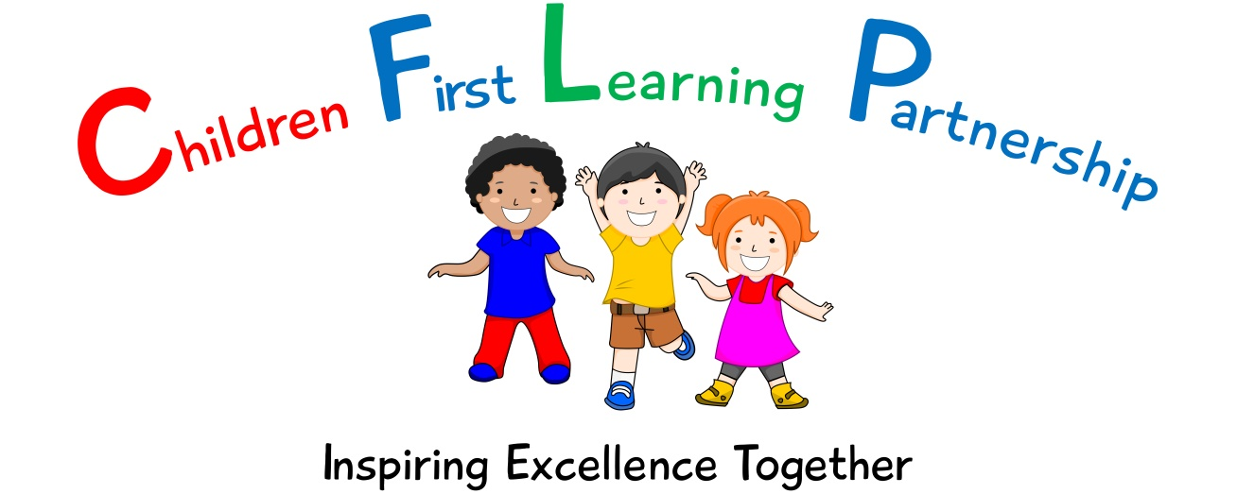

Design & Technology Policy 2023

May 2025
To be reviewed:
15.05.23
Agreed and ratified by the Local Advisory Board on:
Headteacher – Mrs R. Butler

Responsible Officer:
Mr C. Clulow
Chair of Local Advisory Board:
The CFLP Design & Technology Policy in respect of the Children First Learning Partnership has been discussed and adopted by the Local Advisory Board.

Kingsfield First School
Design & Technology Policy 2023

The overall intent of our school curriculum is to:
Recognise uniqueness: in our pupils, staff, resources and whole school community.
Be Inclusive: recognising learning styles, learning needs at all levels and providing solutions to any barriers to learning we encounter.
Engage and Inspire: through knowledge rich, highly enriched, progressive and purposeful contexts.
Promote Aspiration: offering challenge, accountability and responsibility for their learning.
Create citizens of the Future: who thrive on responsibility, see difference as a strength of our community and use democracy to embed their own values and beliefs.
Our Design & Technology curriculum strives to drive all of these intentions and links very closely to the achievement and development of them all.
Intent
To develop children’s experience of Design & Technology by nurturing creativity and innovation through design, and by exploration of the designed and made world in which we all live and work.
We aim to achieve this through allowing the children:
- To be original and willing to take creative risks to produce innovative ideas and prototypes.
- To be able to manage risks exceptionally well to manufacture products safely and hygienically.
- To be a responsible designer and maker, working ethically and safely, using finite materials carefully.
- To be able to carry out research, show initiative and ask questions to develop an exceptionally detailed knowledge of users’ needs.
- To work independently or cooperatively showing a passion for subject knowledge in Design and Technology.
- To have a thorough knowledge of which tools, equipment and materials to use to make a product and be able to evaluate it.
- To be able to apply knowledge from other areas of the curriculum, where appropriate.
Implementation
We use the Development Matters and National Curriculum documents to inform the delivery of Design & Technology at Kingsfield First School.
Through the EYFS framework, pupils should be taught to:
Physical development (ELG)
- Use a range of small tools including scissors, paintbrushes and cutlery

Expressive arts and design (ELG)
- Safely use and explore a variety of materials, tools and techniques, experimenting with colour, design, texture, form and function.
- Share their creations, explaining the process they have used.

Through the National curriculum, our progression documents show a build-up of knowledge and skills across the following areas:
- Designing
- Making
- Evaluating
- Technical Knowledge
- Cookery and Nutrition

These are covered through a range of units, including:
- Structures (Construction)
- Mechanisms
- Textiles
- Cooking and Nutrition
- Electrical systems
- Computing

Design and Technology Techniques
In order to ensure the depth and breadth of our Design and Technology curriculum it has been designed in a way in which it complements the units of study in Art and Design so that skills are revisited and built upon in alternate years.
In Year 1, and 3 children will learn how to construct, use mechanics and cook hygienically and nutritiously.
In Year 2 children will learn how to work with materials and textiles to create products, use mechanics and cook hygienically and nutritiously.
In Year 4 children will learn how to work with materials and textiles to create products, use electronics and use computing to monitor and model models.

Health and Safety
Teachers will always teach the safe use of tools and equipment and insist on good practice. Children will be taught to store tools safely when not in use. Risk assessments are available for the safe use and storage of tools and equipment.
Food-Hygiene and Safety
Food will be bought and used as close as possible to the day it is needed. The school will provide all ingredients and ensure they are stored correctly. Class teachers will ensure that cupboards, tabletops, cooker etc. are clean and in working order. Aprons will be worn by adults and children when working with food. Adults and children will always follow the risk assessments in place.
Unit/Lesson Structure
A Unit of Work (Pathway)
A unit of work typically incorporates the following:
- National Curriculum Programmes of Study are used, alongside our subject specific progression documents, for long term and medium term planning
- Projects on a page are used to support staff in short term planning.
- Prior Learning- this is achieved through targeted questioning and the analysis of a prior learning activity which demonstrates the children’s strengths and areas for development.
- Vocabulary- a wide range of Design and Technology vocabulary is to be modelled and used in context to demonstrate understanding. The vocabulary documents set out clear expectations for each year group.
- Teach the D-M-E model: a design, make and evaluate approach is used to encourage children to engage with cycle of Design and Technology.
- Teach and model specific Design & Technology techniques, that the children are given time to refine before applying them to their own project.
- Application to a composite – children’s knowledge and skills of the unit to be applied in a final piece of work.
- Evaluate – children take part in ongoing self-reflection throughout the cycle culminating in a formal, constructive critique of their final product against the design criteria.

A Lesson (Pathway)
Lessons are planned from the correct Key Stage Programmes of Study from The National Curriculum and our progression documents. Teachers will be aware of the prior learning that needs to be secure from previous year groups to ensure new content can be understood. Lessons are planned sequentially, to ensure knowledge and skills are built upon.

A lesson would typically consist of the following:
- Retrieve - used to revisit and retrieve previously taught knowledge/skills.
- Shared learning objective, success criteria and unit specific vocabulary - help to set the context for a lesson.
- Teaching exposition - a variety of strategies are used to model and explore new concepts.
- Opportunities to discuss learning - children are encouraged to speak in full sentences and reinforce vocabulary in context.
- Assessment for learning (AfL) questions - used to extend and/or support learning.
- Practise/Apply – a range of opportunities to embed skills/knowledge taught.
- Scaffolded learning activities - linked to the learning objective to ensure all children achieve the learning outcome.
- Reflection – a range of techniques are employed to encourage children to think about and discuss their own learning.
- Evaluate – refer back to learning objective and success criteria. This could be at any point throughout the lesson.
These elements could be used flexibly throughout each session.

Impact
What we aim to achieve from our Design & Technology curriculum across the Children First Learning Partnership;
- Children will be original and willing to take creative risks.
- Children will be able to produce their own innovative ideas and concepts.
- Children will be able to work safely and hygienically, managing risks where appropriate.
- Children will understand how to design ethically and responsibly, with a focus on being eco-friendly.
- Children will be able to ask questions about and research products.
- Children will be able to work in a range of social situations, as well as on their own.
- Children will foster a passion for the subject of Design & Technology.
- Children will use research effectively and create with a purpose in mind.
- Children will be able to use their own knowledge and experiences to select the most effective tools and equipment independently and justify their choices.
- Children will be able to draw on their knowledge and skills from the wider curriculum to inform their design choices.

Assessment
Assessment within Design and Technology is based upon many sources of evidence. This will allow for judgements to be evidenced based and secure regarding what pupils know and remember in relation to our planned curriculum outcomes in all year groups. Teachers will use a variety of assessment methods which they will select carefully based upon the quality of evidence it will provide within Design and Technology and will avoid additional workload for pupils and staff.
Formative assessment takes many forms in Design and Technology.
AfL
Teachers and subject leaders value the voice of the pupil. They will observe pupils carefully, question purposefully and listen and use pupil responses in all lessons and the day to day life of the school to adapt teaching in the moment, lesson to lesson and unit to unit to ensure learning is secure and built upon in a sequential and progressive manner. In many lessons and where appropriate, purposefully planned explicit retrieval opportunities will also be used to ensure pupils have secured component knowledge and are ready to move on and make links to previous learning.
Evidence Me
A wealth of other evidence such as practical hands on learning outcomes, behaviours, drama, performances, and group work will also be captured on evidence me to support teacher assessment judgements. At Kingsfield School, we value talk, practical exploration and pupil responses as a method of ensuring all pupils can access our Design and Technology curriculum and demonstrate the gains they are making simply and effectively.
Summative assessment in Design and Technology may in some year groups be available to aid the judgements teachers make about what pupils know and remember:
Pupils work, end of unit quizzes and composite outcomes
Pupils, will where appropriate, capture their understanding, evaluate their own learning or rehearse and secure knowledge in a written form. This will be used effectively to evidence progress and avoid creating barriers to learning for any group of pupils in our school, for example due to their age or any additional needs they may have.
Teacher Assessment Judgements
Children will be judged as meeting curriculum expectations in Design and Technology on a termly basis using evidence from the activities listed above. This judgement will be working at, below or at a greater depth within the year group/key stage unit they have completed. This will be captured on our Arbor system and used to inform curriculum design and developments, resourcing, training and leadership monitoring activities. Teacher assessment judgements in Design and Technology will be shared with parents on an annual basis via their child’s annual report.
Role of Leaders
- Lead the development of design and technology in the school, including identifying the next steps and driving the subject forward.
- Provide CPD opportunities (training, staff meetings, planning clinics, drop-ins and ongoing support) to develop staff.
- Conduct leader research to ensure the subject knowledge and understanding of the leader is up to date. This is disseminated to staff when appropriate.
- Review, monitor and feedback current practice within the subject.
- To ensure that all resources are available for each unit.
- To ensure that risk assessments for the subject Design & Technology are relevant and
up-to-date.
Version | Review Date | Changes Made

