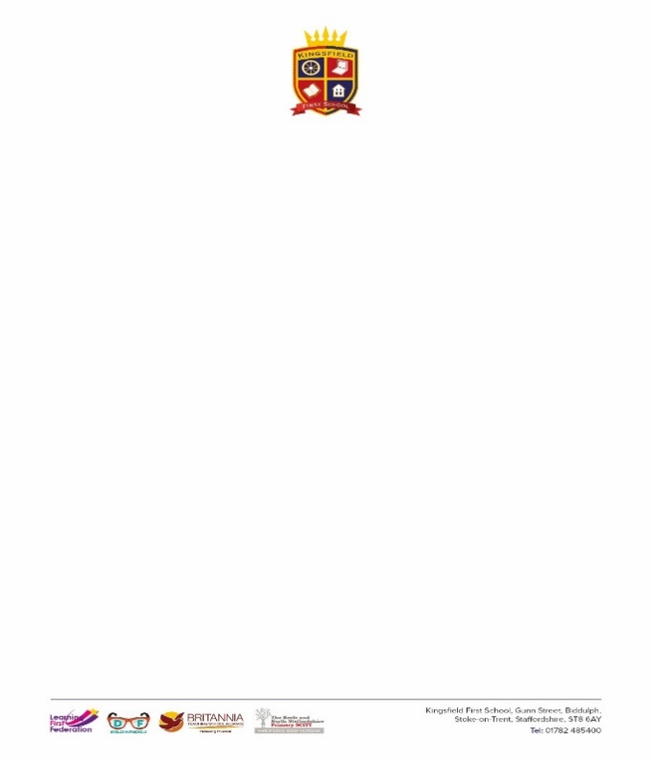

**KS1 Cycle B Art Medium term plan**

|  |  |  |  |  |  |  |
| --- | --- | --- | --- | --- | --- | --- |
|  | **Autumn 1** | | **Spring 1** | | **Summer 1** | |
| **Techniques** | ***Drawing*** | ***Printing*** | ***Drawing*** | ***Painting*** | ***Collage*** | ***Sculpture*** |
| **Significant Person** | Jan Griffier ‘great fire of London’ |  |  | Peter Max (Perspective)  Peter Thorpe |  | Andy Goldsworthy |
| **Vocabulary** | observe, imagination, memory, line, thick, thin, shape, 2D, flat, pattern, texture, gradient, shade, mark,  artist, technique, skill, design, medium, choice, preference, like, dislike | Print, pattern, repeat, multiple, image, mono, experiement, stamp, roll, create, explore, design  purpose, spotted, striped, simple, sponge, crumpled paper, press, rub, share, review, reflect, evaluate.  artist, technique, skill, design, medium, choice, preference, like, dislike | observe, imagination, memory, line, thick, thin, shape, 2D, flat, pattern, texture, gradient, shade, mark,  curved, line, diagonal, vertical, horizontal,  artist, technique, skill, design, medium, choice, preference, like, dislike | Paint, Colour, primary, secondary, bright, warm, cool, shade, explore, add, brush, thickness, purpose, texture, line  artist, technique, skill, design, medium, choice, preference, like, dislike | experiment, materials, texture, overlap, shapes, texture, tactile, rough, smooth, bumpy, soft, hard, prickly, furry, flat, shiny, hairy, share, review, reflect, evaluate.  artist, technique, skill, design, medium, choice, preference, like, dislike | Shape, mould, explore, experiment, research, plan, tool, clay, share, review, reflect, evaluate.  artist, technique, skill, design, medium, choice, preference, like, dislike |
| **I will know….** | **Drawing**  I can use graded pencils to explore shade on a gradient.  I can select a pencil based on its label (2B, 6B etc.) for a purpose.  I can experiment with creating a range of textures using a variety of different marks/lines/rubber  I can create both large and small-scale observational drawings of natural or man-made objects.  **Using a range of materials**  I can investigate different methods of designing; including drawing and decide on methods, materials and processes.    **Ideas, experiences, imagination**  I can observe different artists and begin to identify possible inspiration behind the artist’s work.  I am beginning to create art individually and collaboratively, sharing ideas for design, technique and use of materials.  I can confidently use a range of shapes within my artwork to realistically represent objects.  I can draw from imagination, observation and memory to design things, record observations, tell stories and express thought and feelings to others.  **Range of Artists**  I can discuss and describe the work of notable artists, artisans and designers and begin to recognise different techniques within their work including drawing, collage, painting, use of ICT etc.  I can use some of the studied artists to create art in the style of their works, copying techniques to reproduce the art work.  I can recognise artistic techniques and use a wider range of artistic terminology to describe an artist’s work | **Printing**  I understand that the purpose of printmaking is to create multiple images and patterns.   I can explore and mimic print from the environment (e.g. wallpapers).  I can make mono prints by spreading paint.   I can experiment with a variety of objects to create a print, e.g. press, roll, rub, and stamp to make prints.    **Ideas, experiences, imagination**  I am beginning to create art individually and collaboratively, sharing ideas for design, technique and use of materials.  I can confidently use a range of shapes within my artwork to realistically represent objects. | **Drawing**  I can use graded pencils to explore shade on a gradient.  I can select a pencil based on its label (2B, 6B etc.) for a purpose.  I can experiment with creating a range of textures using a variety of different marks/lines/rubber  I can create both large and small-scale observational drawings of natural or man-made objects.  **Using a range of materials**  I can investigate different methods of designing; including drawing and decide on methods, materials and processes.    I can use a range of mediums to design artwork and decide on a preference.    **Ideas, experiences, imagination**  I can confidently use a range of shapes within my artwork to realistically represent objects. | **Painting**  I can name different types of paint.  I can add different materials to paint to produce different textural effects e.g. water, sand, glitter, sawdust, plaster, glue etc.  I can use white and black paint to create tones of colours (tint and shade).  I can use a wider range of brushes with a purpose: different sizes, different types.  I can use colours with a purpose to create realistic paintings.    **Using a range of materials**  I can choose from a range of artistic processes and techniques and justify my choices.  **Ideas, experiences, imagination**  I can observe different artists and begin to identify possible inspiration behind the artist’s work.  I am beginning to create art individually and collaboratively, sharing ideas for design, technique and use of materials.  I can confidently use a range of shapes within my artwork to realistically represent objects.  **Range of Artists**  I can discuss and describe the work of notable artists, artisans and designers and begin to recognise different techniques within their work including drawing, collage, painting, use of ICT etc.  I can use some of the studied artists to create art in the style of their works, copying techniques to reproduce the art work.  I can recognise artistic techniques and use a wider range of artistic terminology to describe an artist’s work | **Collage**  I can sort and group materials for different purposes in different ways/shapes, i.e. texture, colour, triangles etc.  I can experiment with a range of media (paper, magazines, fabric, photocopies, crepe paper) to create different effects.  I am beginning to experiment with texture by folding, crumpling, tearing and overlapping materials.  **Using a range of materials**  I can investigate different methods of designing; including drawing and decide on methods, materials and processes.    I can use a range of mediums to design artwork and decide on a preference.      **Ideas, experiences, imagination**  I am beginning to create art individually and collaboratively, sharing ideas for design, technique and use of materials.  I can confidently use a range of shapes within my artwork to realistically represent objects. | **Sculpture**  I can manipulate malleable materials in a variety of ways to achieve a desired effect.  I can manipulate and model materials accurately to represent my idea.  I can use a variety of different tools to create different textures and shapes.  I can create a 3D sculpture using clay.    **Using a range of materials**  I can choose from a range of artistic processes and techniques and justify my choices.  **Ideas, experiences, imagination**  I can observe different artists and begin to identify possible inspiration behind the artist’s work.  I am beginning to create art individually and collaboratively, sharing ideas for design, technique and use of materials.  **Range of Artists**  I can discuss and describe the work of notable artists, artisans and designers and begin to recognise different techniques within their work including drawing, collage, painting, use of ICT etc.  I can use some of the studied artists to create art in the style of their works, copying techniques to reproduce the art work.  I can recognise artistic techniques and use a wider range of artistic terminology to describe an artist’s work |

