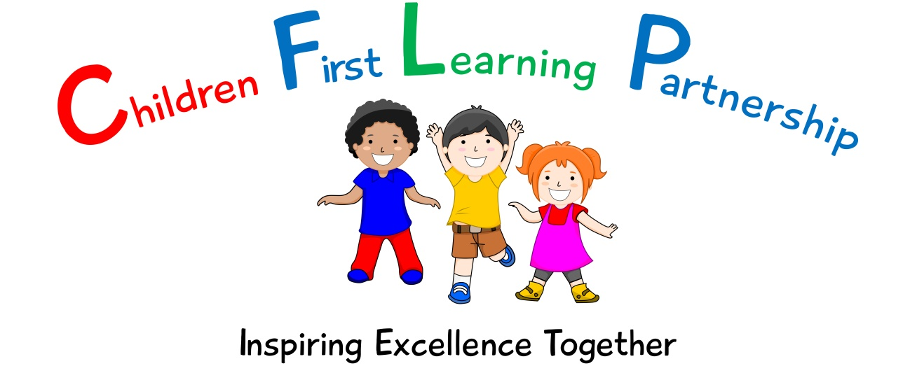

Computing Policy for
Kingsfield First School
2023

May 2024
To be reviewed:

Agreed and ratified by the Local Advisory Board on:
CEO – Mrs A. Rourke
Headteacher – Mrs R. Butler

Responsible Officer:
Mr J.Flowers
Chair of Local Advisory Board:
The CFLP Computing Policy in respect of the Children First Learning Partnership has been discussed and adopted by the Local Advisory Board.

Kingsfield First School Primary School
Computing Policy 2023
(To be used in alongside the E-Safety Policy and PSHRE/Computing curriculum documents)

The overall intent of our school curriculum is to:
Recognise uniqueness: in our pupils, staff, resources and whole school community.
Be Inclusive: recognising learning styles, learning needs at all levels and providing solutions to any barriers to learning we encounter.
Engage and Inspire: through knowledge rich, highly enriched, progressive and purposeful contexts.
Promote Aspiration: offering challenge, accountability and responsibility for their learning.
Create citizens of the Future: who thrive on responsibility, see difference as a strength of our community and use democracy to embed their own values and beliefs.
Our Computing curriculum strives to drive all of these intentions and links very closely to the achievement and development of them all.

Intent
The national curriculum for Computing aims to ensure that all pupils:
- can understand and apply the fundamental principles and concepts of computer science, including abstraction, logic, algorithms and data representation
- can analyse problems in computational terms, and have repeated practical experience of writing computer programs in order to solve such problems
- can evaluate and apply information technology, including new or unfamiliar technologies, analytically to solve problems
- are responsible, competent, confident and creative users of information and communication technology.

Kingsfield First School is devoted to ensuring that pupils develop a well-versed understanding of Computing and technology to prepare them for life in the future. We aim to deliver a well-rounded curriculum that;
- Meets the requirements of the National Curriculum programmes of study for Computing.
- Provides a challenging and entertaining curriculum for all pupils.
- Responds and allows access to new developments in technology.
- Equips pupils with the confidence and capability to use ICT and Computing throughout their later life.
- Ensures a deep and secure understanding of how to use ICT and Computing safely and responsibly.

This policy sets out how we will enable pupils to succeed in their education and thrive in their use of technology, whether they are accessing within the school or at home.

Implementation
EYFS
Computing is a core subject in the National Curriculum and therefore must be taught with a secure and thorough understanding.
In EYFS the Technology aspect of the Framework has recently been reduced, however it is important to give children a broad, play-based experience of Computing in a range of contexts, including outdoor play. Computing is not just about computers. Early years learning environments should feature Computing scenarios based on experience in the real world, such as role play. Children gain confidence, control and language skills through opportunities to explore using non-computer based resources as well as technology including interactive whiteboard and iPads in their classrooms. Additionally, children are introduced to some elements of Computing using parts of the Barefoot Computing Curriculum. This enables children to transition to the National Curriculum as they enter Key Stage 1.
KS1 and KS2
As stated by the Computing National Curriculum 2013,
Key Stage 1 pupils are expected to;
- understand what algorithms are; how they are implemented as programs on digital devices; and that programs execute by following precise and unambiguous instructions
- create and debug simple programs
- use logical reasoning to predict the behaviour of simple programs
- use technology purposefully to create, organise, store, manipulate and retrieve digital content
- recognise common uses of information technology beyond school
- use technology safely and respectfully, keeping personal information private; identify where to go for help and support when they have concerns about content or contact on the internet or other online technologies.
Key Stage 2 pupils are expected to;
- design, write and debug programs that accomplish specific goals, including controlling or simulating physical systems; solve problems by decomposing them into smaller parts
- use sequence, selection, and repetition in programs; work with variables and various forms of input and output
- use logical reasoning to explain how some simple algorithms work and to detect and correct errors in algorithms and programs
- understand computer networks including the internet; how they can provide multiple services, such as the world wide web; and the opportunities they offer for communication and collaboration
- use search technologies effectively, appreciate how results are selected and ranked, and be discerning in evaluating digital content
- select, use and combine a variety of software (including internet services) on a range of digital devices to design and create a range of programs, systems and content that accomplish given goals, including collecting, analysing, evaluating and presenting data and information
- use technology safely, respectfully and responsibly; recognise acceptable/unacceptable behaviour; identify a range of ways to report concerns about content and contact.

This is delivered throughout Key Stage 1 and Key Stage 2 using the Teacher Computing curriculum from the National Centre for Computing Education. Each year group will be introduced to six units of study with a range of focuses. In each year, children access units focussed on:
- Computing systems and networks
- Creating Media
- Data and information
- Programming
These units of study will enable the pupils of Kingsfield First School to have a broad and balanced knowledge of computing techniques and new technology. They will have an understanding of how to approach different computer-based problems and briefs, and the best methods to achieve the desired outcome.
In addition to this, children are provided with a substantive E-Safety curriculum linked heavily with the PSHRE curriculum. Each year group are taught units about:
- Self-image and Identity
- Online Relationships
- Online Reputation
- Online Bullying
- Managing Online Information
- Health, Wellbeing and Lifestyle
- Privacy and Security
- Copyright and Ownership
This is delivered using resources from National Online Safety (https://nationalonlinesafety.com/) and is taught in line with our E-Safety curriculum. Furthermore, whole school assemblies are run on a regular basis to help children to learn how to stay safe online and to approach new threats to children’s online safety which have been discovered.
Evidence of planning can be found by looking at the lesson Active Inspire flipcharts made using the Computing Lesson Pathway in line with Unit Pathway.

Impact
The impact of this policy and its enforcement should be that whilst at school, the pupils are:
- demonstrating the age-related skills in the Computing Policy for their Year group,
- able to access technology, devices and the internet in a way that is safe,
- able to understand how to apply their knowledge to solve a range of problems and access a range of briefs.

By the time pupils leave our school they should be able to:
- collect, organise and handle data effectively,
- connect with others safely and respectfully using all technology,
- understand that their words and actions online have consequences within the law,
- use coding methodically and creatively for different purposes,
- understand how and why devices connect,
- communicate ideas well by using a range of different applications and devices,
- apply my skills and knowledge of technology throughout the curriculum and outside of school.

Assessment
Children will demonstrate their ability to meet the criteria outlined in the Impact section of this document (above) via:
- Pupil voice,
- During computing and e-safety lessons (recorded using EvidenceMe)
- During relevant PSHRE lessons (recorded using EvidenceMe and in books)
- Some learning may be found in the pupils individual/class computing folders.

Role of Leaders
Headteacher and Senior Leaders
The Headteacher and Senior Leaders are responsible for:
- overseeing health and safety policy and practice
- resources budget management
- ratifying the school’s Strategic Development Plan for Technology
- arranging in-service support
- Leading the development and implementation of the school’s E-safety policy in line with other Child Protection policies alongside the E-Safety Leader

Computing Lead
The Computing Leader is responsible for:
- ensuring the consistent implementation of Computing policy
- presenting exemplary practice in the teaching of Computing
- advising colleagues on planning, delivering and assessing Computing
- monitoring the effective use of technology and giving advice where appropriate
- ensuring progression in Computing
- suggesting purchasing plans for hardware and software
- identifying what support / CPD is needed by individual staff / groups of staff / the whole school
- reviewing and revising the Computing policy and other associated documents
- creation of a school portfolio of evidence (if applicable)
- providing training and advice for staff.
- Liaises with the MAT and other relevant bodies.
- Liaises with school technical staff (EVOLVE).

Teaching Staff
All teaching staff are responsible for ensuring that:
- they have an up-to-date knowledge of the Computing Curriculum
- they deliver relevant and engaging Computing lessons pitched at their year group using the Teach Computing Curriculum
- they model responsible use of technology and computing resources

ICT Support Technician
The ICT Support Technician is responsible for ensuring that equipment is supported and maintained through a weekly visit working collaboratively with the Computing Subject Leader.

Version | Review Date | Changes Made
V1.0 |  | N/A

