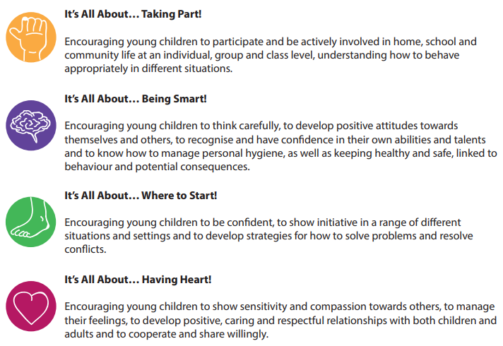
EYFS RECEPTION
As a prime area of the Early Years Curriculum, PSED (Personal, Social and Emotional Development) is known to be a vital part of Early Learning. All key areas of the Early Years PSED curriculum are covered in creative and innovative ways within the Early Years 3D PSHE programme.
Autumn 1 | Spring 1 | Summer 1
’Hide and Seek’ having heart!  - show sensitivity to others’ needs and feelings.  - form positive relationships with adults and other children.  ’Nan’s House’ being smart  - talk about how we and others show feelings.  having heart!  - say why we like some activities more than others.  ‘I Like…’ being smart  - be confident to speak to others about our own needs, wants, interests and opinions.  ’It’s Your Turn’ where to start  - take steps to resolve conflicts with other children by finding compromises.  taking part  - play cooperatively, taking turns with others.  ’What a Problem’ where to start  - begin to be able to negotiate and solve problems without aggression. | ’Rainy Days’ having heart!  - take account of one another’s ideas about how to organise an activity.  being smart  - be confident to speak to others about our own needs, wants, interests and opinions.  - talk about our ideas.  taking part  - be confident to speak in a familiar group  ’I Feel Poorly’ being smart  - ask appropriate questions of others.  ‘Clean and Tidy’ being smart  - talk about our own and others’ behaviour and its consequences.  Bully Boy’ being smart  - talk about our own and others’ behaviour and its consequences. | ’A Piece of Cake’ being smart  - ask appropriate questions of others.  - choose resources we need for our chosen activities.  ’Busy Body’ having heart!  - take account of one another’s ideas about how to organise an activity  ’The New Pet’ having heart  - talk about how we and others show feelings.  ’Dressing Up’ being smart  say when we do and don’t need help.
Autumn 2 | Spring 2 | Summer 2
’Take the Plunge’ being smart  - be confident to try new activities.  - say when we do or don’t need help.  ’An Old Friend’ taking part  - initiate conversations, attend to and take account of what others say.  having heart  - show sensitivity to others’ needs and feelings.  - form positive relationships with adults and other children.  ’Me and You’ being smart  - describe ourselves in positive terms and talk about our abilities.  ’Stick to the Rules’ taking part  - work as part of a group or class and understand and follow the rules. | ’Family Fun’ having heart!  - show sensitivity to others’ needs and feelings.  - form positive relationships with adults and other children.  ’One Gold Star’ being smart  - describe ourselves in positive terms and talk about our abilities.  ’All Join In’ taking part  - explain our own knowledge and understanding.  ’I’m Stuck’ being smart  - say when we do and don’t need help. | ’E-Safety, Be Safe’  being smart  say when we do and don’t need help.  ’Eid Mubarak!’ taking part  - explain our own knowledge and understanding.  having heart!  - show sensitivity to others’ needs and feelings.  - form positive relationships with adults and other children.  ’Playtime Games’ taking part  - play cooperatively, taking turns with others.  being smart  - talk about our own and others’ behaviour and its consequences.  ’Litter Bug!’ taking part  - play cooperatively, taking turns with others.  being smart  - be confident to speak to others about our own needs, wants, interests and opinions.  where to start  - begin to be able to negotiate and solve problems without aggression.

