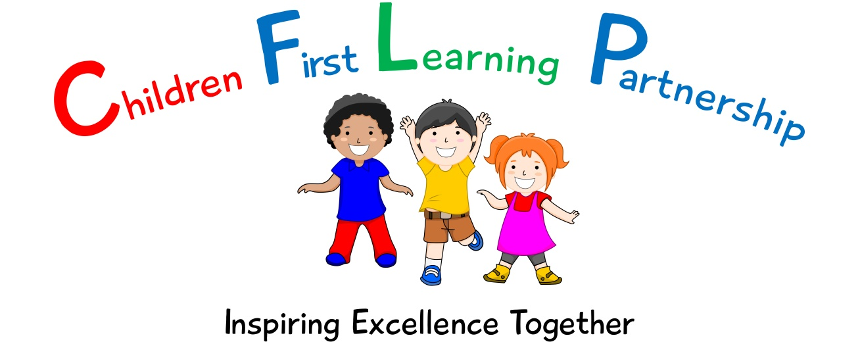

History Policy 2023

May 2025
To be reviewed:
15th May 2023
Agreed and ratified by the Local Advisory Board on:
Headteacher – Mrs R. BUtler

Responsible Officer:
Mr C. Clulow
Chair of Local Advisory Board:
The CFLP History Policy in respect of the Children First Learning Partnership has been discussed and adopted by the Local Advisory Board.

Kingsfield First School
History Policy 2023

The overall intent of our school curriculum is to:
Recognise uniqueness: in our pupils, staff, resources and whole school community.
Be Inclusive: recognising learning styles, learning needs at all levels and providing solutions to any barriers to learning we encounter.
Engage and Inspire: through knowledge rich, highly enriched, progressive and purposeful contexts.
Promote Aspiration: offering challenge, accountability and responsibility for their learning.
Create citizens of the Future: who thrive on responsibility, see difference as a strength of our community and use democracy to embed their own values and beliefs.
Our History curriculum strives to drive all of these intentions and links very closely to the achievement and development of them all.
Intent
To develop children’s substantive knowledge and disciplinary skills of History, inspiring and igniting curiosity about the past and how it helps to shape the future.
We aim to achieve this through allowing the children:
- To research significant events and figures and to understand their impact
- To be able to place historical events in chronological order
- To present their findings about a historical topic
- To ask questions about the past and to interpret their findings
- To use historical evidence to back up their explanations and judgements
- To form their own opinions about what has happened in the past using a range of sources
- To develop the ability to think, reflect, debate, discuss and evaluate the past

Implementation
We use the Development Matters and National Curriculum documents to inform the delivery of History at The Kingsfield First School.
Through the EYFS framework, pupils should be taught to:
Understanding the World (ELG)
- Talk about the lives of people around them and their roles in society
- Know some similarities and differences between things in the past and now, drawing on their experiences and what has been read in class.
- Understand the past through settings, characters and events encountered in books read in class and storytelling.

Through the National curriculum, our progression documents show a build-up of knowledge and skills across the following areas:
KS1 – Pupils should develop an awareness of the past, using common words and phrases relating to the passing of time. They should know where the people and events they study fit within a chronological framework and identify similarities and differences between ways of life in different periods. They should use a wide vocabulary of everyday historical terms. They should ask and answer questions, choosing and using parts of stories and other sources to show that they know and understand key features of events. They should understand some of the ways in which we find out about the past and identify different ways in which it is represented. In planning to ensure the progression described above through teaching about the people, events and changes outlined below, teachers are often introducing pupils to historical periods that they will study more fully at key stages 2 and 3.
Pupils should be taught about:
- changes within living memory. Where appropriate, these should be used to reveal aspects of change in national life
- events beyond living memory that are significant nationally or globally
- the lives of significant individuals in the past who have contributed to national and international achievements. Some should be used to compare aspects of life in different periods
- significant historical events, people and places in their own locality

KS2 – Pupils should continue to develop a chronologically secure knowledge and understanding of British, local and world history, establishing clear narratives within and across the periods they study. They should note connections, contrasts and trends over time and develop the appropriate use of historical terms. They should regularly address and sometimes devise historically valid questions about change, cause, similarity and difference, and significance. They should construct informed responses that involve thoughtful selection and organisation of relevant historical information. They should understand how our knowledge of the past is constructed from a range of sources. In planning to ensure the progression described above through teaching the British, local and world history outlined below, teachers should combine overview and depth studies to help pupils understand both the long arc of development and the complexity of specific aspects of the content.
Pupils should be taught about:
- changes in Britain from the Stone Age to the Iron Age
- the Roman Empire and its impact on Britain
- Britain’s settlement by Anglo-Saxons and Scots the Viking and Anglo-Saxon struggle for the Kingdom of England to the time of Edward the Confessor
- a local history study
- a study of an aspect or theme in British history that extends pupils’ chronological knowledge beyond 1066
- the achievements of the earliest civilizations – an overview of where and when the first civilizations appeared and a depth study of one of the following: Ancient Sumer; The Indus Valley; Ancient Egypt; The Shang Dynasty of Ancient China
- Ancient Greece – a study of Greek life and achievements and their influence on the western world
- a non-European society that provides contrasts with British history – one study chosen from: early Islamic civilization, including a study of Baghdad c. AD 900; Mayan civilization c. AD 900; Benin (West Africa) c. AD 900-1300.

Our whole school History progression documents cover the following areas
- Chronology and causation
- Historical enquiry
- Interpretation and significance

.

Unit and Lesson
Unit
At Kingsfield First School we follow the history progression documents to ensure that both substantive and disciplinary skills are progressive within each year group and therefore across the school. These are supported by the Education in Focus History documents to support staff in planning and delivering an effective historical curriculum. Each unit of work is divided into a number of sequential components which lead to a composite task which allows the children to demonstrate their developing knowledge and skills.

Lesson
Each lesson will start with a revisit/review/retrieval on/of the previous learning. This will be an opportunity for staff to assess where there may be gaps in learning which needs to be addressed. Previous and new vocabulary will be introduced and discussed to ensure all children can access the lesson. Learning outcomes and success criteria are shared so that children are aware of the context of their learning and therefore be successful. Staff will teach knowledge and skills to enable the children to ask questions and apply their knowledge and skills before reflecting on their learning and reaching conclusions (Review/Plenary)
At Kingsfield First school there is a mastery approach to History. All children will start their learning from the same expectation and where necessary children will be scaffolded throughout the lesson to enable their success.
Working walls and other resources are evident within the learning environment and are referred to and used by both staff and children within the lessons.
Assessment
Assessment within History is based upon many sources of evidence. This will allow for judgements to be evidenced based and secure regarding what pupils know and remember in relation to our planned curriculum outcomes in all year groups. Teachers will use a variety of assessment methods which they will select carefully based upon the quality of evidence it will provide within History and will avoid additional workload for pupils and staff.
Formative assessment takes many forms in History.
AfL
Teachers and subject leaders value the voice of the pupil. They will observe pupils carefully, question purposefully and listen and use pupil responses in all lessons and the day to day life of the school to adapt teaching in the moment, lesson to lesson and unit to unit to ensure learning is secure and built upon in a sequential and progressive manner. In many lessons and where appropriate, purposefully planned explicit retrieval opportunities will also be used to ensure pupils have secured component knowledge and are ready to move on and make links to previous learning.
Evidence Me
A wealth of other evidence such as practical hands on learning outcomes, behaviours, drama, performances, group work will also be captured on evidence me to support teacher assessment judgements. At Kingsfield First School we value talk, practical exploration and pupil responses as a method of ensuring all pupils can access our History curriculum and demonstrate the gains they are making simply and effectively.
Summative assessment in History may in some year groups be available to aid the judgements teachers make about what pupils know and remember:
Pupils work, end of unit quizzes and composite outcomes
Pupils, will where appropriate, capture their understanding, evaluate their own learning or rehearse and secure knowledge in a written form. This will be used effectively to evidence progress and avoid creating barriers to learning for any group of pupils in our school, for example due to their age or any additional needs they may have.
Teacher Assessment Judgements
Children will be judged as meeting curriculum expectations in History on a termly basis using evidence from activities listed above. This judgement will be working at, below or at a greater depth within the year group/key stage unit they have completed. This will be captured on our Arbor system and used to inform curriculum design and developments, resourcing, training and leadership monitoring activities. Teacher assessment judgements in History will be shared with parents on an annual basis via their child’s annual report.

Role of Leaders
- Ensure the delivery of a progressive History curriculum
- Monitor compliance, quality and standards in History
- Respond quickly and in a supportive manner to overcome barriers to implementation and impact.
- Use assessment information to provide effective CPD and challenge.
- Provide clear updates to the Local Advisory Board, Head Teacher and SLT.

Version | Review Date | Changes Made

