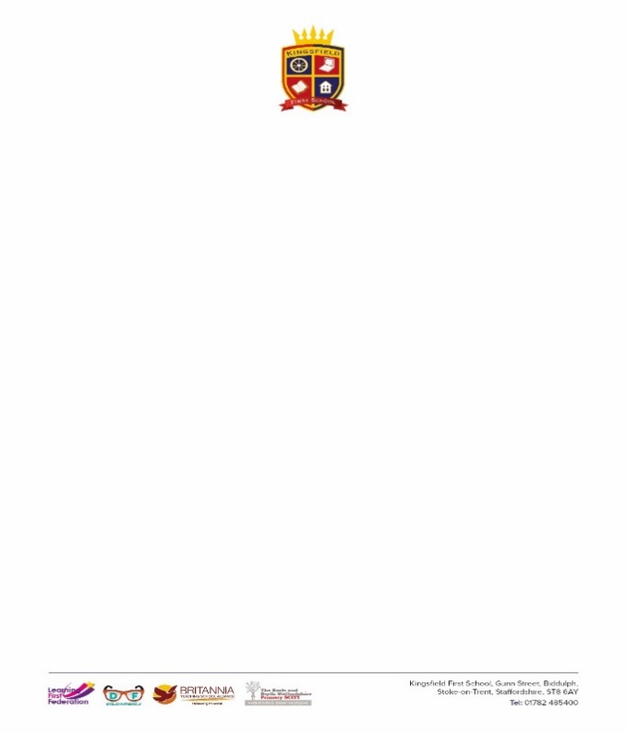

**EYFS History Medium Term Plan**

|  |  |  |  |
| --- | --- | --- | --- |
|  | **Autumn** | **Spring** | **Summer** |
| **Unit** | Eyes, Nose Fingers & Toes  Crazy Creations & Marvellous Music  This is Me!  Our Wonderful World | Tell Me A Story  Down on The Farm  A World of Pure Imagination  All Creatures Great and Small | What is your Super Power?  How does your Garden Grow?  Happily Ever After  Little People, Big Adventures |
| **Vocabulary** | Family, home, me, life remember, old, new, past, present, future, time, change, same, different, before, after, next | People, experience, special, event, change, life, communities, routines, families, friends, same, different | Pattern, change, time, past, present, future, experience, event, old, new, same, different |
| **I will know….** | How to talk about members of my immediate family.  How to name and describe people who are familiar to me.  How to make sense of my own life-story.  How to talk about my family’s history. | How to talk about people in my community.  How to comment on images of familiar situations in the past.  How things were different in the past.  That things happened before I was born. | I can compare and contrast characters from stories, including figures from the past.  What is meant by past and present. |

|  |
| --- |
| **Early Learning Goals**  *To be achieved by the end of Reception* |
| **Past and Present** |
| How to talk about the lives of people around me and their roles in society. |
| How to compare things in the past and now, drawing on my experience and what has been read in class. |
| How to understand the past through settings, characters and events encountered in books read in class and storytelling. |