**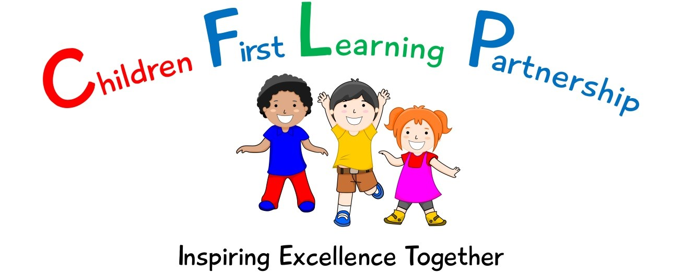**

****

Marking & Feedback Policy 2023

*May 2025*

*To be reviewed:*

*Agreed and ratified by the Local Advisory Board on: 15.05.2023*

*Headteacher – Mrs R Butler*

*Responsible Officer:*

*Mrs C. Clulow*

*Chair of Board:*

The Marking & Feedback Policy in respect of Kingsfield First School has been discussed and adopted by the Local Advisory Board in May 2023

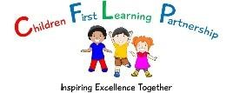



**Kingsfield Marking & Feedback Policy**

**May 2023**

**INTRODUCTION:**

Within the Children First Learning Partnership we take a professional approach to the tasks of marking work and giving feedback on it. All our children are entitled to regular and comprehensive feedback on their learning, which is an essential part of our learning process and inclusive values. We encourage all children to reflect upon their own learning and contribute to the evaluation of their work and progress. This policy is based on a wide range of research around the reduction of teacher workload from sources such as: Workload Review Group Report ‘Eliminating unnecessary workload around marking’ (WRGR,

2016), the Education Endowment Foundation report ‘A marked Improvement’ (EEF, 2016) Education Endowment Foundation’s ‘A marked improvement?’ report (Elliott et al 2016)Reducing teacher workload through ‘real-time’ personalised feedback Research report March 2018 Ruslan Protsiv, Patricia Pipola – St Patrick’s Catholic Primary School, Aquinas Teaching and Learning Trust

**AIMS:**

Typically, feedback (both written and oral) has two main purposes:

* To praise and motivate: positive feedback reinforces and supports good performance, increasing confidence and self-esteem, encouraging children to continue working at that standard.
* To support improvement: feedback will identify specific learning needs and address how to improve. It supports learners in moving on from their current performance to meeting the desired learning outcomes.

**OUTCOMES OF MARKING AND FEEDBACK IN OUR SCHOOLS:**

* Promotes progress
* Extends learning and thinking
* Promotes independence and accountability
* Manageable for staff workload

**PURPOSE:**

The purpose of marking children’s work and providing feedback includes the following:

* to celebrate success and/or to raise expectation of future success
* identify learning needs and key priorities for improvement, promote self and peer assessment.
* correct errors
* check knowledge, skills and levels of understanding to inform planning, inform teacher assessment and reporting to parents.

**GUIDELINES:**

Sometimes lots of children will benefit from a next step comment, other times, no one will. As a school, we will encourage our teaching team to use their professional judgement to decide when the right time to provide verbal feedback, written feedback, positive highlighting or when a next step comment is the right approach. It must go without saying that this judgement needs to be based on what will most positively impact that child’s progress.

**Methods of feedback:**

1. Live, ‘in the moment’ feedback from teacher/TA during a lesson- whole group, whole class and individual. This may take the form of:
   * Teacher/TA verbal comments during a lesson
   * Teacher/TA written symbol during a lesson, using visual approaches wherever possible
2. Peer and self-assessment used in English
3. Whole class/group feedback at the start of the following lesson based on the categories of: reteach, consolidate or extend.
4. Feedback - (verbal or feedback) which could be short or lengthier and may be written if appropriate to the age/ability of the child. Feedback is personalised and may suggest targets or strategies for improvement set by Teacher/TA. Lengthier feedback in writing often follow a “dazzle” write, in maths after a prior learning White Rose unit test and in for children on the Little Wandle phonics Programme they take place every half term which are recorded in Home-School Links.

**How we will mark and provide feedback:**

We promote the use of teacher judgements on how to deploy the methods of feedback above, however purposeful instant verbal and written feedback are promoted within lessons to motivate pupils and extend learning where appropriate alongside the need to reduce teacher workload and bureaucracy**.**

**Opportunities for feedback:**

* the planned and informed deployment of an adult within a lesson to offer instant verbal feedback or/and written feedback and to identify basic errors and misunderstandings within children’s work
* mini plenaries within lessons containing focused questioning and instant praise, verbal feedback and extension to groups, individuals and or the whole class
* guided learning sessions or mentoring conferences where verbal feedback is continuous, in depth and provides clear next steps for learning
* the use of peer and self-assessment
* written feedback using visual/symbols to ensure pupils can access feedback swiftly
* verbal feedback to targeted groups at the start of the next lesson

All of the above could also lead to the identification of misconceptions regarding the new skills, knowledge and understanding being delivered during the lesson. In this case all staff will use well embedded AfL strategies to redirect the lesson and future teaching and learning to ensure the very highest levels of progress is made by our children.

**Marking Codes**

We have an agreed code for marking (see below), to ensure that we all mark in the same way and the children learn to understand it.

In KS1 the first four codes are used and then the others are introduced when appropriate to the child. The symbol is then ticked once the child has made the correct response.

* Punctuation should not be used here - ∆ x (insert the relevant punctuation mark inside triangle)
* Punctuation is missing here - ∆ .,!” (insert the correct punctuation mark inside triangle)
* Wrong spelling –– a squiggly line is drawn under the misspelt word, the child writes the in the margin. For the more able pupil, put the squiggle line in the margin and they locate the word and re-write in the margin.
* ^ - a word is missing, insert in the body of the
* Rewrite this bit so that I understand - ( ) (Children to use a number \* (if there is more than one bracket) to rewrite at the bottom of the page)
* ↑ - up-level, by the individual word in the body of the text or in the margin for the sentence.
* Repetition – you find it and change it – R
* There is something wrong here – you find it and put it right - ∆ an empty triangle (ensuring this is a mistake that the child can identify independently, it may be related to punctuation, spelling or sentence construction)

Marking for praise (green pen…….it’s good to be green)

* One tick ✓ to recognise good learning that relates specifically to the lesson’s success criteria
* “WOW!” in the body of learning to recognise that you are especially impressed by the pupil’s efforts.

**Marking Codes & Colours**

The following codes should be adopted to indicate levels of support:

* IW – Independent work
* AW – Assisted work
* VF – Verbal feedback in the form of a mentoring conference when learning is discussed with an adult (for both praise and direction) VF in pink if the conversation was to ask the child to think and VF in green if it was offering praise for good learning.
* The learning facilitator will be using IW (on the sticker) and VF in the margin

**Visual symbols**

To communicate effectively, (particularly to the younger children) and mark efficiently the following symbols are used:-

* **Use finger spaces **
* **Improve your handwriting in pink if it is required and it green for praise**
* **Speed up **
* **Take your time **
* **Your ideas were great **

*NB – The role of the learning facilitator is to mark errors and keep the pupils focussed and on track with their learning. They mark against the learning objective, reinforce via praise and challenge children to ensure accountability.*

**Peer and Self Assessment - The Developmental Continuum**

|  |  |  |  |  |
| --- | --- | --- | --- | --- |
| **EYFS** | **Y1** | **Y2** | **Y3** | **Y4** |
| To say what is good about their work and begin to recognise how they can improve their work | Chn to use some of the language associated with self assessment to discuss their work and improvements with a partner | Chn to use some of the language associated with AfL to verbally assess their partners work with increasing accuracy | Chn to become familiar with some forms of written self & peer assessment and use AfL language within their verbal and written feedback | Children to accurately self & peer assess work using a consistent format justifying their opinions using the correct vocabulary |

Peer & Self-Assessment Formats

|  |  |  |
| --- | --- | --- |
| C:\Users\lizg\AppData\Local\Microsoft\Windows\Temporary Internet Files\Content.IE5\V20BINNK\magnifying_glass[1].pngC:\Users\lizg\AppData\Local\Microsoft\Windows\Temporary Internet Files\Content.IE5\N702V2O0\happy-pencil[1].pngI assessed and discussed possible improvements  with my partner  Year 1 | | |
| Date: | My Name | Partner’s name |

|  |  |  |
| --- | --- | --- |
| C:\Users\lizg\AppData\Local\Microsoft\Windows\Temporary Internet Files\Content.IE5\V20BINNK\magnifying_glass[1].pngC:\Users\lizg\AppData\Local\Microsoft\Windows\Temporary Internet Files\Content.IE5\YC91VATJ\green-foot-print[1].pngWe assessed and discussed our work giving  each other feedback  Year 2 | | |
| Date: | My Name | Partner’s name |

|  |  |  |
| --- | --- | --- |
| C:\Users\lizg\AppData\Local\Microsoft\Windows\Temporary Internet Files\Content.IE5\V20BINNK\magnifying_glass[1].pngC:\Users\lizg\AppData\Local\Microsoft\Windows\Temporary Internet Files\Content.IE5\RDQIQOLJ\1194986818603360813target_with_arrow_virgin_01.svg.hi[1].pngWe assessed and discussed our work using AfL language  Year 3/4 | | |
|  | Stars C:\Users\lizg\AppData\Local\Microsoft\Windows\Temporary Internet Files\Content.IE5\7JLICSUO\808px-Sun_Star.svg[1].png | C:\Users\lizg\AppData\Local\Microsoft\Windows\Temporary Internet Files\Content.IE5\CY2VYY11\thumb-magic-wand-pictofigo-hi-009[1].pngWishes |
| Date: | My Name | Partner’s name |

**Editing**

When marking is in depth and children are responding to the marking to improve their work, or as part of an editing lesson, children would use the purple pen of power to show where they have corrected, improved or up-levelled their work. During the editing process more use of the other editing symbols are likely to be used more.

**Learning Objective**

In all lessons a sticker will communicate the lesson objective to clearly communicate the lesson intention. By the end of the lesson, if this has been achieved, the teaching staff will highlight the lesson objective green. If not achieved this will be highlighted pink. In KS2 children reflect on their confidence levels at the start of the lesson in English & Maths.

**Success Criteria**

In English and Maths lessons, a sticker will communicate the success criteria that is required in order to achieve the lesson objective. Success criteria is communicated in written or symbol format depending on the age and ability of the pupils. Examples of such symbols can be seen below. At the end of the lesson the teaching staff will highlight the success criteria green if it has been met. If it has not been met, the success criteria will be left blank.

At the beginning of the lesson, KS2 children will use ticks or crosses to share their levels of confidence towards the success criteria. At the end of the lesson, these are then reviewed in light of completed work.

Here are a few examples of the English success criteria

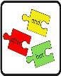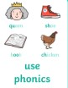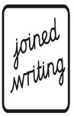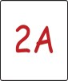

Here are a few examples of the Maths success criteria

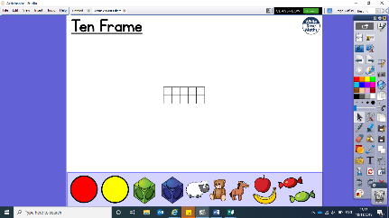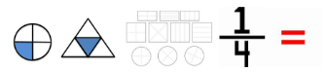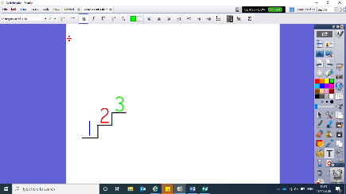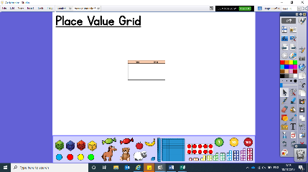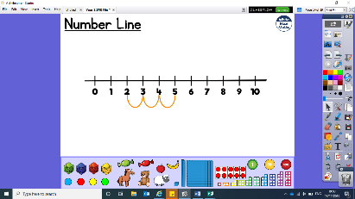

**÷**



## Inclusion and assessment for learning

Our school is an inclusive school. We actively seek to remove the barriers to learning and participation that can hinder or exclude individual pupils, or groups of pupils. For example, by providing verbal feedback or visual success criteria and marking symbols.

We achieve educational inclusion by continually reviewing what we do, by monitoring data, and through asking ourselves questions about the performance of these individuals and groups of pupils. In this way, we make judgements about how successful we are being at promoting racial and gender equality, and including pupils with disabilities or special educational needs.

## Moderation of standards

All leaders moderate examples of children's work withing their own class, key stage and within the CFLP schools. By doing this, we ensure that we make consistent and accurate judgements about standards in our school based on a range of high quality evidence.

## Monitoring and review

The Headteacher together with the SLT and all subject leaders are responsible for the monitoring the implementation of this policy. We allocate dedicated time for this task. Leaders use this time to inspect samples of the children's work and to observe the policy being implemented in the classroom.

This policy will be reviewed every two years, or earlier if necessary.