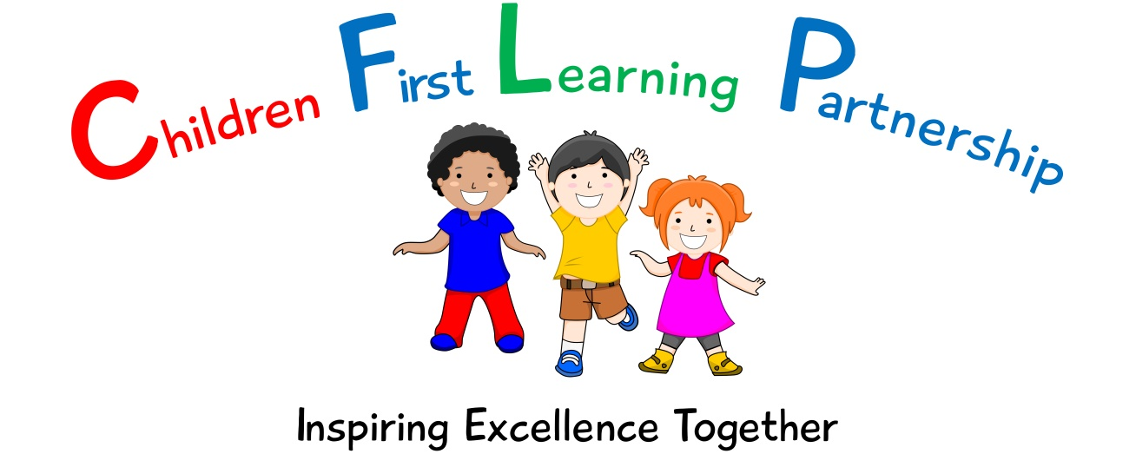

Geography Policy 2023

May 2025
To be reviewed:
15th May 2023
Agreed and ratified by the Local Advisory Board on:
Headteacher – Mrs R. BUtler

Responsible Officer:
Mr C. Clulow
Chair of Local Advisory Board:
The CFLP Geography Policy in respect of the Children First Learning Partnership has been discussed and adopted by the Local Advisory Board.

Reginald Mitchell Primary School
Geography Policy 2023

The overall intent of our school curriculum is to:
Recognise uniqueness: in our pupils, staff, resources and whole school community.
Be Inclusive: recognising learning styles, learning needs at all levels and providing solutions to any barriers to learning we encounter.
Engage and Inspire: through knowledge rich, highly enriched, progressive and purposeful contexts.
Promote Aspiration: offering challenge, accountability and responsibility for their learning.
Create citizens of the Future: who thrive on responsibility, see difference as a strength of our community and use democracy to embed their own values and beliefs.
Our Geography curriculum strives to drive all of these intentions and links very closely to the achievement and development of them all.
Intent
To develop children’s experiences and understanding of Geography, inspiring and igniting their curiosity about the wider world.
We aim to achieve this through allowing the children:
- To develop a sense of own location in relation to the rest of the world
- To develop a passion and a real sense of curiosity of the world and the people who live there
- To develop an ability to explore and enquire geographical skills and techniques through fieldwork and map skills
- To be able to enquire, question, analyse and present geographical concepts
- To be able to express opinions that are justified and reasoned through good knowledge around issues in society and the environment
- To apply creativity, critical thinking and curiosity to give reasoned views on places, fieldwork and features of the world around us.
- To be able to reach clear conclusions and develop a reasoned argument to explain findings

Implementation
We use the Development Matters and National Curriculum documents to inform the delivery of Geography at Kingsfield First School.

Our progression documents shows a build-up of knowledge and skills across the following areas:
EYFS – Pupils should explore their immediate and natural environment. They should have an awareness of different environments across the world and identify similarities and differences between their own environment and others.

Through the EYFS framework, pupils should be taught to:
Understanding the world (ELG)
- Describe their immediate environment using knowledge from observation, discussion, stories, non-fiction texts and maps
- Explain some similarities and differences between life in this country and life in other countries, drawing on knowledge from stories, non-fiction texts and (when appropriate) maps.
- Know some similarities and differences between the natural world around them and contrasting environments, drawing on their experiences and what has been read in class.
- Understand some important processes and changes in the natural world around them, including the seasons.

KS1 – Pupils should develop knowledge about the world, the United Kingdom and their locality. They should understand basic subject-specific vocabulary relating to human and physical geography and begin to use geographical skills, including first-hand observation, to enhance their locational awareness.

Pupils should be taught to:
Locational knowledge
- name and locate the world’s seven continents and five oceans
- name, locate and identify characteristics of the four countries and capital cities of the United Kingdom and its surrounding seas
Place knowledge
- understand geographical similarities and differences through studying the human and physical geography of a small area of the United Kingdom, and of a small area in a contrasting non-European country
Human and physical geography
- identify seasonal and daily weather patterns in the United Kingdom and the location of hot and cold areas of the world in relation to the Equator and the North and South Poles
Use basic geographical vocabulary to refer to:
- key physical features, including: beach, cliff, coast, forest, hill, mountain, sea, ocean, river, soil, valley, vegetation, season and weather
- key human features, including: city, town, village, factory, farm, house, office, port, harbour and shop
Geographical skills and fieldwork
- use world maps, atlases and globes to identify the United Kingdom and its countries, as well as the countries, continents and oceans studied at this key stage
- use simple compass directions (North, South, East and West) and locational and directional language [for example, near and far; left and right], to describe the location of features and routes on a map Geography
- use aerial photographs and plan perspectives to recognise landmarks and basic human and physical features; devise a simple map; and use and construct basic symbols in a key
- use simple fieldwork and observational skills to study the geography of their school and its grounds and the key human and physical features of its surrounding environment.

KS2 – Pupils should extend their knowledge and understanding beyond the local area to include the United Kingdom and Europe, North and South America. This will include the location and characteristics of a range of the world’s most significant human and physical features. They should develop their use of geographical knowledge, understanding and skills to enhance their locational and place knowledge.
Pupils should be taught to:

Locational knowledge
- locate the world’s countries, using maps to focus on Europe and North and South America, concentrating on their environmental regions, key physical and human characteristics, countries, and major cities
- name and locate counties and cities of the United Kingdom, geographical regions and their identifying human and physical characteristics, key topographical features (including hills, mountains, coasts and rivers), and land-use patterns; and understand how some of these aspects have changed over time
- identify the position and significance of latitude, longitude, Equator, Northern Hemisphere, Southern Hemisphere, the Tropics of Cancer and Capricorn, Arctic and Antarctic Circle, the Prime/Greenwich Meridian and time zones (including day and night)
Place knowledge
- understand geographical similarities and differences through the study of human and physical geography of a region of the United Kingdom, a region in a European country, and a region within North or South America
Human and physical geography
- describe and understand key aspects of:
- physical geography, including: climate zones, biomes and vegetation belts, rivers, mountains, volcanoes and earthquakes, and the water cycle
- human geography, including: types of settlement and land use, economic activity including trade links, and the distribution of natural resources including energy, food, minerals and water

Geographical skills and fieldwork
- use maps, atlases, globes and digital/computer mapping to locate countries and describe features studied
- use the eight points of a compass, four and six-figure grid references, symbols and key (including the use of Ordnance Survey maps) to build their knowledge of the United Kingdom and the wider world
- use fieldwork to observe, measure, record and present the human and physical features in the local area using a range of methods, including sketch maps, plans and graphs, and digital technologies

Our whole school geography progression documents cover the following areas:

- Locational Knowledge
- Place Knowledge
- Human and Physical Geography
- Geographical skills and Fieldwork

Unit and Lesson
Unit
At Kingsfield First School we follow the geography progression documents to ensure that both substantive and disciplinary skills are progressive within each year group and therefore across the school. These are supported by the Education in Focus Geography documents to support staff in planning and delivering an effective geographical curriculum. Each unit of work is divided into a number of sequential components which lead to a composite task which allows the children to demonstrate their developing knowledge and skills.

Lesson
Each lesson will start with a revisit/review/retrieval on/of the previous learning. This will be an opportunity for staff to assess where there may be gaps in learning which needs to be addressed. Previous and new vocabulary will be introduced and discussed to ensure all children can access the lesson. Learning outcomes and success criteria are shared so that children are aware of the context of their learning and therefore be successful. Staff will teach knowledge and skills to enable the children to ask questions and apply their knowledge and skills to map work and fieldwork before reflecting on their learning and reaching conclusions (Review/Plenary)
At Kingsfield First School there is a mastery approach to Geography. All children will start their learning from the same expectation and where necessary children will be scaffolded throughout the lesson to enable their success.
Working walls and other resources are evident within the learning environment and are referred to and used by both staff and children within the lessons.
Assessment
Assessment within Geography is based upon many sources of evidence. This will allow for judgements to be evidenced based and secure regarding what pupils know and remember in relation to our planned curriculum outcomes in all year groups. Teachers will use a variety of assessment methods which they will select carefully based upon the quality of evidence it will provide within Geography and will avoid additional workload for pupils and staff.
Formative assessment takes many forms in Geography.
AfL
Teachers and subject leaders value the voice of the pupil. They will observe pupils carefully, question purposefully and listen and use pupil responses in all lessons and the day to day life of the school to adapt teaching in the moment, lesson to lesson and unit to unit to ensure learning is secure and built upon in a sequential and progressive manner. In many lessons and where appropriate, purposefully planned explicit retrieval opportunities will also be used to ensure pupils have secured component knowledge and are ready to move on and make links to previous learning.
Evidence Me
A wealth of other evidence such as practical hands on learning outcomes, behaviours, drama, performances, group work will also be captured on evidence me to support teacher assessment judgements. At Kingsfield First School we value talk, practical exploration and pupil responses as a method of ensuring all pupils can access our Geography curriculum and demonstrate the gains they are making simply and effectively.
Summative assessment in Geography may in some year groups be available to aid the judgements teachers make about what pupils know and remember:
Pupils work, end of unit quizzes and composite outcomes
Pupils, will where appropriate, capture their understanding, evaluate their own learning or rehearse and secure knowledge in a written form. This will be used effectively to evidence progress and avoid creating barriers to learning for any group of pupils in our school, for example due to their age or any additional needs they may have.
Teacher Assessment Judgements
Children will be judged as meeting curriculum expectations in Geography on a termly basis using evidence from activities listed above. This judgement will be working at, below or at a greater depth within the year group/key stage unit they have completed. This will be captured on our Arbor system and used to inform curriculum design and developments, resourcing, training and leadership monitoring activities. Teacher assessment judgements in Geography will be shared with parents on an annual basis via their child’s annual report.
Role of Leaders
- Ensure the delivery of a progressive Geography curriculum
- Monitor compliance, quality and standards in Geography
- Respond quickly and in a supportive manner to overcome barriers to implementation and impact.
- Use assessment information to provide effective CPD and challenge.
- Provide clear updates to the Local Advisory Board, Head Teacher and SLT.

Version | Review Date | Changes Made

