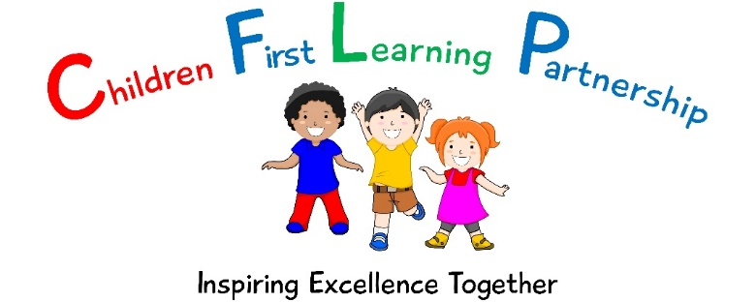

Looked After Child Policy
March 2023

March 2024
To be reviewed:
March 2023
Agreed and ratified by the Directors Board on:
Headteacher – Mrs R. Butler
Responsible Officer:
Mr C. C:lulow
Chair of Local Advisory Board:
The Looked After Child Policy has been discussed and adopted by the Local Advisory Board

The aim of this policy is :
To promote the educational achievement and welfare of looked after children.
b) The Name of the Designated Teacher for Mr L Anderson-Pugh
c) The Role of the Designated Teacher for Looked After Children
Within School Systems:
- to ensure that all staff, both teaching and non-teaching, have an understanding of the difficulties and educational disadvantage faced by Looked After Children and understand the need for positive systems of support to overcome them;
- to inform members of staff of the general educational needs of Looked After Children, and to promote the involvement of these children in school homework clubs, extra-curricular activities, home reading schemes, school councils etc.
- to act as an advocate for Looked After Children;
- to develop and monitor systems for liaising with carers, Vulnerable Children’s’ Services and the Education Inclusion Department.
- to hold a supervisory brief for all Looked After Children e.g. to ensure all relevant education and care information is available to school staff and carer(s), and that this information is kept up to date;
- to monitor the educational progress of Looked After Children in order to inform the school’s development plan;
- to intervene if there is evidence of individual underachievement, absence from school or internal truancy.
Work with Individual Looked After Children:
- to enable the child to make a contribution to the educational aspects of their care plan;
- to help ensure that each pupil has a Personal Education Plan (the PEP should be initiated by the young person’s social worker);
- to ensure that a home-school agreement is drawn up with the primary carer and signed by the social worker;
Liaison:
- To liaise with the member of staff responsible for monitoring children on the Child Protection Register;
- To help co-ordinate education and Looked After Children review meetings, so that the Personal Education Plan can inform the child’s Care Plan;
- To attend, arrange for someone else to attend, or to contribute in other ways to Looked After Children care planning meetings;
- To be the named contact for colleagues in Education Inclusion and Vulnerable Children’s’ Service; and
- To ensure the speedy transfer of information between agencies and individuals.
Training:
- To develop knowledge of Vulnerable Children/Education Inclusion procedures by attending training events organised by the Local Authority; and
- To cascade training to school staff as appropriate Looked After Children Policy Passed ratified by Directors in Spring 2023– Due for review Spring 2024

d) The name of a Local Advisory Board Member with special responsibility for Looked After Children is our Safeguarding Link – Mr C. Hawthorne
e) The role of that Link Local Advisory Board (LA ) member is to report to the Local Advisory Board on an annual basis:
- a comparison of test scores as a discrete group, compared with those of their pupils;
- the attendance of pupils as a discrete group, compared with other pupils;
- the level of fixed term/permanent exclusions; and
- pupil destinations.
The safeguarding link LAB member should be satisfied that the school’s policies and procedure:
- ensure that looked-after pupils have equal access to:
- the national curriculum;
- public examinations;
- careers guidance;
- additional educational support;
- extra-curricular activities; and
- work experience.
f) Responsibility for Looked After Children in School
- It is important that all teaching staff who are in contact with the child or young person are aware that he/she is being looked-after by the Local Authority. The responsibility for the transfer of this information should be that of the Headteacher and/or the Designated Teacher for Looked After Children.
- It is appropriate for Learning Support Assistants to have knowledge that the young person is being looked-after only when directly involved in the teaching of the young person.
- In the absence of the usual class teacher, some information regarding the child’s circumstances should be shared with the teacher covering the class. The extent of this sharing should be determined by the Headteacher or the Designated Teacher for Looked After Children.
g) Admission Arrangements
On admission, records (including the P.E.P.) will be requested from the pupil’s previous school and a meeting will be held with carer/parent/social worker. A date will be agreed upon for a new Personal Education Plan. An appropriate school induction will take place.
h) Involving the Young Person
It is important that a young person is aware that information is being recorded regarding their personal circumstances. How this is shared with them clearly depends on their age and understanding. The explanation should emphasise that the school, the Social Worker, and their carer(s) are working together to promote their education.
i ) Communication with Other Agencies
Schools should ensure that a copy of all reports (e.g. end of year reports) should be forwarded to the young person’s Social Worker in addition to the foster carer or Residential Social Worker. Schools, Education Inclusion and the Vulnerable Children’s’ Service should endeavour to coordinate their review meetings, e.g. to have an Annual Review of a Statement combined with a Statutory Care Review. Looked After Children in Staffordshire Policy Passed by Governors Summer 2022 – Due for review Summer 2023 Vulnerable Children’s’ Service, the Education Inclusion Service and schools will need to exchange information between formal reviews if there are significant changes in the young person’s circumstances, e.g. if school is considering an exclusion, there is a change of care placement or there are significant attendance issues.
j) Assessment, Monitoring and Review Procedures
Each looked-after pupil will have a Care Plan that will include a Personal Education Plan (PEP) that the Social Worker takes a lead in developing. This will identify specific areas of concern and include achievable targets. Areas for consideration will include:
• Attendance;
• Achievement Record (academic or otherwise);
• Behaviour;
• Homework;
• Involvement in Extra Curricular Activities;
• Special needs (if any);
• Development needs (short and long term development of skills, knowledge or subject areas and experiences); and
• Long term plans and aspirations (targets including progress, career plans and aspirations). The PEP will be updated at least every six months, as part of the Statutory Reviewing process carried out by the Vulnerable Children’s’ Service. The named Safeguarding Link Local Advisory Board member will report annually to the Local Advisory Board on the progress of all Looked After Children against the key indicators outlined above.

k. Pupil Premium Plus
Following assessment, monitor and review in PEP. Plan will be drawn up where Pupil Premium Plus money will be spent to best support each individual child.

