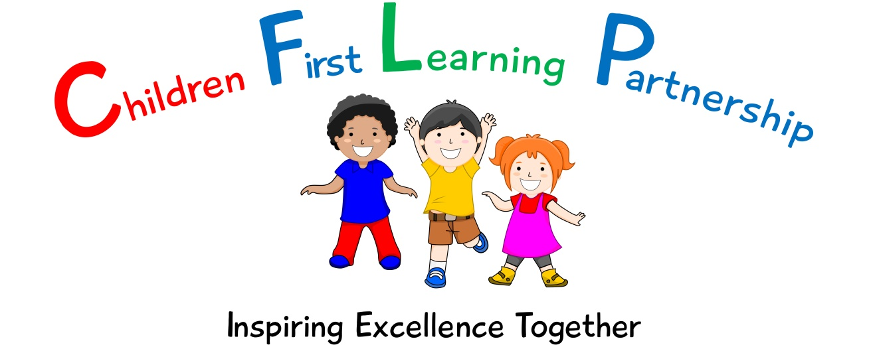

Curriculum Policy 2023

June 2025 or earlier if required
To be reviewed:
13.03.2023
Agreed and ratified by the Local Advisory Board on:
Kingsfield Headteacher- Mrs R Butler

Responsible Officer:
Mr. C Clulow
Chair of Local Advisory Board:
The Curriculum Policy in respect of the Children First Learning Partnership has been discussed and adopted by the Local Advisory Board

Please read this policy in conjunction with our individual subject specific policies and the Teaching and Learning Policy

Introduction

At Kingsfield First School we define the curriculum as the coherent and integrated offer we provide to our children from the coverage of the EYFS and National curriculums to the opportunities we provide both explicitly and intrinsically via our strong community based ethos by encouraging children to develop their unique personalities and to act as respectful, responsible, confident, tolerant well-mannered and caring individuals. We believe that the curriculum is a powerful tool that promotes a love of learning and willingness to explore, provide the time to have fun, promote equality and also a sense of wonder at the world we live in.

We are continually reviewing and adapting the curriculum we offer to our children. The curriculum at Reginald Mitchell is evolving according to the needs of our children and to the aspirations of the local and national community in which we live.

Our Curriculum Intent
The intent of our curriculum is based on the context of our school and the needs of our pupils. We believe there are 5 clear and fundamental aims:

- Recognise our uniqueness
- Be Inclusive
- Engage and Inspire
- Promote Aspiration
- Create Citizens of the Future

The rationale for our choices and priorities to achieve them are listed below and are reflected in our individual subject specific intentions. (Please refer to our individual subject specific policies alongside this policy for further information)

Kingsfield First School
Curriculum Intent

Our Key Curriculum Intentions are to: | By Promoting | Rationale
Recognise our Uniqueness  Built in 1908, Kingsfield First School is at the heart of the Biddulph town centre. Generations of families have attended the school and we are very much working in partnership with our local community. Working together with our stakeholders allows us to become stronger and achieve the best outcomes for all pupils. The success of the school is built on the strong relationships between staff, parents & carers, other schools, outside agencies and local visitors.  Our wealthy school environment consisting of woodland areas, sports fields, computer suite, music room, cookery room, library, outdoor adventure trails, and generous teaching rooms provides a rich variety of opportunities for our Nursery to Year 4 children. Together with our dedicated staff who strive to provide a welcoming, happy and secure place where children will flourish, is what makes Kingsfield unique. Our pupils leave us as responsibly, achieving individuals and they then head off together of our two local Middle Schools in Biddulph. | Oracy | A growing proportion of our pupils enter school with poor oracy and a range of speech and language issues. We recognise the need for children to have a wide vocabulary, understand what words mean and use them in the correct context in an age-related manner.
 | Pupil well being | Our children come from a diverse economic background. We work hard to develop children’s resilience, social and emotional attributes to support with diverse pressures that they sometimes face.
 | Evidenced based practice | We recognise the risks of being an inward facing organisation and value the use of active research both across our MAT and that being carried out by a wide range of sources such as the EEF, local research school and teaching school in both improving and selecting practice and approaches for future innovation.
 | Parental involvement | Serving families with a diverse economic demographic parents can be hard to reach for different reasons. Working closely with our parents does make a difference to outcomes for our pupils and the well-being of their families. We work hard to establish and maintain these links and continually review accessibility, participation and the impact of the work that we do to support our children.
 | Learning Outdoors | Our school has a wealth of outdoor learning resources which we use to engage, enthuse and bring learning to life.
Be Inclusive  All lessons have the same high expectations for all pupils. Achievement in all subject areas is tracked and our progressive curriculum ensures pupils gain a deep understanding and embedded key skills. We recognise that children have different family backgrounds, different starting points and strengths and we ensure the support is in place, to gain maximum pupil fulfilment for all children.  Successes within lessons are celebrated, as too are pupil achievements outside of school, along with school events such as the choir’s performance. We recognise that our pupils have a range of interests and we endeavour to provide opportunities that identify and show case them through lessons, partnership school events and clubs. | Ambition for all | Our SEN and PP pupils are a significant group who are closely monitored and supported. Our curriculum and extended school opportunities ensure access to learning, challenge and experiences are there for all pupils. We focus on the effective deployment of resources, innovative and reflective practice and strong subject knowledge.
 | External agencies | We ensure our staff actively seek out a range of expertise beyond our school and multi academy trust to provide advice, support and resources to unlock potential barriers to learning for our pupils and their families in all areas of the curriculum.
 | Bespoke provision | Every child is unique and this can mean through our in-depth knowledge of our pupils we have to adapt/adjust our curriculum provision in order for them to access the curriculum that they are entitled to. As a school with some mixed aged classes this is paramount to ensure all our pupils build on their prior knowledge and make good progress from their starting points.
 | Varied teaching styles | Through reflective practice and strong subject knowledge our teachers and teaching assistants are flexible and adaptable in their teaching approaches and respond to children’s learning styles to ensure effective subject delivery.
Engage and Inspire  We aim to ignite interest and inspire future dreams. This we achieve through a topic-based curriculum that drives standards in the core and non-core subjects. Teachers, alongside Subject Leaders have developed a progressive, engaging curriculum which drives learning, imparts knowledge and embeds skills. Entwined through this are carefully planned trips, guest visitors, enrichment days, clubs, forest schools, community events and partnership school activities all of which provide pupils with a variety of experiences to unlock new talents, make strong connections to embed learning, gain knowledge and deepen their verbal communication. | Themes and key questions | We recognise that cognitive development and the acquisition of new knowledge by our pupils is deepened by making links between new and prior learning, creating a clear context and ensuring skills can be deepened, applied and built upon.
 | Enrichment | We believe pupils learn best if they have a context and reason to do so. We aim to provide a context via a range of enrichment experiences to ignite and bring learning alive for our pupils in all areas of the curriculum including those beyond the core subjects.
 | Knowledge Rich | Our curriculum recognises the vital need to impart knowledge, both disciplinary and substantive in an accessible way to our pupils including via the use of subject specific vocabulary, providing time to secure and explore it in order to make links and aid retention.
 | Progressive curriculum | Our curriculum has been purposefully designed to be sequential and progressive, made up of key components that lead to an end composite. As a result, pupils make connections, embed and apply knowledge ensuring they ‘know more and remember more’ over time.
Promote Aspiration  Pupils work in partnership with staff to drive learning outcomes in response to marking and dialogue. Achievement is celebrated through classroom and whole school strategies. Alongside academic achievement Kingsfield also promotes pupils leaderships qualities through a variety of roles thus developing aspiration for all children. | Celebrate success | We celebrate key aspects of achievement effectively and regularly. This will encourage children to work hard and achieve their very best.
 | Characteristics of Effective Learning | Children need to have a thirst to learn and be ready to learn. Our curriculum and the organisation of our resources will provide opportunities to develop a range of skills such as being resilient, taking risks, an effective team player, independence and the ability to be reflective. Our classrooms are organised to support pupils’ in developing a range of metacognitive strategies through working walls, ‘metacognition Magician Stations and Kingsfield Characteristics lanyards etc.
 | Challenge at all levels | We recognise the entitlement all our pupils have to access high quality learning opportunities. We use assessment for learning highly effectively to ensure learning is flexible, responsive and involves pupils at all times. We deliver a mastery approach and ensure appropriate challenge and scaffolding is in place to cater for all pupils’ needs including SEND and the lowest 20%.
 | Accountability for learning | We believe that children should be active participants in their own learning and subsequent progress, as a first school our pupils need these attributes to support transition to our local middle schools.
Create Citizens of the Future  At Kingsfield we nurture and grow individual children, whose personalities are unique, valued and respected by all. We believe that personal qualities, combined with talents and academic achievement provide for a well-rounded, balanced pupil to succeed and achieve their future prospects. Developing a strong moral compass where pupils have a sense of responsibility is key to developing confident, independent citizens. Strategies to achieve this include class leadership roles such as the class “Super Friend,” school council representative and the Eco Warrior to name a few. We also use emotion boards, worry monsters, nurture-based groups, peer mentors, monitors, links within the local community, team work, staff training and work with outside professionals to provide any specialist support. | Celebrate difference | As a predominantly white British school we recognise the importance of providing our children and their families with the knowledge and skills to be aware of different faiths, religions and races as well as ensuring our curriculum embraces difference across our school community.
 | Healthy relationships | It is our moral duty to ensure children are kept safe whilst in our care and can also keep themselves safe within their home, community, online and in school.
 | Promoting democracy | We promote pupil and parental involvement in the future development of our school, its policies and procedures. We believe this ownership strengthens relationships and embeds all that we value and wish to achieve.
 | Respect and Responsibility | We have the very highest expectations for our pupils in relation to their behaviour, conduct and involvement in their own learning. This promotes a culture of learning in a warm, supportive and respectful environment. As our pupils move to a new school at the end of year 4 these skills and attributes all contribute to a successful transition.

Curriculum Drivers
Our curriculum intent recognises the acquisition of key knowledge alongside the development of range of subject specific skills.
At Kingsfield First School we intend to promote and plan for the development and use of the 4 curriculum drivers (Communication, Evaluation, Create & Problem Solving) in all that we do to enhance engagement, deepen learning, develop key life skills and raise attainment for all:-

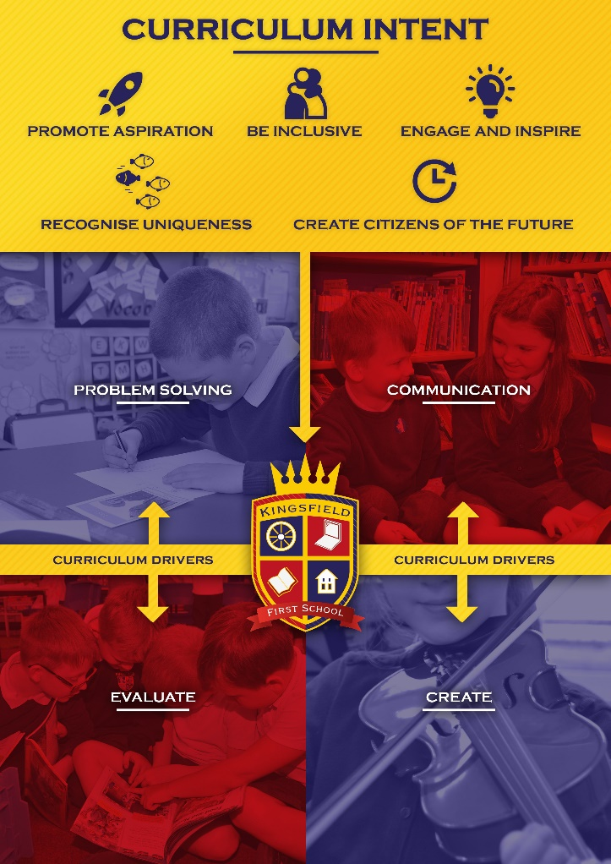

Communication | Evaluate | Create | Problem Solving
Focus for Development in the Early Years
Respect |  | Explore | Inquisitive
Taking turns |  | Imagination
Listening
Focus for Development in KS1
Tolerance | Self-driven | Responsive | Team work
Good Understanding | Open minded | Open minded | Challenge
Vocab rich | Confident | Inquisitive | Adaptable
Co-operation | Resilience | Independence | Reasoning
Confidence | Reason | Individuality | Perseverance
Compromise | appreciation | Adaptation | Interest
Ask questions | Optimism | Inspired | Drive
Patience |  | Experience | Acceptance
Body Language |  | Resilience | Communication
 |  |  | Application of skills
Focus for Development in KS2
Articulate | Objectively acceptance of praise/criticism | Learn from mistakes | Logic
Accept others' opinion | Balance view | Resourceful | Methodical
Awareness of audience | Reflective
Empathy | Empathy
Debate

What do we teach?

The provision we offer is guided by the requirements of the EYFS Curriculum, National Curriculum and the requirements of the Local Authority Agreed Syllabus for RE.
Our provision takes into account every aspect of a child’s development. The curriculum gives all of our children the aspiration and opportunity to achieve the highest possible standards in all subject areas. We recognise that reading is the key to unlocking our curriculum and a high emphasis is placed upon it from the moment a child arrives at our school. To enable our children to develop socially, morally, physically, emotionally and spiritually, we provide stimulating learning environments in which children are encouraged to learn how to learn through their own experiences and apply their knowledge independently. Within this framework of both a broad and balanced curriculum, our planning and progression documents ensure that our curriculum suits the needs of all pupils in school where lessons are practical in real-life contexts where possible to provoke curiosity we want our children to have in order to fully engage in our exciting curriculum. The individual needs of each child are met through well planned and varied learning activities, including visits, workshops and specialist tuition.

Teaching for depth of learning
At Kingsfield First School, our progressive curriculum has been carefully designed, organised and planned to ensure that our children are not merely covering the statutory content of the EYFS and National Curriculum but achieving a depth of learning through the widening and deepening of essentials knowledge and skills thus allowing these to be used across all areas of the curriculum. Within our curriculum, we build in many opportunities for repetition and practise to ensure that children are able to revisit previous learning, which allows them to gradually develop and build upon this to achieve a clear depth of understanding. This includes time to teach subject specific language and time to use such language in the correct context.

Teaching for a breadth of learning
At Kingsfield First School, we carefully design, plan and implement our curriculum to provide balance across areas of learning to allow for children to develop both academically, personally and socially. It is part of our underlying belief that every child should feel valued and experience feeling success in a wide range of curriculum areas as responsible and resourceful pupils who reflect on their learning, building resilience and taking risk whilst understanding that we learn from our mistakes. In addition to this we want to ensure that our children build and develop and maintain strong relationships.

Furthermore, we place high priority on ensuring children’s physical and mental wellbeing are met. We understand that children will not be successful learners unless they are emotionally secure, therefore we adopt a flexible approach through the effective use of assessment for learning techniques so that we can meet and respond to the needs of our pupils both in advance via prior learning opportunities and in the moment during our learning pathways via effective questioning, learning facilitation and the informed and timely use of a wide range of resources and learning prompts.

Our balanced curriculum is not at the expense of high standards in core subjects in fact we believe the more curriculum breadth and depth we offer our pupils the wider range of knowledge and skills they will have to achieve high standards. Our cross curricular approach to learning ensures that high standards and expectations of our children’s work and outcomes are consistent across all areas of their learning.
Our full, rich and varied curriculum, with its excellent range of experiences, ensures that every pupil at Kingsfield First School makes excellent progress both academically and personally. It is unique to our school and allows our children to flourish.

Teaching for knowledge, understanding and skills

Our subjects are taught discreetly through themes and key questions which may last a half term or term so that our children are aware of the many subjects within our curriculum and the skills within these (both subject specific and transferable), alongside knowledge and understanding. Our themes and key questions have been selected based on their ability to enthuse and motivate our pupils alongside the need to create a cohesive long term plan which utilizes our school resources and local contexts effectively. We plan very carefully to always ensure there are purposeful links to interweave subjects where it naturally fits. This ensures that planning and learning is sequenced appropriately to help support understanding and for progression and to allow children to be able to obtain knowledge whilst applying the skills necessary and vice versa. This is done through our unit pathways and non-negotiables for lessons, all written individually by leaders for their subjects areas.

Our intent is to ensure that our children develop the knowledge and understanding needed in what we must cover statutory from the EYFS and National Curriculum as a starting point, but to also take their learning deeper to ensure it has ‘stickability’. Alongside the knowledge and understanding, are the many subject specific and transferable skills we teach. We recognise the need for children to both know and remember what they have taught in order for longer term memory gains to occur and transferability and recall to be achieved.
Beyond the Classroom

We are fully committed to providing the children with a wide and rich range of learning experiences beyond the classroom and this is based on the resources we have and the needs of our children.
20% of our pupils are those most disadvantaged. Due to this, offering pupils those opportunities to develop a ‘cultural capital’ and context to learn is vital to ensure engagement can be higher and knowledge can be grasped first hand. We also want to open our pupil’s eyes to the world beyond their community, raising aspiration and an inquisitiveness to explore and gain a thirst for future knowledge.

Educational Visits
We build opportunities for children to visit museums, galleries, theatres, parks, places of worship and historical landmarks. Not only do our children regularly explore our local area, visiting places such as the library for special events and residential home, we also take full advantage of the wealth of our local heritage. We expect that all children will participate in all educational visits as it links and enhances their classroom learning.

Specialist Visitors and Projects
Artists, musicians, authors, religious leaders, sports coaches and theatre groups frequently visit our school to work with children, providing specialist support in developing new skills. We also introduce swimming lessons in Year 1, where we use the facilities of Knypersley First School with whom we are federated with and is one of our multi-academy partners. Such lessons are taught by a swimming coach. A forest schools programme is also integrated throughout the year for all classes including Nursery, here learning is linked to themes/key questions to deepen knowledge as well as developing key skills. The programme of forest schools is delivered by a specialist forest schools teacher in conjunction with our staff.

School Residential
We feel it is important that children experience a residential as part of their learning experience to help in their personal and social development. Children get the opportunity to experience this in Year 4. Parents pay a contribution towards the cost of these.

Extra-Curricular Activities
We are committed to developing the whole child. We extend the curriculum by offering a wide range of extra extra-curricular activities, including: sporting clubs, crafts, choir, maths, and drama. Such clubs are delivered by both specialist coaches and school practitioners. We are also the key host school for the HAF holiday programme which provides support for the whole family and is inclusive for both the working and disadvantaged families.

The role of the Headteacher
-provides strategic lead and direction for the curriculum ensuring it matches the school intent and planned implementation.
-supports and offers advice and challenge to colleagues on issues related to their subject
-provides appropriate subject specific CPD
-provides efficient resource management
-(alongside subject leaders) monitors how their subjects are taught through monitoring the medium and short term planning and ensuring that appropriate teaching strategies are used
- ensure evidence of the impact of the curriculum intent is gathered effectively and used to inform future actions.

The role of the Subject Leader:

Within the school’s organisation, each class teacher takes on the responsibility for leading a subject area. It is the role of the subject leader to:
- Provide a clear and relevant vision for their subject intent and implementation
-keep up to date with developments in their key area of learning both at local and national levels
-review the way the subjects are taught in the school and plan for improvement linking to whole school priorities
-monitor how their subjects are taught through monitoring the medium and short term planning
-lead improvement though supporting colleagues
-review curriculum plans for their key areas ensuring there is full coverage of the National Curriculum and that a coherent and progressive gain in knowledge and skills is planned for
-oversee the mechanism and analysis of the impact of their subject provision within the whole school curriculum
-audit, order and manage resources to enhance learning experiences for the pupils

Monitoring and Review

Our Local Advisory Board Curriculum Link Governor and Children First Learning Partnership Curriculum Champion are responsible for monitoring the way the school curriculum intent is implemented and the impact it has on pupil outcomes. This may be through the analysis of data, the impact of CPD, pupil voice or by scrutinising the monitoring findings and actions of the Headteacher and subject leaders.

The Headteacher is responsible for the day-to-day organisation of the curriculum and monitors the curriculum through planning, classroom observation, liaising with the Subject Leaders and School Leadership Team.

Subject leaders monitor the way their subject is taught throughout the school ensuring their planned intent is implemented resulting in a clear and positive impact. They examine long-term and medium-term planning, and ensure that appropriate teaching strategies are used. Subject leaders have responsibility for monitoring standards and ensuring that teachers have the skills and resources they need.

REVIEW

Unless the need arises before this date, the Local Advisory Board will review this policy every 2 years via the Local Advisory Board Summer 1 meeting, modify or amend it as it considers necessary to ensure the policy meets the needs of The Kingsfield First School.

