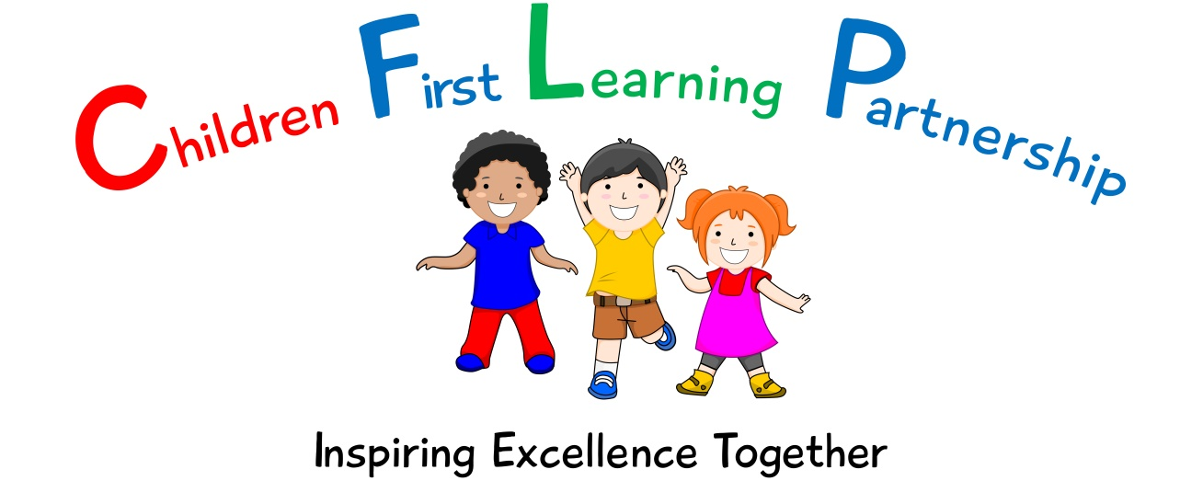

Spelling Policy for

Kingsfield First School

2023



*February 2024*

*To be reviewed:*

*________________*

*Agreed and ratified by the Local Advisory Board on:*

*Head Teacher – Mrs R Butler*

*Responsible Officer:*

*Mr. C. Clulow*

*Chair of Local Advisory Board:*

*The CFLP English Policy in respect of the Children First Learning Partnership has been discussed and adopted by the Local Advisory Board.*

**Kingsfield First School Primary School**

**Spelling Policy 2023**

The overall intent of our school curriculum is to:

**Recognise uniqueness**: in our pupils, staff, resources and whole school community.

**Be Inclusive:** recognising learning styles, learning needs at all levels and providing solutions to any barriers to learning we encounter.

**Engage and Inspire:** through knowledge rich, highly enriched, progressive and purposeful contexts.

**Promote Aspiration:** offering challenge, accountability and responsibility for their learning.

**Create citizens of the Future:** who thrive on responsibility, see difference as a strength of our community and use democracy to embed their own values and beliefs.

Our English curriculum strives to drive all of these intentions and links very closely to the achievement and development of them all.

**Intent**

Our challenging and creative English curriculum aims to enable all pupils to achieve ambitious levels of literacy. Children are provided with an exciting and innovative curriculum which promotes a love of reading and a belief that everybody is an author.

Children are exposed to high quality literature to inspire their own writing and to model engaging uses of the English language. Through the critique of these texts, children develop their oral comprehension skills. Imagination and originality are nurtured through exploration, discussion and drama. Spelling, punctuation, grammar and phonics teaching ensure that children have the skills and confidence to develop their writing style across a range of genres and in varied contexts.

We recognise the importance of communication and language development in achieving academic success in English. Therefore, oracy is at the heart of our curriculum. Children are immersed in a language rich curriculum that intends to give all pupils an extensive vocabulary and oral proficiency.

**Implementation**

We use the **National Curriculum** programmes of study for Spelling and the Rising Stars half termly overviews as detailed in our spelling progression document (see English webpage) to determine the content of coverage in each year group.

Discreet spelling lessons are taught daily in years 2-4 using the following format:

Review

Revisit

Teach

Apply

Fast five (this can be spelling pattern or common exception word focused)

Within these lessons a range of spelling strategies are used (see appendix 1).

Spellings are explored, taught and practised regularly and are commented upon during marking conferences and live facilitation to ensure our high expectations are met. Children have a mixture of CEW and spelling patterns to learn on a weekly basis.

Weekly challenges are set on the online platform Spelling Shed to reinforce the spelling rule or pattern of the week. This provides the children with the opportunity to reinforce their learning at home.

Pitch, Pace and Challenge

Across the Children First Learning Partnership the expectation is that the majority of children will move through the spelling progression at broadly the same pace. However, decisions about when to progress will always be based on the security of children’s understanding and their readiness to progress to the next stage.

Inclusivity

Those children that are working significantly below their year group expectations will be exposed to the spellings which are at the appropriate level for them and where appropriate links to their PLP targets.

**Impact**-

What we aim to achieve from our English curriculum across the Children First Learning Partnership;

* Children will be able to use a range of spelling strategies.
* Children will be able to apply the spelling rules in their independent writing.
* Children will be use common exception words correctly in their writing.
* Children will have a confident, positive attitude towards their spelling.

**Assessment** -

Our impact will be measured by using both formative and summative assessment.

Formative

Assessment is not just used to track children’s learning through the use of assessment trackers but also provides teachers with up-to-date and accurate information about the specifics of what children do and do not know. This information allows teachers to adapt their teaching so it builds on children’s existing knowledge and focuses on the next steps that they need in order to make progress.

Staff will facilitate to ensure that misconceptions are dealt with immediately and high attaining children are challenged appropriately. Our staff are highly skilled to provide a personalised and flexible curriculum for individual children that may need reasonable adjustments. These adaptations increase access to the lesson content, enabling them to reach their full potential.

Effective marking and feedback within English lessons, make direct links to the spelling lessons. This may be given either orally during live marking or in written format during a marking conference.

Summative

As part of our assessment and to support teacher’s judgements, each class will undertake a half termly formal assessment of SPAG and phonics. This is analysed and evaluated half termly by English leaders and acted upon quickly to direct CPD, resources and support to help pupils to overcome barriers to learning or from reaching their full potential.

**Role of Leaders**

* Plan an effective and varied schedule of monitoring including moderation, which is triangulated through our internal school, leader and triad moderation, so that the Quality of Education in English is embedded throughout the school and the CLFP.
* Respond quickly and in a supportive manner to overcome barriers to implementation and impact.
* Use assessment information to provide effective CPD and challenge.
* Provide clear updates to the Local Advisory Board, Head Teacher and SLT.



Appendix 1

