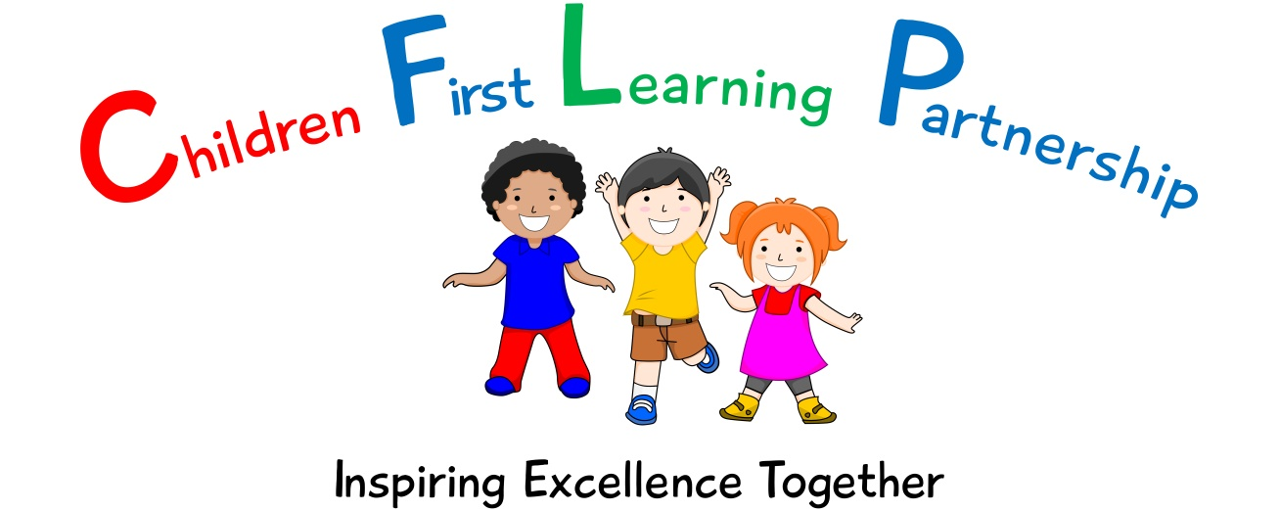

English Policy 2023

May 2025 or earlier if required
To be reviewed:
________________
Agreed and ratified by the Local Advisory Board on:
Head Teacher – Mrs R. Butler

Responsible Officer:
Mr. C Clulow
Chair of Local Advisory Board:
The CFLP English Policy in respect of the Children First Learning Partnership has been discussed and adopted by the Local Advisory Board.

Kingsfield First School
English Policy 2023
(To be read in conjunction with the school handwriting, spelling & phonics policies)
The overall intent of our school curriculum is to:
Recognise uniqueness: in our pupils, staff, resources and whole school community.
Be Inclusive: recognising learning styles, learning needs at all levels and providing solutions to any barriers to learning we encounter.
Engage and Inspire: through knowledge rich, highly enriched, progressive and purposeful contexts.
Promote Aspiration: offering challenge, accountability and responsibility for their learning.
Create citizens of the Future: who thrive on responsibility, see difference as a strength of our community and use democracy to embed their own values and beliefs.
Our English curriculum strives to drive all of these intentions and links very closely to the achievement and development of them all.
Intent
Our challenging and creative English curriculum aims to enable all pupils to achieve ambitious levels of literacy. Children are provided with an exciting and innovative curriculum which promotes a love of reading and a belief that everybody is an author.
Children are exposed to high quality literature to inspire their own writing and to model engaging uses of the English language. Through the critique of these texts, children develop their oral comprehension skills. Imagination and originality are nurtured through exploration, discussion and drama. Spelling, punctuation, grammar and phonics teaching ensure that children have the skills and confidence to develop their writing style across a range of genres and in varied contexts.
We recognise the importance of communication and language development in achieving academic success in English. Therefore, oracy is at the heart of our curriculum. Children are immersed in a language rich curriculum that intends to give all pupils an extensive vocabulary and oral proficiency.
Implementation
We use the National Curriculum programmes of study for Reading, Writing, Spelling, Grammar and Punctuation. We ensure that basic literacy skills are entwined through our text based units and the wider curriculum.

Reading is an integral part of school life. We value reading and we have a reading core offer which is embedded within our everyday school practice. Our school follows Little Wandle Letters and Sounds Revised to teach phonics and early reading. This progressive scheme enables the children to become fluent and comprehensive readers by the end of Year 1. (Please see separate phonics policy). The teaching of reading is delivered through individual, group and whole class teaching sessions using challenging texts to apply new skills and knowledge taught. (Please see Appendix 1 for our Reading band Phase 1, 2, 3, 4 & 5 (EYFS / Y1) Book Band Colours Y2 - 4)
Reading for Pleasure
Our children deserve a rich curriculum that encourages a love of literature. All classes share books (in their entirety where possible) and are given access to a wide range of texts across different subjects. We believe that active encouragement of reading for pleasure is a core part of every child's educational entitlement, because we know that extensive reading and exposure to books makes a huge contribution to children’s vocabulary, understanding and subject knowledge. Reading is promoted through the use of our school libraries, class reading areas and whole school assemblies.
Spellings are explored, taught and practised regularly and are commented upon during marking and live facilitation to ensure our high expectations are met. Children have a ‘Fast Five’ of CEW and spelling patterns to learn on a weekly basis.
Writing
The progression documents show progression of writing skills across the school. At the Children First Learning Partnership children are taught a range of genres to embed the basic skills across the curriculum.
Lessons are planned from the correct year groups Programmes of Study from The National Curriculum. Teachers will be aware of the prior learning that needs to be secure from previous year groups to ensure new content can be understood. The progression documents are then broken down into smaller steps to ensure lessons are driven by sharp learning objectives that are progressively linked. We use our flow of writing (See Appendix 3) to support the learning process and to practise and embed new skills and knowledge in the different genres.

Individual lessons are carefully designed using the most effective teaching materials, so that pupils are given the best opportunities to show their understanding. Variation is consciously built in by teachers, so that pupils can apply their learning to different genres and make cross curricular links.

We use Penpals handwriting scheme throughout school. Staff teach the formation of letters specifically in the EYFS/ Y1 (& SEN) alongside phonics, saying a rhyme to aid memory and follow Little Wandle Letters and Sounds Revised supported by teaching handwriting through Penpals Scheme for letter formation and joins (lead out).

English Language
Across the Children First Learning Partnership we understand that the English technical language is crucial to children’s thinking. So we introduce new words from the curriculum through text based units and WAGOLLs. Key vocabulary used in a text based unit/genre are displayed on the English working walls.
In lessons children work in a variety of ways including pairs; whole class, groups and individually. Children work together so that through their dialogue they can develop a much stronger understanding.

All adults model the correct use of technical language and insist pupils do the same, including correct use of standard English language.

Pitch, Pace and Challenge
Across the Children First Learning Partnership the expectation is that the majority of children will move through the units at broadly the same pace following a Mastery Approach. However, decisions about when to progress will always be based on the security of children’s understanding and their readiness to progress to the next stage. Children will be taught analytical strategies which helps the children comprehend unfamiliar content.
Editing

Pupils are encouraged to develop a ‘have a go’ attitude and are comfortable with making mistakes, as they are seen as part of the learning process. Children have the opportunity to edit and improve their work.

Basic Skills
Embedding of basic skills within reading and writing and will enable pupils to accelerate their learning and close any gaps. Children requiring further support, will be scaffolded in a variety of ways during lessons, including the use of word mats, talking tins, adults and accessing the classroom metacognition stations.
Inclusivity
All children are exposed to their year group age related expectations in a keep up approach through the mastery format. Those children that are significantly working below their year group expectations will be exposed to learning which is at the appropriate level for them and where appropriate links to their PLP targets.
Impact-
What we aim to achieve from our English curriculum across the Children First Learning Partnership;
- Children will have a love of reading and a belief that everybody is an author.
- Children will have creative minds and build imagination and originality.
- Children will be secure in basic skills including SPAG and phonics.
- Children will have an extensive vocabulary and oral proficiency.
- Children will read and write for pleasure.
- Children will work collaboratively and independently to share ideas.
Assessment -
Our impact will be measured by using both formative and summative assessment.
Formative
Assessment is not just used to track children’s learning through the use of assessment trackers, but also provides teachers with up-to-date and accurate information about the specifics of what children do and do not know. This information allows teachers to adapt their teaching so it builds on children’s existing knowledge and focuses on the next steps that they need in order to make progress.
Within the Children First Learning Partnership, assessment in English is continuous. From the beginning of every lesson, teachers and teaching assistants will be assessing prior knowledge through assessment for learning to identify the current stage and next steps in learning. Staff will facilitate to ensure that misconceptions are dealt with immediately and high attaining children are challenged appropriately. Our staff are highly skilled to provide a personalised and flexible curriculum for individual children that may need reasonable adjustments. These adaptations increase access to the lesson content, enabling them to reach their full potential.
Effective marking and feedback are an important element of teachers and TAs responses to children’s learning. This may be given either orally during live marking or marking conference, but is always:
- specific, accurate, and clear
- celebrates success
- compares what a pupil is doing right now with what they have needed to improve before
- provides specific guidance on how to improve as their next step
Summative
As part of our assessment and to support teacher’s judgements, each class will undertake a half termly formal assessment of SPAG and phonics. This is then analysed and evaluated half termly by English leaders and acted upon quickly to direct CPD, resources and support to help pupils to overcome barriers to learning or from reaching their full potential.
Role of Leaders
- Plan an effective and varied schedule of monitoring including moderation, which is triangulated through our, in school moderation, English leader and Triad moderation, so that the Quality of Education in English is embedded throughout the school and the CLFP.
- Respond quickly and in a supportive manner to overcome barriers to implementation and impact.
- Use assessment information to provide effective CPD and challenge.
- Provide clear updates to the Local Advisory Board, Head Teacher and SLT.

Version | Review Date | Changes Made
V3 | 12.01.23 | In conjunction with… phonics policy
 |  | Reading – Our school follows Little Wandle Letters and Sounds Revised to teach phonics and early reading. This progressive scheme enables the children to become fluent and comprehensive readers by the end of Year 1. (Please see separate phonics policy).
 |  | Writing - We use Penpals handwriting scheme throughout school. Staff teach the formation of letters specifically in the EYFS/ Y1 (& SEN) alongside phonics, saying a rhyme to aid memory and follow Little Wandle Letters and Sounds Revised supported by teaching handwriting through Penpals Scheme for letter formation and joins (lead out).
 |  | Pitch, Pace & Challenge - Across the Children First Learning Partnership the expectation is that the majority of children will move through the units at broadly the same pace following a Mastery Approach
 |  | Basic Skills - Children requiring further support, will be scaffolded in a variety of ways during lessons, including the use of word mats, talking tins, adults and accessing the classroom metacognition stations.
 |  | Summative - As part of our assessment and to support teacher’s judgements, each class will undertake a half termly formal assessment of SPAG and phonics. This is then analysed and evaluated half termly by English leaders and acted upon quickly to direct CPD, resources and support to help pupils to overcome barriers to learning or from reaching their full potential.
 |  | Inclusivity (New) - All children are exposed to their year group age related expectations in a keep up approach through the mastery format. Those children that are significantly working below their year group expectations will be exposed to learning which is at the appropriate level for them and where appropriate links to their PLP targets.
 |  | Appendix 1 – Updated for Little Wandle
 |  | Appendix 2 – Removed (Little Wandle Scheme now followed) and appendixes renumbered.
 |  | Appendix 4 changed to fit in with Penpals Handwriting Scheme.

Appendix1 Guide to Reading Levels
 |  |  |  | End of year expectation
Little Wandle Phase Band | Book Band |  | On track expectation | Rec | Year 1 | Year 2
Foundation Level | Lilac |  | Reception, Autumn 1
Phase 2, set 1 | Pink 1 |  | Reception, Autumn week 3/4 & Autumn 2
Phase 2, set 2 | Pink 1 |  | Reception, Autumn 2
Phase 2, set 3 | Pink 2 |  | Reception, Autumn 2
Phase 2, set 4 | Pink 2 |  | Reception, Spring 1
Phase 2, set 5 | Pink 2 | Red 1 | Reception, Spring 1
Phase 3, set 1 | Red 1 |  | Reception, Spring 2 | REC ELG
Phase 3, set 2 | Red 2 |  | Reception, Summer 1 |  | Year 1 BLW
Phase 4, set 1 | Yellow |  | Reception, Summer 2 |  | Year 1 BLW
Phase 4, set 2 | Blue |  | Year 1, Autumn 1 |  | Year 1 WTS
Phase 5, set 1 | Blue |  | Year 1, Autumn 2 |  | Year 1 WTS
Phase 5, set 2 | Blue | Green | Year 1, Spring 1 |  | Year 1 WTS
Phase 5, set 3 | Green |  | Year 1, Spring 2 |  | Year 1 WTS | Year 2 BLW
Phase 5, set 4 | Orange | Turq | Year 1, summer 1 & 2 |  | Year 1 ARE | Year 2 WTS
Phase 5, set 5 | Turq | Purple | Year 2, Autumn 1 |  | Year 1 GD | Year 2 WTS
 | Purple |  | Year 2, Autumn 2 |  | Year 1 GD | Year 2 WTS
 | Purple | Gold | Year 2, Spring 1 |  |  | Year 2 WTS
 | Gold |  | Year 2, Spring 2 |  |  | Year 2 ARE
 | White |  | Year 2, Summer |  |  | Year 2 ARE
 | Lime |  |  |  |  | Year 2 ARE+/GD
 | Copper |  |  |  |  | Year 2 GD
 | Topaz |  | Year 3S
 | Ruby
 | Emerald
 | Sapphire |  | Year 4S
 | Diamond
 | Pearl (Free)

Note – this offers a guide to help your judgements, when selecting your teacher assessments. This table matches the level of reading required to meet the National Curriculum objectives for Word Reading (KS1) and the ELG for EYFS. The term-by-term expectation should help to see who is on track to meet expectations at the end of the year.
In KS1 - You must also consider the NC objectives for Comprehension. If a child can read these levels fluently, they may meet the word reading objectives, but if they do not meet the descriptors for comprehension, they cannot be deemed to be at this level.

Appendix 2 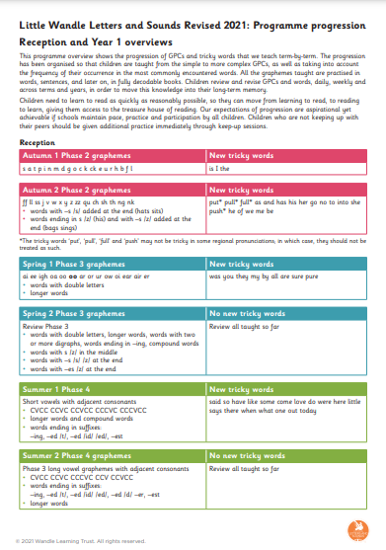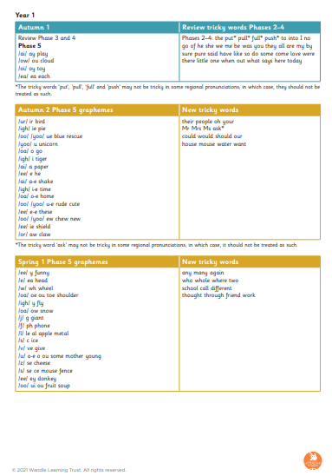
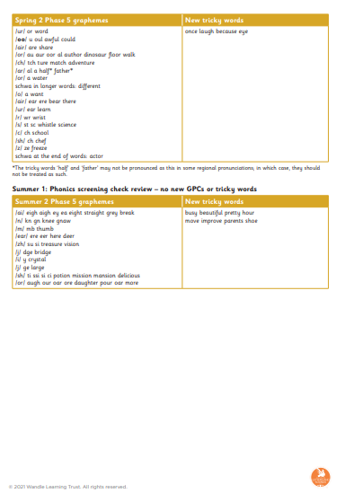

Appendix 3
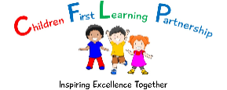
Flow of writing

Prior Learning | Explore | Develop | Dazzle Me
- List the features  - Sorting activity – sentences, extracts  - Spider diagram  - Comparison of two texts – Non-fiction, fiction  - Cold write  - Odd one out – Which one is the letter?  - Tense of language  - Bad WAGOLL – Spot the mistakes | - Identify features, highlighting  - WAGOLLs  - Drama – hot seating, conscience alley, retell role play, small world re-enactment  - Story mapping  - Sequencing  - Freeze framing  - Piecing together | - Planning  - Skills and sentences  - Writing elements of the genre  - Exploring skills  - Writing a full piece of genre – retells, twists, own versions  - Up-level/improve group/teachers version  - Guided writing | - Edit,  - Redraft  - Up-level language – thesaurus, word bank, resources  - Up-level spellings – dictionaries, zap its  - Peer assessment  - Self-Assessment against criteria

Appendix 4

