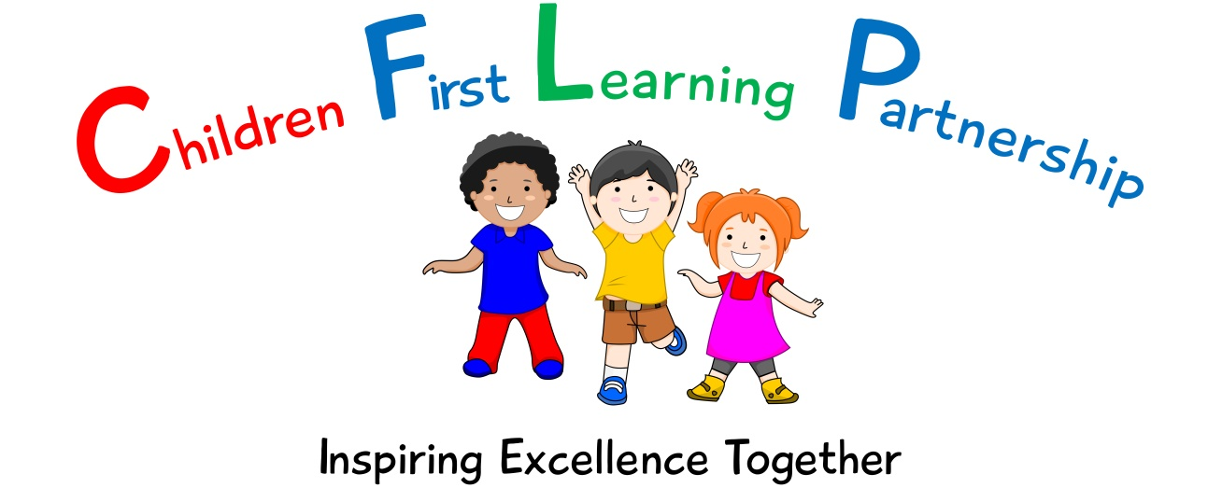

Handwriting
Policy 2022

May 2024 or earlier if required
To be reviewed:
_____________
Agreed and ratified by the Local Advisory Board on:
Kingsfield Headteacher- Mrs R Butler

Responsible Officer:
Mr. C Clulow
Chair of Local Advisory Board:
The Handwriting Policy in respect of the Children First Learning Partnership has been discussed and adopted by the Local Advisory Board
Kingsfield First School Handwriting Policy
The overall intent of our school curriculum is to:
Recognise uniqueness: in our pupils, staff, resources and whole school community.
Be Inclusive: recognising learning styles, learning needs at all levels and providing solutions to any barriers to learning we encounter.
Engage and Inspire: through knowledge rich, highly enriched, progressive and purposeful contexts.
Promote Aspiration: offering challenge, accountability and responsibility for their learning.
Create citizens of the Future: who thrive on responsibility, see difference as a strength of our community and use democracy to embed their own values and beliefs.
Our English curriculum strives to drive all of these intentions and links very closely to the achievement and development of them all.
Intent
Our challenging and creative English curriculum aims to enable all pupils to achieve ambitious levels of literacy. Children are provided with an exciting and innovative curriculum which promotes a love of reading and a belief that everybody is an author.
Children are exposed to high quality literature to inspire their own writing and to model engaging uses of the English language. Through the critique of these texts, children develop their oral comprehension skills. Imagination and originality are nurtured through exploration, discussion and drama. Spelling, punctuation, grammar and phonics teaching ensure that children have the skills and confidence to develop their writing style across a range of genres and in varied contexts.
We recognise the importance of communication and language development in achieving academic success in English. Therefore, oracy is at the heart of our curriculum. Children are immersed in a language rich curriculum that intends to give all pupils an extensive vocabulary and oral proficiency.
Implementation
Year Group Expectations:
EYFS expectations:
Pupils should be taught to:
Use a pencil and hold it effectively to form recognisable letters, most of which are formed correctly.
• Use some clearly identifiable letters to communicate meaning, representing some sounds correctly and in sequence.
• Write own name and other things such as labels and captions.
• Attempt to write short sentences in meaningful contexts.

Year 1 expectations:
Pupils should be taught to:
- Sit correctly at a table, holding a pencil comfortably and correctly
• Begin to form lower-case letters in the correct direction, starting and finishing in the right place
• Form capital letters
• Form digits 0-9 & 10-20
• Understand which letters belong to which handwriting ‘families’ (i.e. letters that are formed in similar ways) and to practise these (giraffe, robot, curly caterpillar & zig zag monsters).

Year 2 expectations:
Pupils should be taught to:
- Form lower-case letters of the correct size relative to one another
• Start using some of the diagonal and horizontal strokes needed to join letters and understand which letters, when adjacent to one another, are best left un-joined
• Write capital letters and digits of the correct size, orientation and relationship to one another and to lower case letters
• Use spacing between words that reflects the size of the letters.

Years 3 and 4 expectations:
Pupils should be taught to:
- Use the diagonal and horizontal strokes that are needed to join letters and understand which letters, when adjacent to one another, are best left un-joined
• Increase the legibility, consistency and quality of their handwriting [for example, by ensuring that the down strokes of letters are parallel and equidistant; that lines of writing are spaced sufficiently so that the ascenders and descenders of letters do not touch].

Teaching and Learning Methods
• In Nursery children begin by developing their physical movement and finger manipulation through Squiggle While you Wiggle and ‘Dough Disco’ sessions. This involves using a tub of dough to roll, punch, pinch, flatten and squeeze the dough into shape whilst listening to a music track. This is continued into Reception for those children who need additional motor skills support. As the children are focussing on recognising initial sounds letter formation is modelled and supported by adults through facilitation.
• In Reception, children take part in daily letter formation practice, which is reinforced through the daily phonics Little Wandle sessions. Children in Reception also have access to Funky Fingers activities Formation station. Handwriting is taught 3x a week and then this is reinforced with the daily formation practice in the morning.
• Y1 will complete Penpals handwriting with a focus on the 4 letter formations, giraffe, robot, curly caterpillar and zig zag monsters. They also secure number formation.
Once children have a consistent style, they begin to join (following Penpals) from Y2 upwards:

To develop a clear, legible style of writing, children are taught to:
• Hold a pencil comfortably; promoting a legible style that encourages writing from left to right, from top to bottom of the page and starting and finishing letters correctly
• Develop a consistent size and shape of letters and a regularity of spacing between letters and words
• Join letters correctly (from Y2 if appropriate)
• Develop greater control and fluency as they become increasingly confident.
• Children will use the back of their English book for handwriting practice.
• As English writing is levelled and moderated, handwriting and letter formation forms part of the overall assessment.
• Day to day marking may also comment on handwriting where there is a need.

Inclusivity
Those children that are working significantly below their year group expectations will be exposed to the handwriting expectations which are at the appropriate level for them and where appropriate links to their PLP targets. They will not be expected to join their writing. Increased access to the use of word processing facilities will be made where appropriate. When appropriate children will also be given pencils designed to encourage correct pencil grip.
Impact-
What we aim to achieve from our English curriculum across the Children First Learning Partnership;
• To raise attainment and encourage a consistent approach throughout the school
• To develop correct letter formation.
• To encourage a high standard of presentational skills in all contexts when writing.
• To enable children to produce a legible, consistent and fluent handwriting style which enables the children to write efficiently in terms of speed.
• For all handwriting to be modelled effectively by both teachers and support staff throughout the school.

Role of Leaders
- Plan an effective and varied schedule of monitoring including moderation, which is triangulated through our internal school, leader and triad moderation, so that the Quality of Education in English is embedded throughout the school and the CLFP.
- Respond quickly and in a supportive manner to overcome barriers to implementation and impact.
- Use assessment information to provide effective CPD and challenge.
- Provide clear updates to the Local Advisory Board, Head Teacher and SLT.

