Monday 23rd January 2023

Dear Parents/Carers,

YOUNG VOICES 2023 TIMINGS

.

We wanted to inform you about timings of the day for our YV performance at the Manchester Arena on Wednesday 1st February 2023.

11.30am – Lunchtime

12pm – Children leave Kingsfield to go to Manchester by coach

1.30pm – Children arrive at Manchester. Choir check in

2.15pm – Whole choir rehearsal (2hrs 45)

5pm – Rehearsal ends. Tea break begins

6pm - Tea break ends. Doors open to parents

7pm – CONCERT STARTS

8.45pm – CONCERT ENDS. Schools will be dismissed a section at a time

9 – 9.15pm approx. – Children to make their way back to the coach

10.30pm approx. – Children to arrive back at Kingsfield

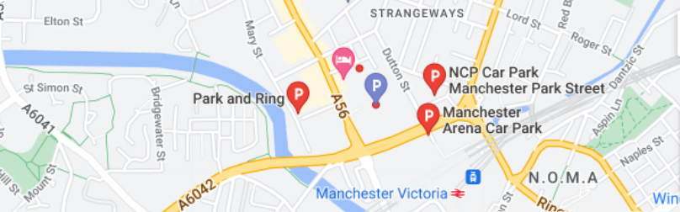

If you are travelling by car, there are several places to park as seen in the map above. The journey time from Biddulph is around 1 hour 15 minutes. It is important to consider rush hour and traffic around the arena so please give yourself plenty of time to get to the arena.

If travelling by train, as seen on the map, the nearest station is Manchester Victoria. There are trains leaving from Congleton at ten past the hour which will get you to Manchester Victoria. The journey time is 1 hour 15 minutes and includes 1 change at Manchester Piccadilly. This will be the same on the return journey. Please be aware that all children will be coming home on the coach to be collected at school.

We will eat our lunch at school. School dinners can be ordered and eaten earlier, but we ask that you all send a packed lunch for your child’s tea, in a named plastic bag, as we will be eating in the arena and there are no facilities to buy food during the rehearsals. It is also important that you send your child with 2 water bottles to last for the time we are at the arena as it can be warm and your child will need to keep well hydrated.

We will return to school at approximately 10:40pm (we will remain in contact via text) and we ask that your child is collected from outside the school front entrance. We will keep you informed about what the children are getting up to via Twitter, where we will post lots of pictures of our day.

I have been assured that the parent tickets will be at Kingsfield imminently and as soon as I have them I will arrange a time for you to collect these. The t-shirts will be available on the day of the concert so please send your child in a white t-shirt so they can wear the Young Voices t-shirt over the top. They will also need to wear normal school uniform (trousers/skirt and jumper). Please make sure the jumper is named as we will take these off for the concert.

Please return the below slip no later than Friday 27th January indicating if your child requires a hot dinner on the day of the concert.

Thank you for your continued support,

Mrs Gray

-----------------------------------------------------------------------------------------------------

My child _____________________________ in class _____

does/does not (please circle) require a hot dinner for Wednesday 1st February. I understand that I will need to collect my child from school that night at approximately 10:30pm.

Signed _______________________________ Date ________________