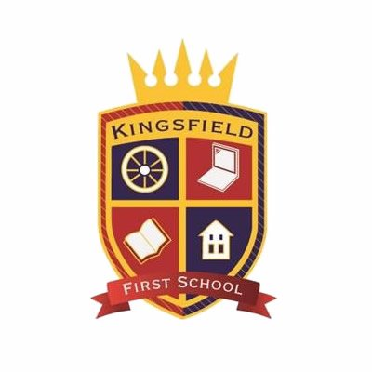**Kingsfield First School**

**School Council Minutes of Meetings**

|  |  |
| --- | --- |
| **Date:** | Friday 9th December |
| **Present:** | George, Henry, Oliver, Fearne, Max, Eden (HG), Lucas (HB), Millie and Miss Mohring |
| **Absent:** | Effie, Fletcher, Mitchell |
| **Agenda item:** | Fundraising for Kingsfield |
| **Discussed:** | The school council shared ideas from classes about what they want to raise money for.  The ideas were:   * School pet * New playhouse * Markings on the playground (for KS1) * More Christmas decorations for school * Resources for reading areas such as book shelfs, new books etc * New reading books 0 votes * Pens and pencils * Toys for lunchtime * More maths equipment * Class set of ipads (for KS2) 3 votes * More science equipment * New computers 5 votes |
| **Next steps:** | After Christmas we will meet to decide on how we will be fundraising. |