Marking & Feedback Policy

INTRODUCTION:
Within the Learning First Federation we take a professional approach to the tasks of marking work and giving feedback on it. All our children are entitled to regular and comprehensive feedback on their learning, which is an essential part of our learning process and inclusive values. We encourage all children to reflect upon their own learning and contribute to the evaluation of their work and progress. This policy is based on a wide range of research around the reduction of teacher workload from sources such as: Workload Review Group Report ‘Eliminating unnecessary workload around marking’ (WRGR, 2016), the Education Endowment Foundation report ‘A marked Improvement’ (EEF, 2016) Education Endowment Foundation’s ‘A marked improvement?’ report (Elliott et al 2016) Reducing teacher workload through ‘real-time’ personalised feedback Research report March 2018 Ruslan Protsiv, Patricia Pipola – St Patrick’s Catholic Primary School, Aquinas Teaching and Learning Trust

AIMS:
Marking and feedback should aim to:
- motivate our pupils by showing that we value their work and efforts, and encourage them to value it too;
- be meaningful to our children
- be manageable for our staff

OUTCOMES OF MARKING AND FEEDBACK IN OUR SCHOOLS:
- Promotes progress
- Extends learning and thinking
- Promotes independence and accountability

PURPOSE:
The purpose of marking children’s work and providing feedback includes the following:
- to celebrate success and/or to raise expectation of future success
- identify learning needs and key priorities for improvement, promote self and peer assessment.
- correct errors
- check knowledge, skills and levels of understanding to inform planning, inform teacher assessment and reporting to parents.

GUIDELINES:
Sometimes lots of children will benefit from a next step comment, other times, no one will. As a school, we will encourage our teaching team to use their professional judgement to decide when the right time to provide verbal feedback, written feedback, positive highlighting or when a next step comment is the right approach. It must go without saying that this judgement needs to be based on what will most positively impact that child’s progress.

Methods of feedback:
- Live, ‘in the moment’ feedback from teacher/TA during a lesson- whole group, whole class and individual. This may take the form of:
- Teacher/TA verbal comments during a lesson
- Teacher/TA written comment during a lesson, using visual approaches wherever possible
- Peer and self-assessment
- Whole class/group feedback at the start of the following lesson based on the categories of: re-teach, consolidate or extend.
- In depth written feedback and targets for improvement possibly in the form of a ‘guided learning session’ or ’marking conference’
- Written feedback completed outside of the lesson.

How we will mark and provide feedback:
We promote the use of teacher judgements on how to deploy the methods of feedback above, however purposeful instant verbal and written feedback are promoted within lessons to motivate pupils and extend learning where appropriate alongside the need to reduce teacher workload and bureaucracy.

Opportunities for feedback:
- the planned and informed deployment of an adult within a lesson to offer instant verbal feedback or/and written feedback and to identify basic errors and misunderstandings within children’s work
- mini plenaries within lessons containing focused questioning and instant praise, verbal feedback and extension to groups, individuals and or the whole class.
- guided learning sessions or marking conferences where written and verbal feedback is continuous, in depth and provides clear next steps for learning.
- the use of peer and self-assessment which follows our agreed continuum. (Refer to assessment policy)
- written feedback and next steps comments using visual/symbols to ensure pupils can access feedback swiftly
- verbal feedback to targeted groups (Marking Conferences)

All of the above could also lead to the identification of misconceptions regarding the new skills, knowledge and understanding being delivered during the lesson. In this case all staff will use well embedded AfL strategies to redirect the lesson and future teaching and learning to ensure the very highest levels of progress is made by our children.

MARKING /FEEDBACK APPENDIX

KINGSFIELD FIRST SCHOOL:

The learning facilitator will be providing regular feedback related to the lesson objective and marking children’s books using symbols in the margin to indicate where an error or where an improvement could be made. Here marking is personal to each child and swift, hence symbols are used together with verbal feedback to highlight both praise and areas for improvement.

Where feedback is more detailed during a guided session/marking conference, lengthier comments will provide more detailed verbal and written feedback both for praise and points for development. Written feedback must be appropriate to the age and ability of the child and in line with the handwriting policy.

The following are strategies to follow to ensure consistency in how we mark for our pupils:-

- All pieces of work must include a date, title, lesson objective. This may be written by the children or will be printed on a label, dependent on the age/ability of the pupil. (Long date in English and Topic and short date in Maths)
- Success criteria will be printed on a label using words or symbols, dependent on the age/ability of the pupil. The success criteria will be highlighted to identify achievements.
- In writing use the punctuation triangles (see below) in the margin to indicate where errors or improvement are required.
- Use abbreviations such as AW IW GW in every piece of work etc.
- Continue to address spelling issues and select words to correct or practise relevant to their child’s ability.
- Address handwriting and formation as a point for children to respond to.
- All comments/marking symbols must be made in relation to the LO.
- Teachers should avoid using general comments such as good try, lovely work, instead use comments such as great adjectives or super sentences, well done you have used…… accurately – linked to what you were looking for.
- Use GREEN pen, in the body of work to indicate achievement and praise
- Use pink pen to indicate that the pupil needs to think
- Highlight off in green when the success criteria has been secured and in pink when the pupil still needs to think and further consolidation is required
- Next step comments would be a focus during the learning conference. For more challenge a how, why and explain questions (see suggestions list for ideas) should be used.
- Ensure your handwriting is neat and in line with the school policy.

Marking symbols to correct errors and improve (pink pen…….think pink)

In KS1 use the first four and then introduce the others when appropriate to the child.

- Punctuation should not be used here - ∆ x (insert the relevant punctuation mark inside triangle)
- Punctuation is missing here - ∆ .,!” (insert the correct punctuation mark inside triangle)
- Wrong spelling –– a squiggly line is drawn under the misspelt word, the write the correct word in the margin.
- Rewrite this bit so that I understand - ( ) (Children to use a number * (if there is more than one bracket) to rewrite at the bottom of the page)
- Up level ⬆
- Repetition – you find it and change it – R
- There is something wrong here – you find it and put it right - ? (ensuring this is a mistake that the child can identify independently, it may be related to punctuation, spelling or sentence construction)
The learning facilitator will mostly likely use bullet points 1,2,3 & 7

Marking for praise (green pen…….it’s good to be green)
- One tick ✔ to recognise good learning that relates specifically to the lessons success criteria
- “WOW!” in the body of learning to recognise that you are especially impressed by the pupil’s efforts.
The learning facilitator will use all of the praise marks.

Marking codes to indicate independence levels
The following codes should be adopted to indicate levels of support:
IW – Independent work
AW – Assisted work
GW – Guided work
VF – Verbal feedback if learning is discussed with an adult (for both praise and direction) VF in pink if the conversation was to ask the child to think and VF in green if it was offering praise for good lerning
The learning facilitator will be using IW (on the sticker) and VF

For Younger/Less Able Pupils
To communicate effectively, (particularly to the younger children) and be mark efficiently the following symbols are used:-

- Use finger spaces 
- Improve your handwriting 
- Speed up 
- Take your time 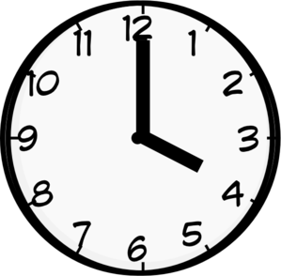

- Your ideas were great 

NB – The role of the learning facilitator is to mark errors and keep the pupils focussed and on track with their learning. They mark against the learning objective, reinforce via praise and challenge children to ensure accountability. The facilitator role would also be to assess outcomes and re-direct children up and down the challenges to ensure the correct pitch and challenge. The facilitator promotes learning DOES NOT TEACH.

Editing
When marking is in depth and children are responding to the marking to improve their work, or as part of an editing lesson, children would use the purple pen of power to show where they have corrected, improved or up-levelled their work. During the editing process more use of the other editing symbols are likely to be used more.

Success Criteria
In English & Maths a sticker will communicate the lesson objective and success criteria needed to achieve that. At the end of the lesson the learning facilitator will highlight the success criteria to indicate the pupils confidence levels as evidenced in the book. Green for secure understanding and pink for consolidation(think).

Self-assessment
During some lessons pupils will reflect on their learning to indicate how they feel they have achieved.
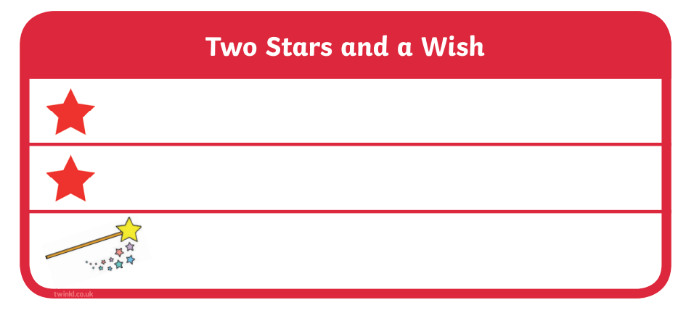

Peer assessment-
Sharing, praising and reflecting on each others learning is an integral part of learning.

Peer assessment
  2 stars: |   1 wish:
Assessed by:

EYFS – say what they think with the support of an adult modelling and questioning
KS1 –verbal
Upper KS1/Y2 and KS2 – for those able children, use the above sheets.

