Dear Parent/Carer,
As you will be aware we are holding an EvidenceMe evening for parents to attend. It is on Thursday 15th September and there will be 2 sessions available for you to choose. 3.30pm or 5.30pm. Please scan the QR code and select a session. Alternatively, a link to the session form can be accessed on the class page on the school website
During the session we will show you what EvidenceMe is all about and how you can access and contribute to your child’s online learning journey. Whilst you are here we will set you up so you are ready to go. All we will need is your email address!
Please note if your child attended Kingsfield First School Nursery last year and you are already set up on EvidenceMe then you do not need to attend.
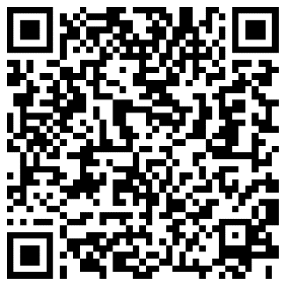
Look forward to seeing new to Kingsfield Parents on Thursday.
Many Thanks
EYFS Team
Scan me!

A note from the Headteacher:
During the initial weeks for the reception aged children they will all participate in a Government run baseline assessment. This will consist of a series of activities led by the class teachers based on Literacy and Mathematics. For more information please see the class page where the document for parents has been posted.
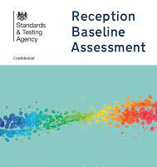
Many Thanks
Mrs Butler

