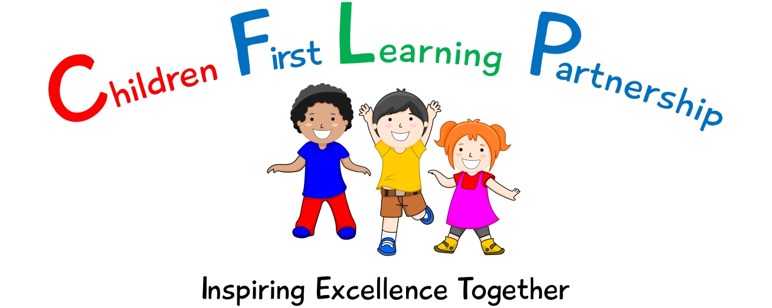



Behaviour Policy 2022

July 2023 or earlier if required
To be reviewed:
July 2022
Agreed and ratified by the Local Advisory Board on:
Kingsfield Headteacher- Mrs R Butler

Responsible Officer:
Mr. C Clulow
Chair of Local Advisory Board:
The Behaviour Policy in respect of the Children First Learning Partnership has been discussed and adopted by the Local Advisory Board

Behaviour Policy

1 Aims and expectations

1.1 It is a primary aim of our school that every member of the school community feels valued and respected, and that each person is treated fairly and well. We are a caring community, whose values are built on mutual trust and respect for all. The school behaviour policy is therefore designed to support the way in which all members of the school can live and work together in a supportive way. It aims to promote an environment where everyone feels happy, safe and secure.

1.2 The school has a number of school rules, but the primary aim of the behaviour policy is not a system to enforce rules. It is a means of promoting good relationships, so that people can work together with the common purpose of helping everyone to learn. This policy supports the school community in aiming to by allowing everyone to work together in an effective and considerate way.

1.3 The school expects every member of the school community to behave in a considerate way towards others.

1.4 We treat all children fairly and apply this behaviour policy in a consistent way.

1.5 This policy aims to help children to grow in a safe and secure environment, and to become positive, responsible and increasingly independent members of the school community.

1.6 The school rewards good behaviour, as it believes that this will develop an ethos of kindness and co-operation. This policy is designed to promote good behaviour, rather than merely deter anti-social behaviour.

1.7 The class teacher will discuss the school rules with their class. In addition to the school rules, each class also has its own classroom rules, which are created and agreed by the children and displayed on the wall of the classroom. In this way, every child in the school knows the standard of behaviour that we expect in our school. If there are incidents of anti-social behaviour, the class teacher will discuss these with the whole class during ‘circle time’.

1.8 The school does not tolerate bullying of any kind. (Refer to our Anti Bullying Policy.) If we discover that an act of bullying or intimidation has taken place, we act immediately to stop any further occurrences of such behaviour. While it is very difficult to eradicate bullying, we do everything in our power to ensure that all children attend school free from fear.

1.9 Teachers in our school do not hit, push or slap children. Staff only intervene physically to restrain children or to prevent injury to a child, or if a child is in danger of hurting him/herself. The actions that we take are in line with government guidelines on the restraint of children. (Please refer to our Restrictive Physical Intervention Policy.)

2 The role of all staff

2.1 It is the responsibility of all staff to ensure that the school and class rules are enforced in their classroom, in the hall and at break times and that their class behaves in a responsible manner.

2.2 All staff in our school have high expectations of the children in terms of behaviour, and they strive to ensure that all children work and play to the best of their ability.

2.3 Staff treat each child fairly and enforce the classroom and school rules consistently. The teacher treats all children with respect and understanding.

2.4 The class teacher liaises with external agencies, as necessary, to support and guide the progress of each child. The class teacher may, for example, discuss the needs of a child with a Trailblazers or refer to the DIP.

2.5 The class teacher reports to parents about the progress of each child in their class, in line with the whole–school policy. The class teacher may also contact a parent if there are concerns about the behaviour or welfare of a child.

3 Rewards and sanctions

3.1 We praise and reward children for good behaviour in a variety of ways:
- Linked with the behaviour traffic light systems in all classes there are 3 levels of rewards; bronze, silver and gold. Bronze is rewarded with a sticker, silver a certificate and sticker. For gold, the child receives a gold sticker, certificate, a Headteacher’s Award sticker plus s Headteacher’s Treat, their name is also mentioned on the weekly newsletter!
- Teachers praise children either verbally or written when marking work;
- Teachers give children house points and winning teams are rewarded every half term.
- Lunchtime supervisors are encouraged to give out stickers and team points.
- Each week we nominate a star of the week from each class to celebrate good behaviour, attitude or achievement and these children receive a certificate in the school.
- Parents are informed of children’s achievements outside of school, the golden ticket winners and the house point winning team via the newsletter.
- Special texts home to parents are sent to reward good work or behaviour, or to acknowledge outstanding effort or acts of kindness in school;
- All classes have an opportunity to lead an assembly where they are able to show examples of their best work, often parents are invited to these.
- Each class rewards the learner of the lesson (KS2) and learner of the day (EYFS & KS1) and their name is displayed on the class board.
- Every week the Special Person is awarded during a class circle time where they celebrate that person’s special qualities. The pupil then becomes the line leader each week.
- In recognition of special efforts for specific curriculum areas, subject trophies are awarded.

The school also employs a number of sanctions to enforce the school rules, and to ensure a safe and positive learning environment. We employ each sanction appropriately to each individual situation.

In class (refer to Appendix 1):
- We expect children to listen carefully to instructions and work hard. However, adults in the room must be constantly trying to identify why the child is demonstrating such behaviour, including discussing this with the child and planning how to avoid such an issue arising again. Understanding and pre-empt what triggers may cause the behaviour dip are important in order to support and reduce such behaviour occurrences.
- If a child’s behaviour does not improve, we ask them either to move to a place nearer to the teacher, or to sit on their own.
- If a child continues to be disruptive in class, the teacher will talk to the child and use the behaviour traffic lights. Their name will be moved from green to yellow and the children must work hard to ensure they get back to green.
- However, if misbehaviour continues, the class teacher will move them further down the traffic lights to orange and they will miss their next play.
- If poor behaviour persists the child moves to red on the traffic lights and the class teacher will seek help and advice from the Assistant Headteacher and in some cases the Head Teacher. Parents will be informed by the teacher at the end of the day and they miss their next play.
- If a serious incident occurs it may merit a straight to red.
- Red incidents will be recorded using Arbor to monitor behaviour. Behaviour report books may be issued to some children in order to communicate daily to parents on their child’s behaviour in order to support and improve behaviour.
- If a child threatens, hurts or bullies another pupil, the class teacher records the incident and work is done with them to ensure such an incident does not happen again.
- If a child repeatedly acts in a way that disrupts or upsets others, the Headteacher will contact the child’s parents to invite them to discuss the situation, this is with the aim to improve the behaviour of the child by establishing an individual behaviour plan.

Breaktimes and Lunchtimes

- Children are expected to follow the school rules.
- If a child breaks these rules they will be asked to walk with a member of staff to calm down.
- If poor behaviour continues an adult will discuss the situation with the child and they will reflect on their behaviour.
- If it is a wet playtime the lunchtime supervisors will fetch a member of staff to support them, if necessary.
- If a serious incident takes place the Headteacher will be informed to deal with the situation.
- It is the responsibility of either the staff on duty or lunchtime supervisors to inform the class teacher of any incidents which merit being recorded on the traffic lights.
- If this continues the headteacher will become involved and ask parents to work with her to support their child. This may be in the form of establishing an individual behaviour plan for their child.

4 The role of the Headteacher

4.1 It is the responsibility of the Headteacher, under the School Standards and Framework Act 1998, to implement the school behaviour policy consistently throughout the school, and to report to governors, when requested, on the effectiveness of the policy. It is also the responsibility of the Headteacher to ensure the health, safety and welfare of all children in the school.

4.2 The Headteacher supports the staff by implementing the policy, by setting the standards of behaviour, and by supporting staff in the implementation of the policy and in some cases an individual behaviour plan when appropriate.

4.3 The Headteacher keeps records of all reported serious incidents of misbehaviour and all records are analysed on a monthly basis. Where patterns or incidents persist, actions and support will be put into place.

4.4 The Headteacher has the responsibility for giving fixed-term exclusions to individual children for serious acts of misbehaviour. For repeated or very serious acts of anti-social behaviour, the Headteacher may permanently exclude a child. Both these actions are only taken after the LAB and CEO have been informed and have had an opportunity to share in this decision.

5 The role of parents

5.1 The school works collaboratively with parents, so children receive consistent messages about how to behave at home and at school.

5.2 We explain the school rules in the Home-School Agreement, and we expect parents to read these and support them.

5.3 We expect parents to support their child’s learning, and to co-operate with the school, as set out in the home–school agreement. We try to build a supportive dialogue between the home and the school, and we inform parents immediately if we have concerns about their child’s welfare or behaviour.

5.4 If the school has to use reasonable sanctions to punish a child, parents should support the actions of the school. If parents have any concern about the way that their child has been treated, they should initially contact the class teacher. If the concern remains, they should make an appointment to discuss the issue with the Headteacher. If these discussions cannot resolve the problem, the governors will become involved and a formal grievance or appeal process can be implemented.

6 The role of governors

6.1 The LAB has the responsibility of setting down these general guidelines on standards of discipline and behaviour and of reviewing their effectiveness. The governors support the Headteacher in carrying out these guidelines.

6.2 The Headteacher has the day-to-day authority to implement the school behaviour and discipline policy, but governors may give advice to the Headteacher about particular disciplinary issues. They Headteacher must take this into account when making decisions about matters of behaviour.

7 Fixed-term and permanent exclusions

7.1 After informing the LAB, the Headteacher has the power to exclude a pupil from school. The Headteacher may exclude a pupil for one or more fixed periods, for up to 45 days in any one school year. The Headteacher may also exclude a pupil permanently. It is also possible for the Headteacher, after discussions with the governors and CEO to convert a fixed-term exclusion into a permanent exclusion, if the circumstances warrant this.

7.2 If the Headteacher excludes a pupil, s/he informs the parents immediately, giving reasons for the exclusion. At the same time, the Headteacher makes it clear to the parents that they can, if they wish, appeal against the decision to the LAB. The school informs the parents how to make any such appeal.

7.3 The Headteacher informs the LA and the LAB about any permanent exclusion, and about any fixed-term exclusions beyond five days in any one term.

7.4 The LAB itself cannot either exclude a pupil or extend the exclusion period made by the Headteacher.

7.5 The LAB will create a discipline committee which is made up of between three and five members. This committee considers any exclusion appeals on behalf of the governors.

7.6 When an appeals panel meets to consider an exclusion, they consider the circumstances in which the pupil was excluded, consider any representation by parents and the LA, and consider whether the pupil should be reinstated.

7.7 If the governors’ appeals panel decides that a pupil should be reinstated, the Headteacher must comply with this ruling.

8 Monitoring

8.1 The Headteacher monitors the effectiveness of this policy on a regular basis. She also reports to the LAB on the effectiveness of the policy and, if necessary, makes recommendations for further improvements.

8.2 The school keeps a variety of records of incidents of misbehaviour. The class teacher records minor classroom incidents. The Headteacher records those incidents where a child is sent to him/her on account of bad behaviour. We also keep a record of any incidents that occur at break or lunchtimes.

8.3 The Headteacher keeps a record of any pupil who is suspended for a fixed-term, or who is permanently excluded and this is reported to Governors on a termly basis via the Headteacher’s School in Action Report.

8.4 It is the responsibility of the LAB to monitor the rate of suspensions and exclusions, and to ensure that the school policy is administered fairly and consistently.

9 Review

9.1 The LAB reviews this policy annually. They governors may, however, review the policy earlier than this, if the government introduces new regulations, or if the LAB receives recommendations on how the policy might be improved.

APENDIX 1

Gold – Super Star
You will receive a special gold sticker, a certificate, a mention on the school newsletter and most importantly a prize from Mrs Butler’s Golden Box!

Silver – WOW
You will receive a special silver sticker, silver certificate and an Assistant Headteachers sticker from Mrs Nesbitt.

Bronze – Great
You will receive a special bronze sticker and you will move your name up to bronze so all your peers know.

Green – Good

Yellow – Stop and think.
Stop and think about your behaviour. Change your actions and try and work your way back to green.

Orange – Warning
Your behaviour must not have changed, so you will need to miss the next play time to reflect on your behaviour and change your actions.

Red – Out
Your behaviour is not appropriate so you will be sent out of the class to another
classroom. If your behaviour doesn’t improve, you will then be sent to Mrs Butler.
Depending on the severity of your behaviour, you may be sent straight to Mrs Butler.

